**Project Report**

**Customer Retention Case Study Report**



***Submitted by: Safiya Firdose Khan***

**ACKNOWLEDGMENT**

It is my deepest pleasure and gratification to present this report. Working on this project was an incredible experience that has given me a very informative knowledge regarding the data analysis process. All the required information and dataset are provided by Flip Robo Technologies (Bangalore) that helped me complete the project. I want to thank my SME Khushboo Garg for giving the dataset and instructions to perform the complete case study process.

**What is Customer Retention?**

Customer retention refers to a company’s ability to turn customers into repeat buyers and prevent them from switching to a competitor. It indicates whether your product and the quality of your service please your existing customers. It is also the lifeblood of most subscription-based companies and service providers.

**Customer retention strategies** are the processes and initiatives businesses put in place to build customer loyalty and improve customer lifetime value.

Customer retention is different from customer acquisition or lead generation. It focuses on customers who have already signed up for a service or purchased a product from you. But retaining customers is about more than just transactions—it is about relationships. Research shows that customers view their relationships with brands similarly to their relationships with friends. Customers like brands that are reliable, authentic and aware of what matters to them. Focus on buyer relationships with your existing customers to boost their brand loyalty. These shoppers will continue to choose your brand even when presented with other options. With this loyal base, your brand will be more likely to weather explosive markets.

**Why is customer retention important?**

Keeping your current customers happy is generally more cost-effective than acquiring first-time customers. According to the Harvard Business Review, acquiring a new customer can be five to 25 times more expensive than holding on to an existing one.

**Acquiring a new customer can be five to 25 times more expensive than holding on to an existing one.**

You do not need to spend big on marketing, advertising or sales outreach. It is easier to turn existing customers into repeating ones, since they already trust your brand from previous purchases. New customers, however, often require more convincing when it comes to that initial sale. Customer loyalty will not just give you repeat business. Loyal customers are more likely to give free recommendations to their colleagues, friends and family. Creating that cycle of retained customers and viral marketing is one way your company can cultivate customer loyalty for long-term success.

**Customer retention benefits**

* Cost savings: Customer retention is generally more cost-effective than acquiring first-time customers
* Positive word of mouth marketing: Loyal customers are more likely to tell their friends and family about your brand
* A better bottom line: Increasing retention rates by just 5 percent can increase revenue by 25 percent to 95 percent

**How do you measure your customer retention rate?**

The customer retention rate is the percentage of previous customers who remained loyal to your business over a period of time. To calculate it, pick a period of time you want to measure and then identify the following:

* Number of customers at the start of a given time period (S)
* Number of customers at the end of that period (E)
* Number of new customers added over the duration of that period (N)

Then, you can calculate your customer retention rate (X) with the following formula:

**Customer retention formula**

**((E – N) / S) * 100 = X**

**6 strategies to improve customer retention**

1. Respond to customer support queries quickly

2. Use context to deliver personalised support interactions

3. Simplify customer service workflows

4. Offer omnichannel support to reach customers where they are

5. Consistently gather customer feedback

6. Incentivise loyalty

Improving customer retention means improving the customer experience. If you make interactions more convenient, personal and rewarding for your customers, they are likely to be more loyal in return.

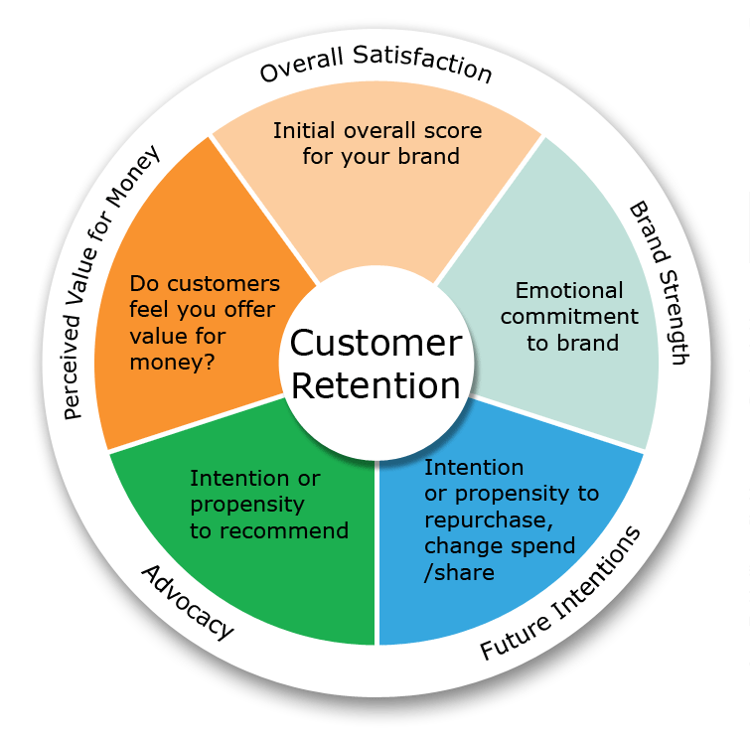

|  |
| --- |
| **Use Case Diagram** |



|  |
| --- |
| In the use case diagram above, you can see that the intent of repeated purchases is basically based on a customer retention strategy based on pleasure value and utilitarian value. We also find that the perceived risks affect your purchase and repurchase intent. Pleasure value is made up of five key components: satisfaction, role, best offer, social aspects, and adventurous standards. In terms of utility value, we have product offerings, convenience, product information, and money savings. |

**Motivation for the Problem Undertaken:**

The main objective behind this problem is to help the ecommerce websites to find the e-retail factors for customers activation and retention. The online shopping was considered by almost everyone to be convenient. The store is always open and it is easy, less stress and time saving to shop from home. Participants also seemed to agree that internet shopping gives access to a large range of stores and products from the entire world and offers best price to their consumers. So, in this project we will be analysing how these online stores attracts the customers and whether the customers satisfied by their products or not.

**Details of the Dataset:**

* The dataset contains two excel sheets, one is detailed datasheet and the other one is encoded datasheet. I have used detailed datasheet for the processing.
* The dataset consists of 269 rows and 71 columns, which is comprised of categorical columns. All the features contain object data type, except the feature Pin code (integer data type).

Firstly, I have imported the necessary libraries and dataset.

|  |
| --- |
| After I got the dataset in my Jupyter Notebook I noticed that due to large number of rows and columns the information was truncated. Therefore, to overcome this challenge I used the pandas code as shown below. |
|  |

I checked the names of the columns and found them to be too lengthy, and hence renamed them.

Then, I checked the type of the dataframe and the detailed info about the dataframe.

I also checked the null values present in the dataset and found out that no null values were present in out dataset.



I also checked the unique values present in the dataset by using the nunique method.



Then, I checked the datatypes of the columns, and found out that all the columns are of object datatype, except the column ‘Pin_Code’. So, I converted the datatype of column ‘Pin_Code’ from integer datatype to object datatype.

|  |
| --- |
| I used a for loop to take a look at all the unique values present in the categorical columns covering the number of rows in the dataset. |

**Data Visualization**

**Univariate Analysis:**

I have used count plots for univariate analysis.

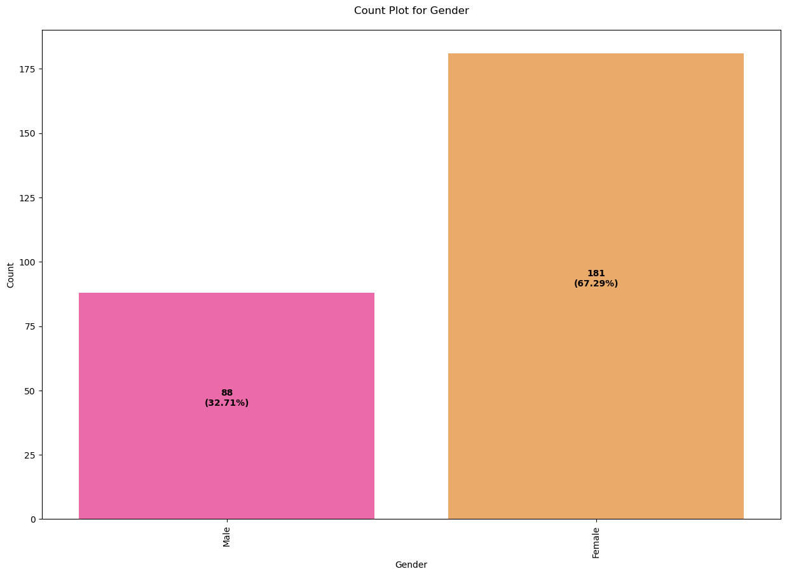

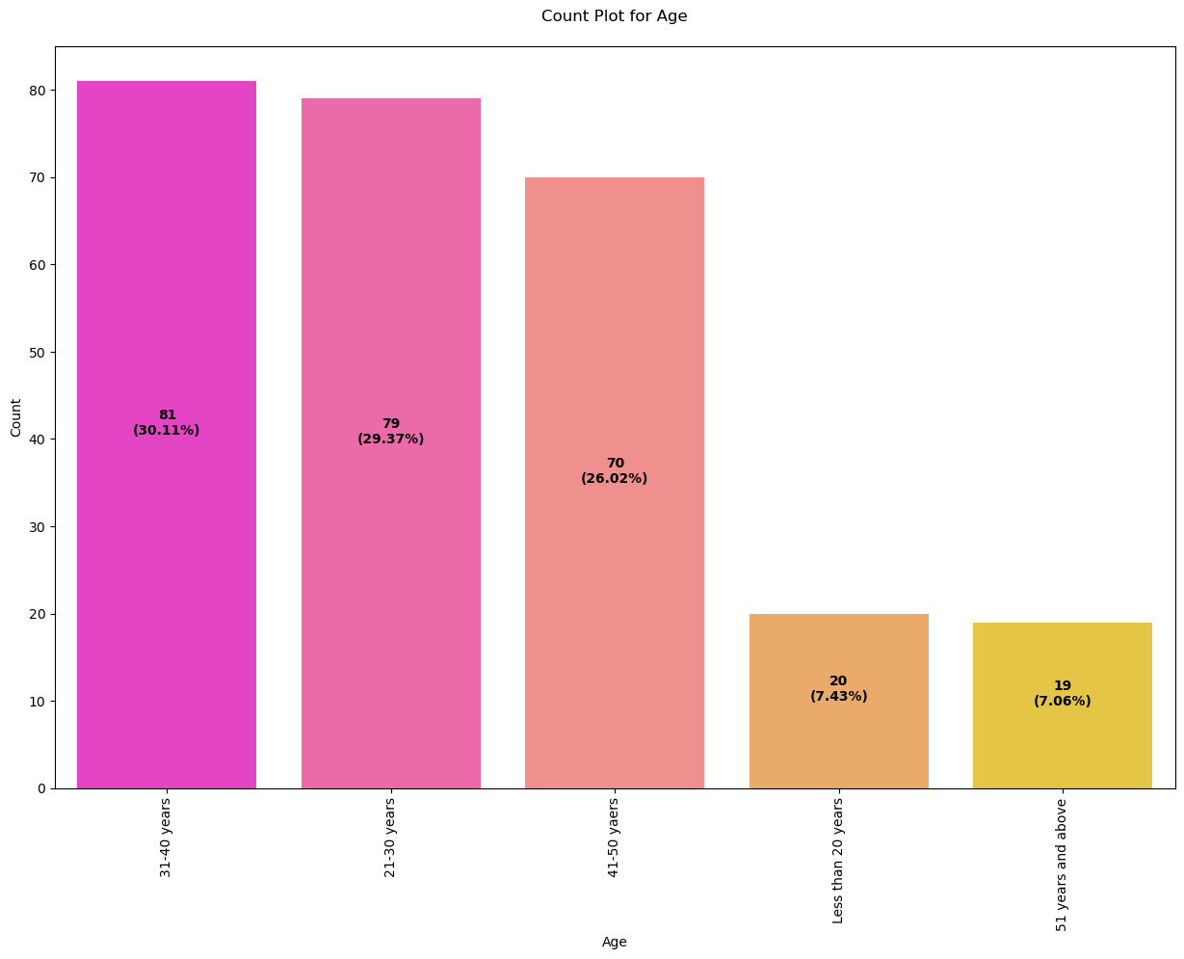

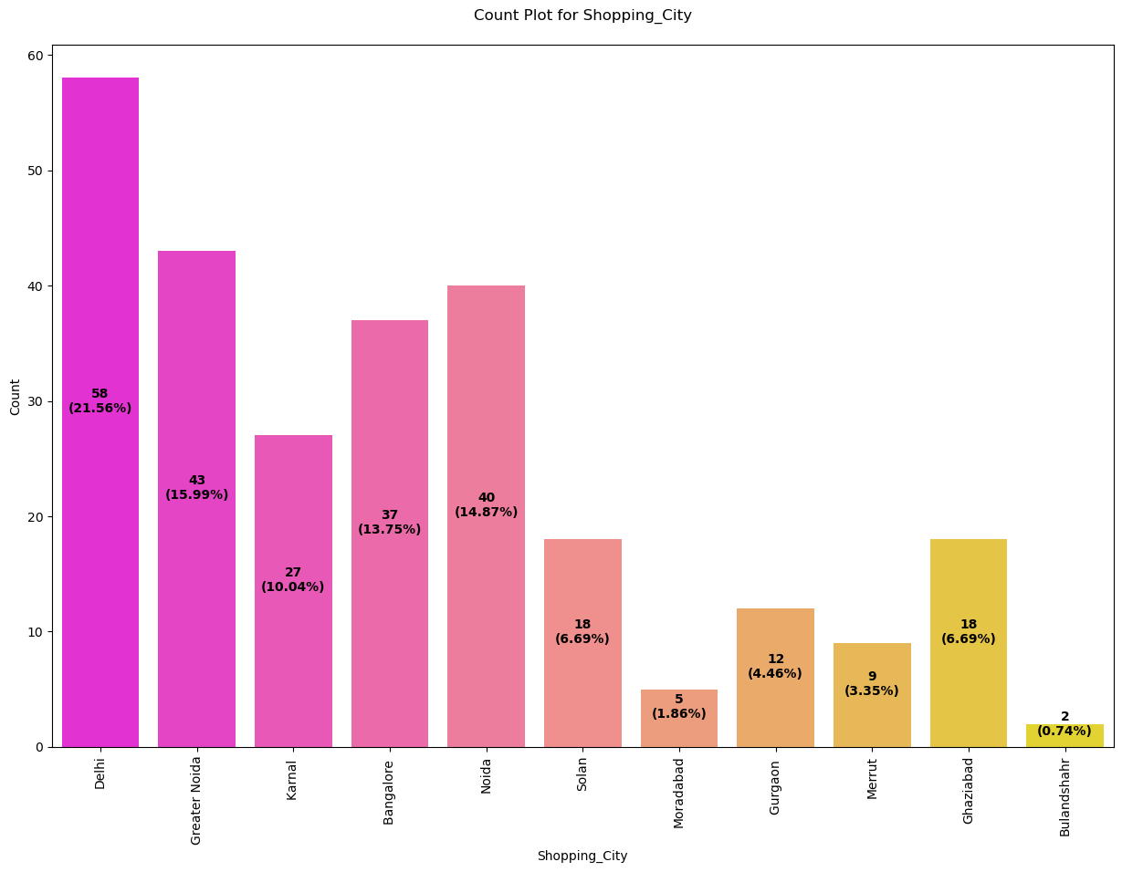

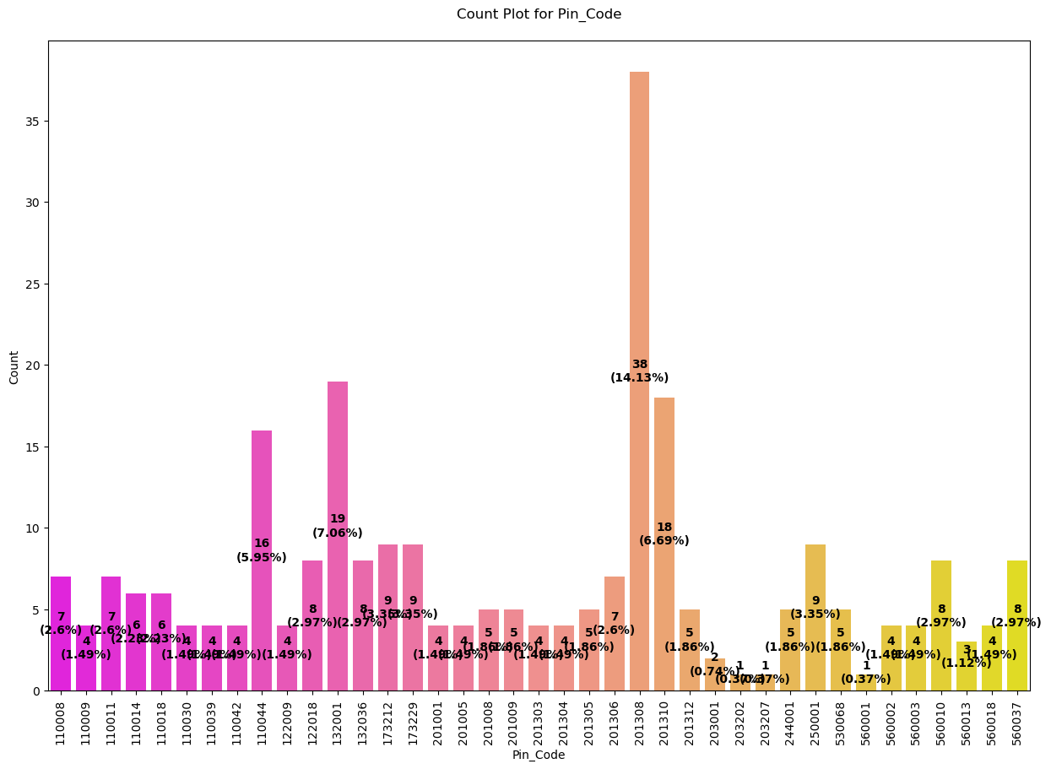

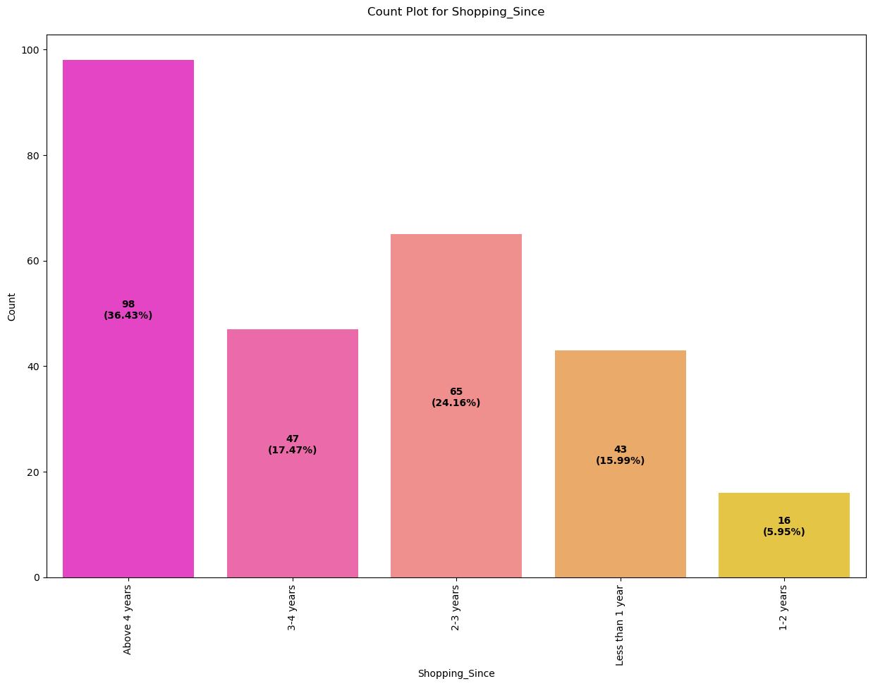

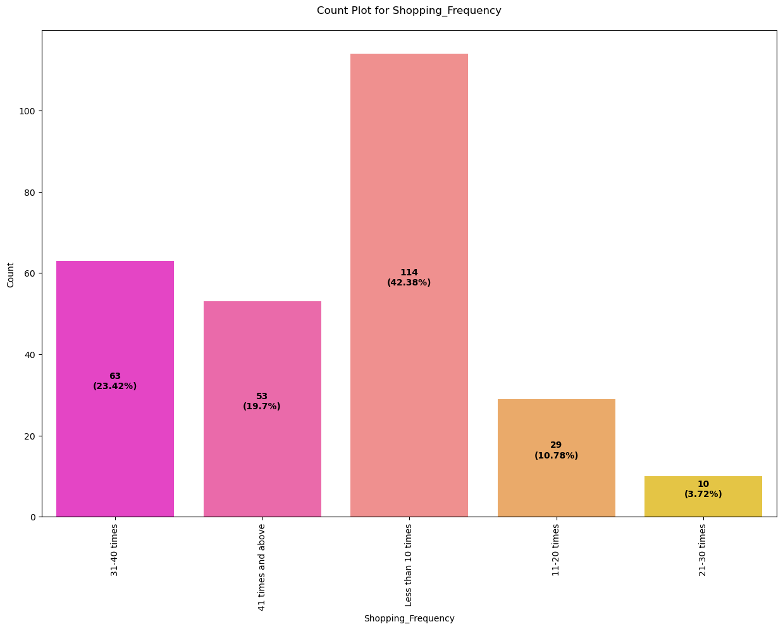

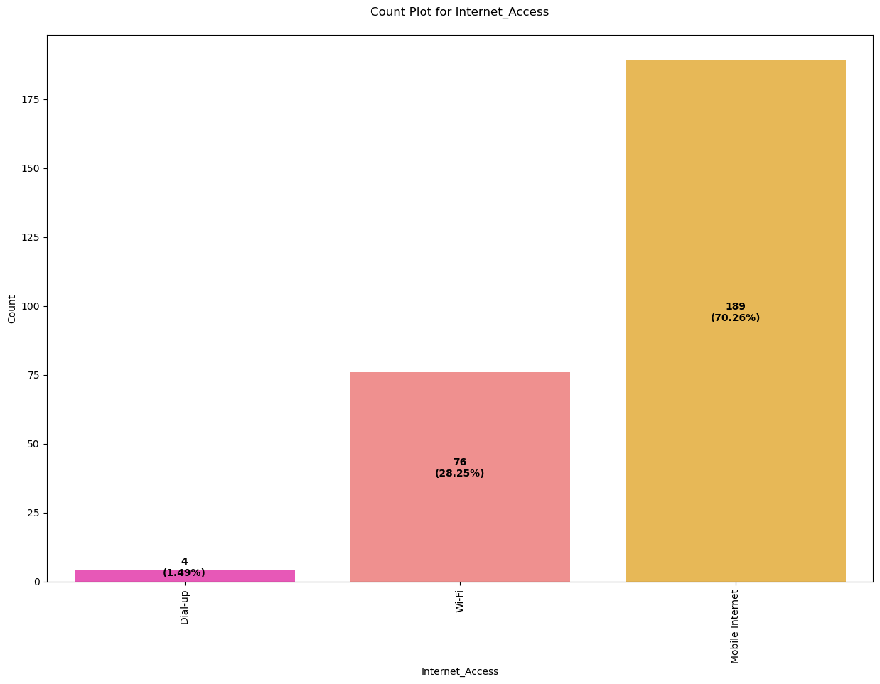

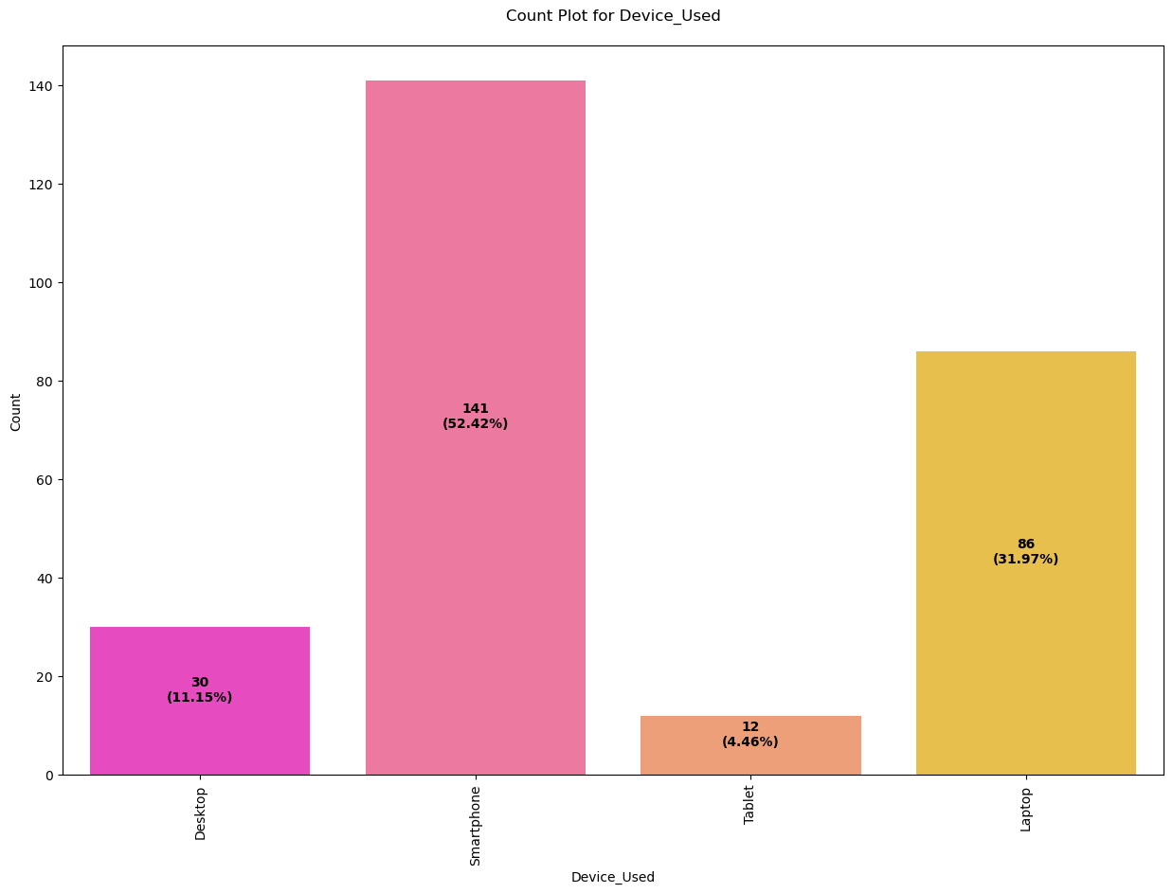

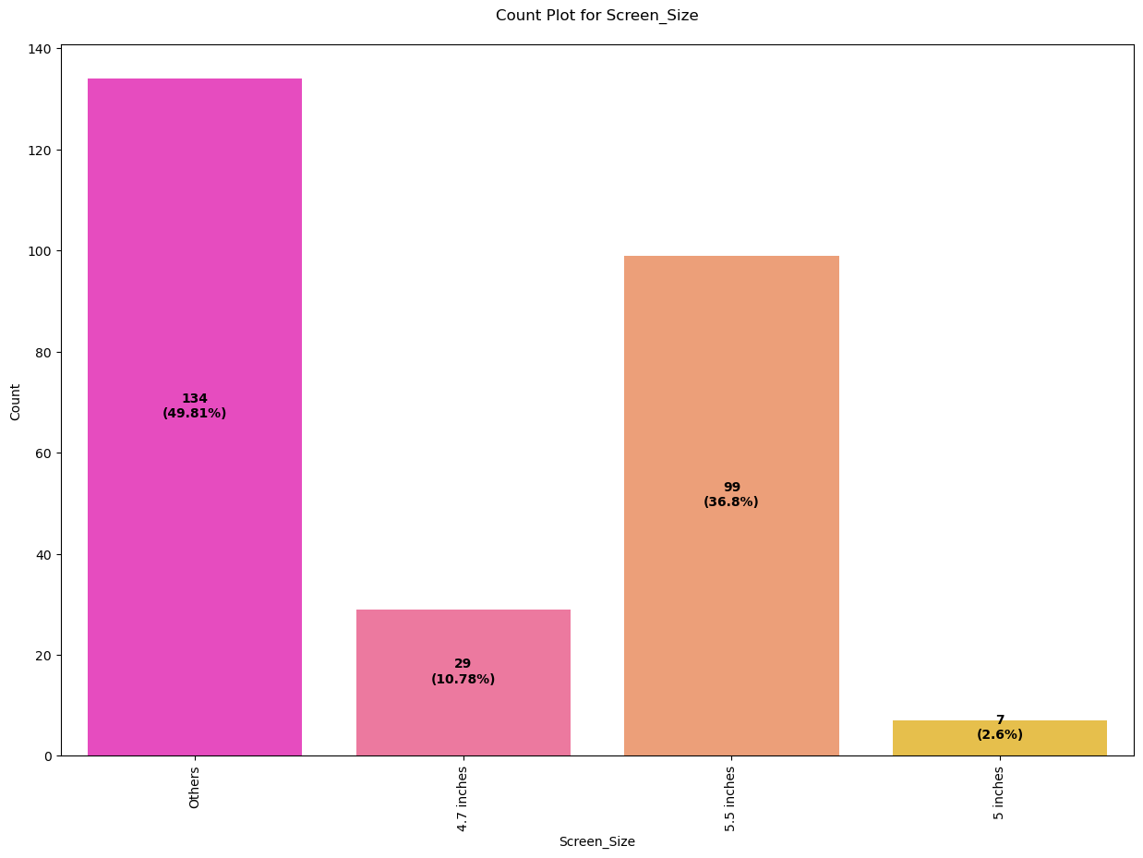

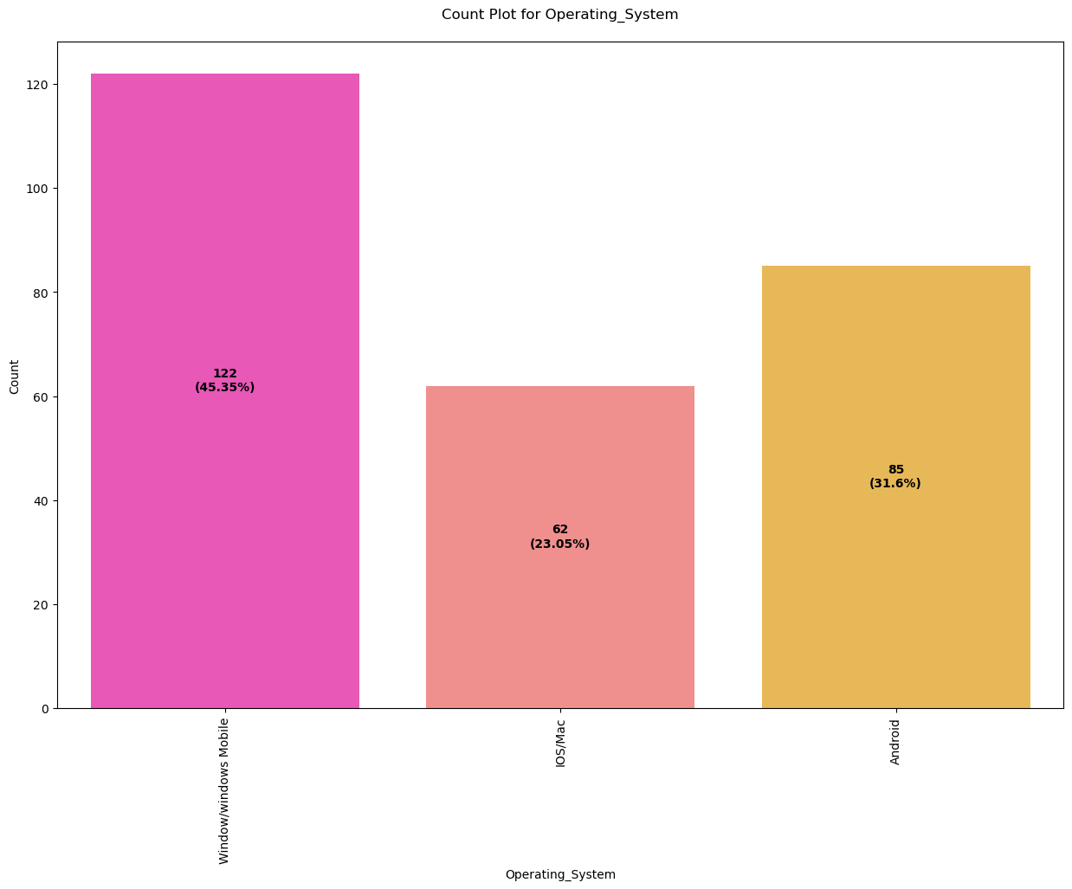

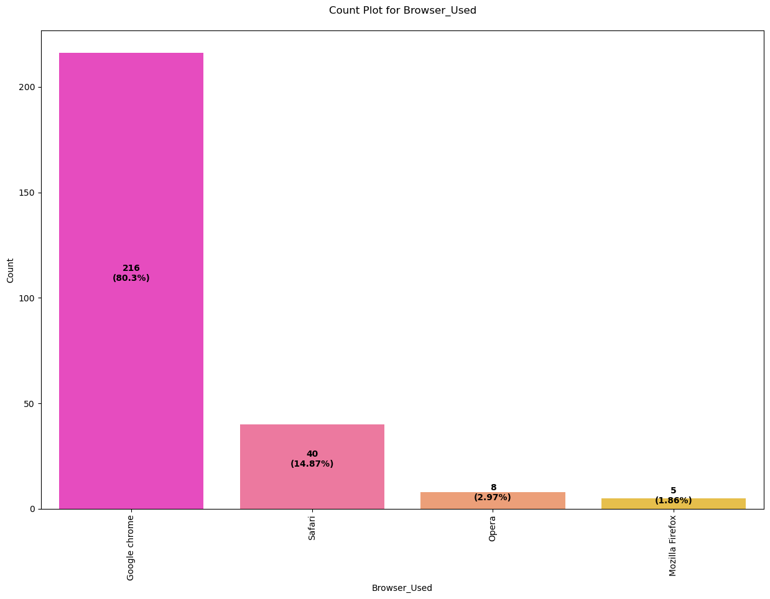

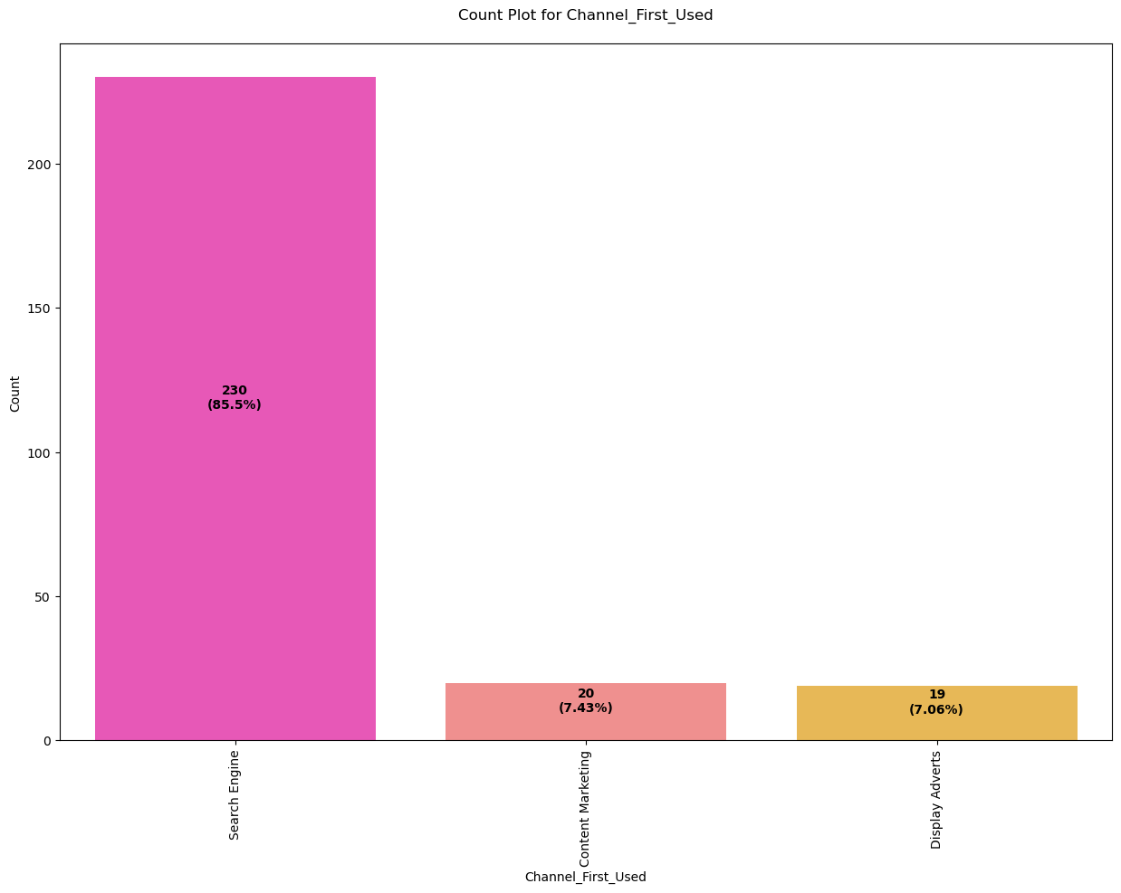

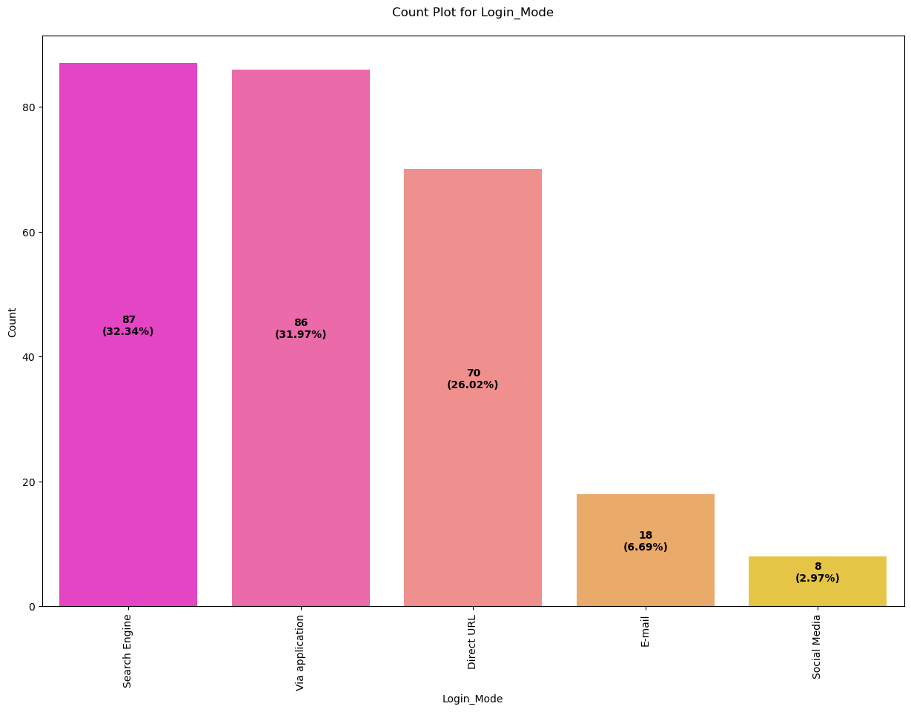

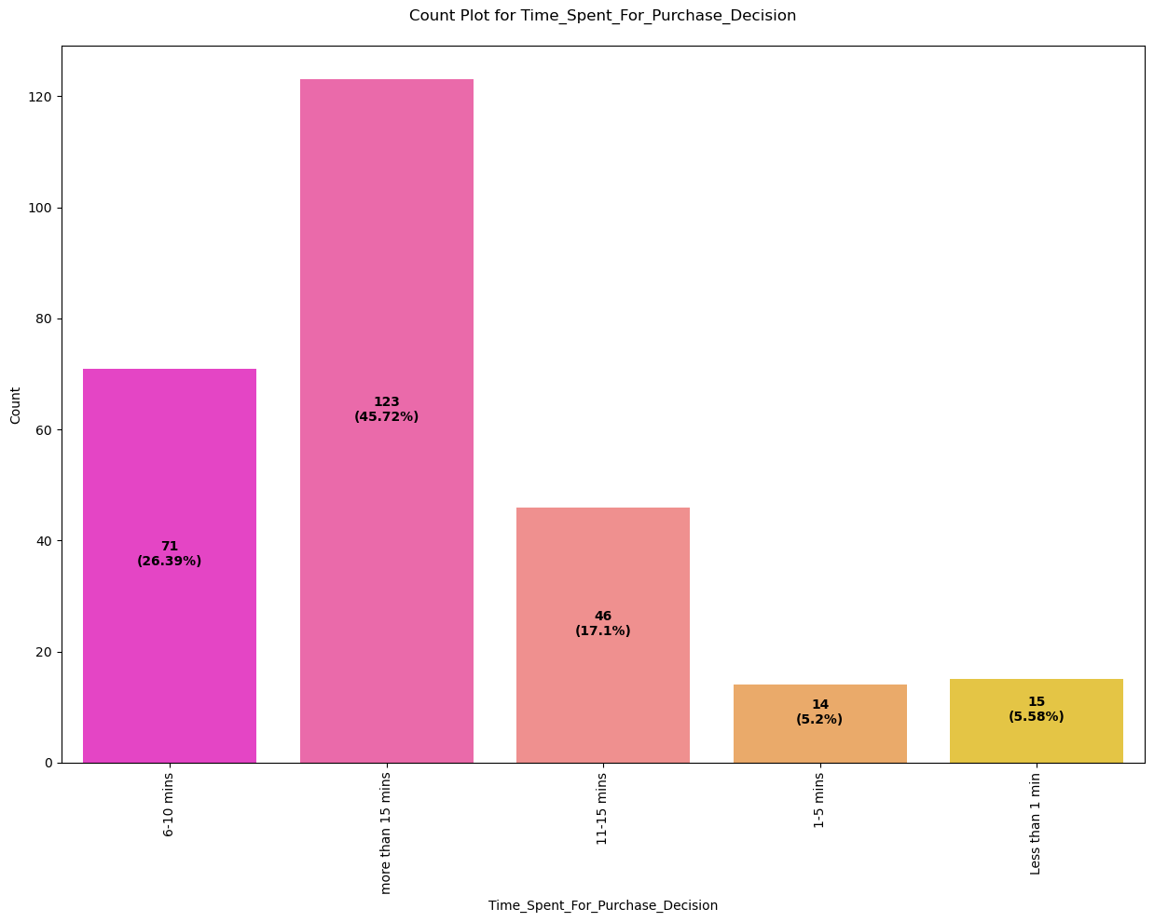

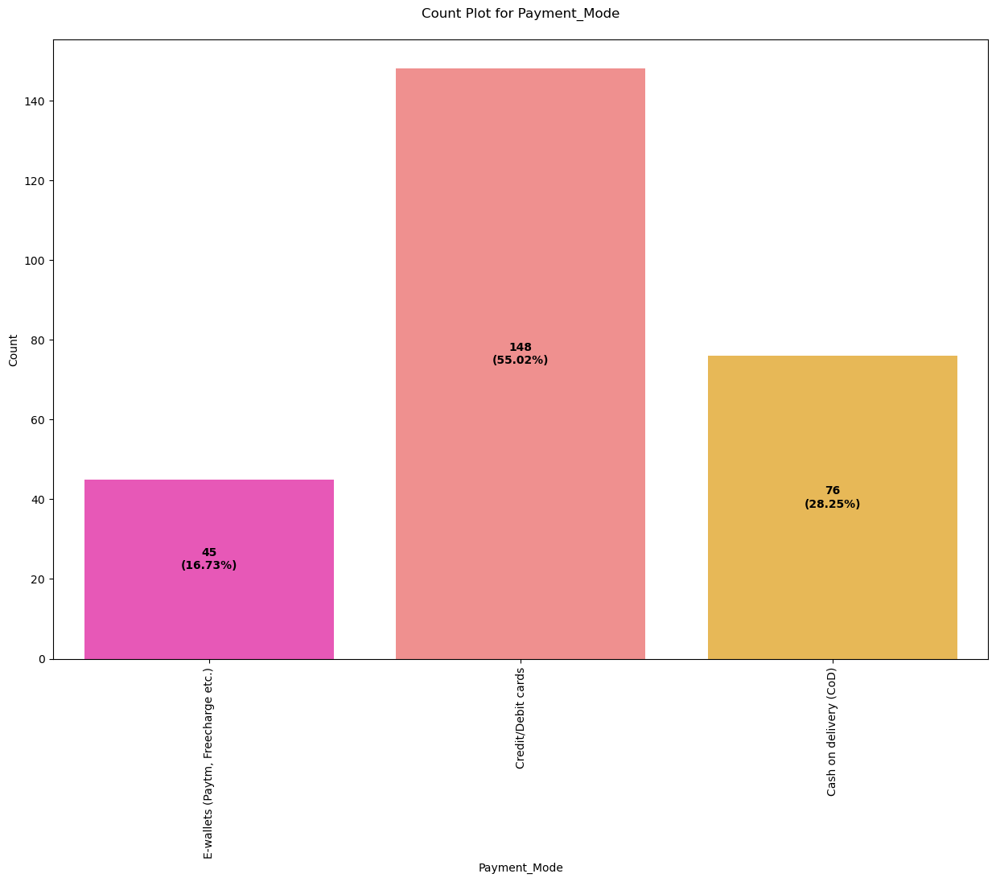

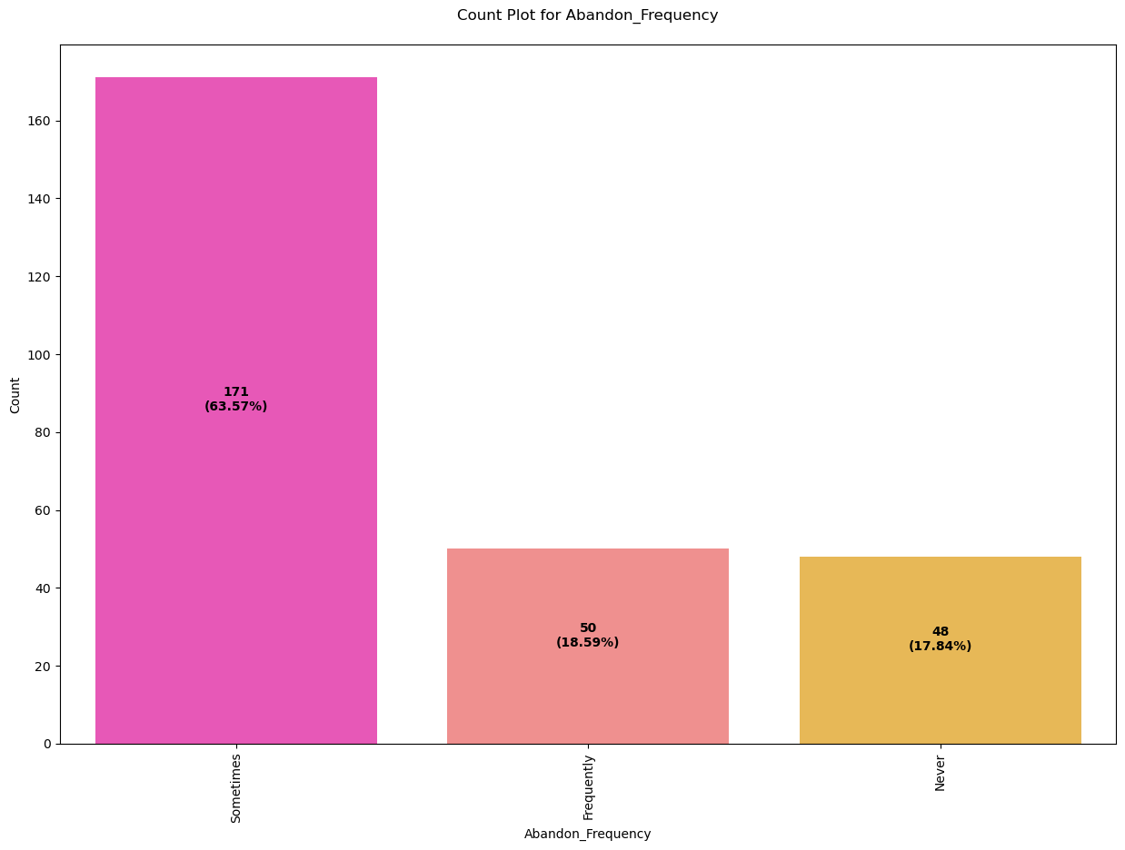

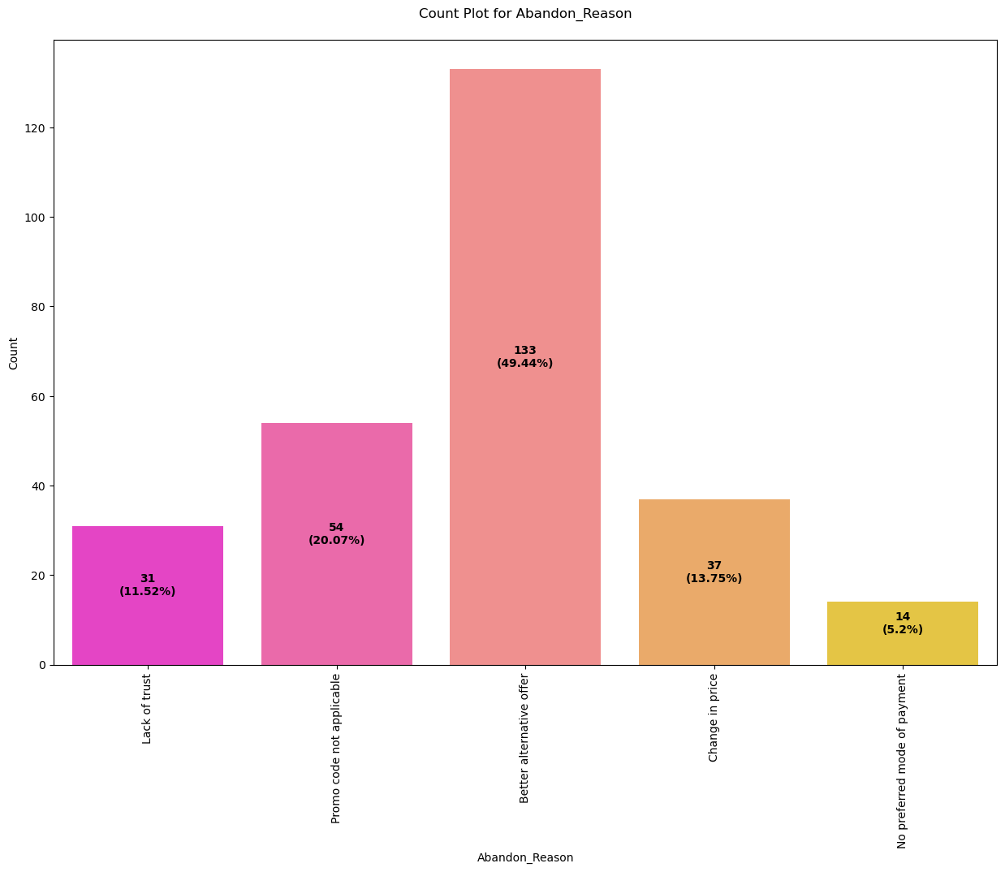

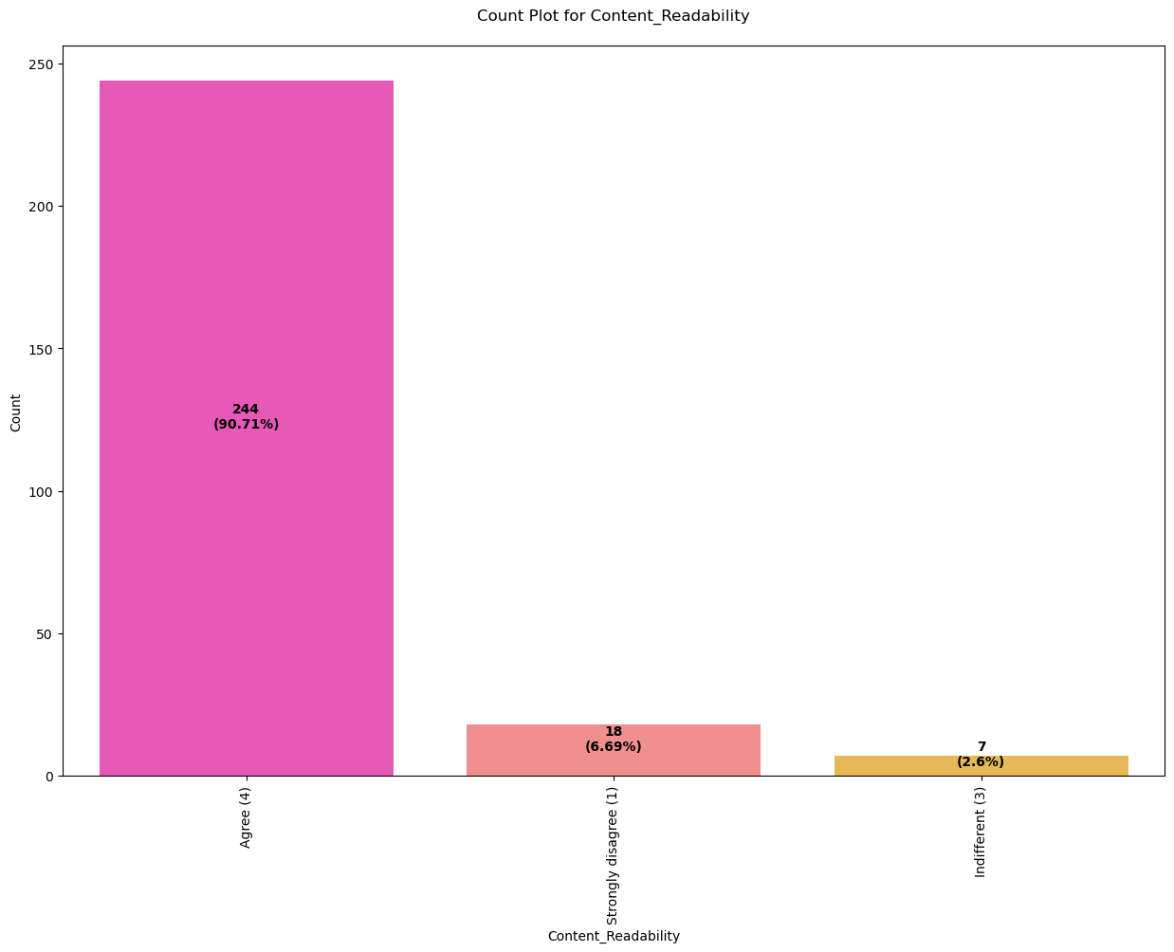

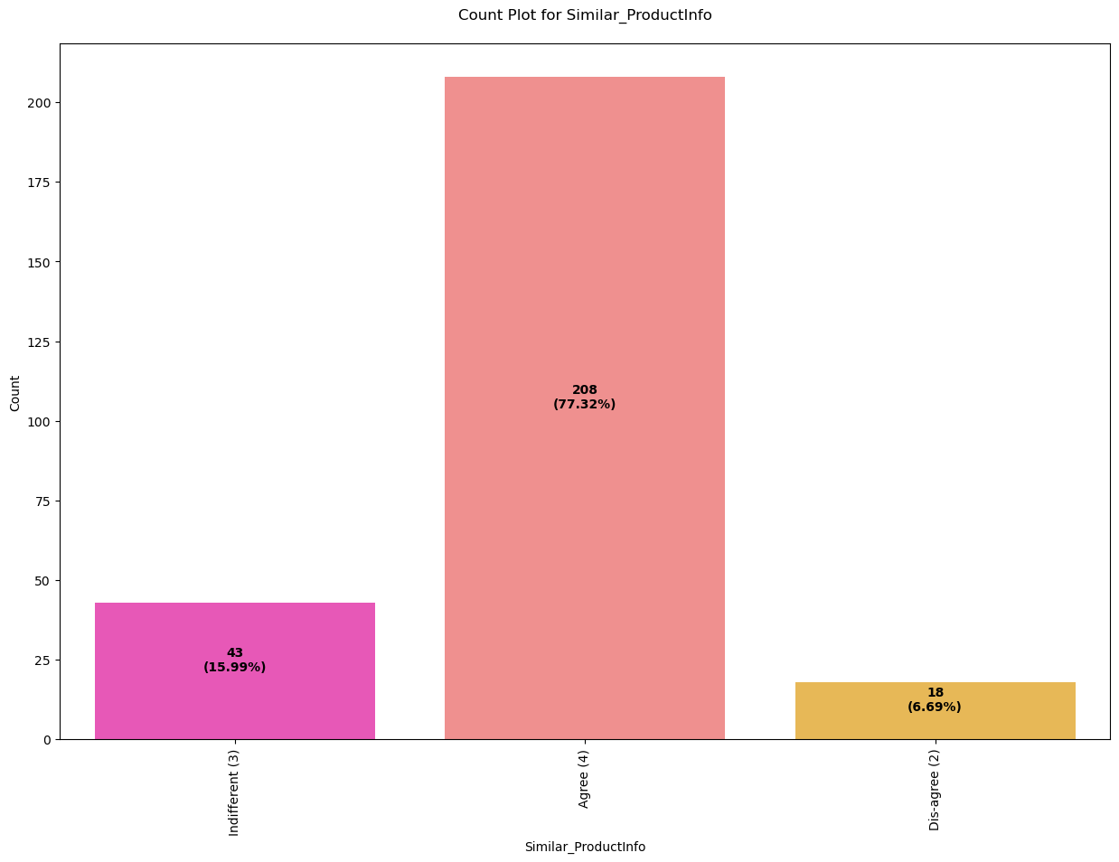

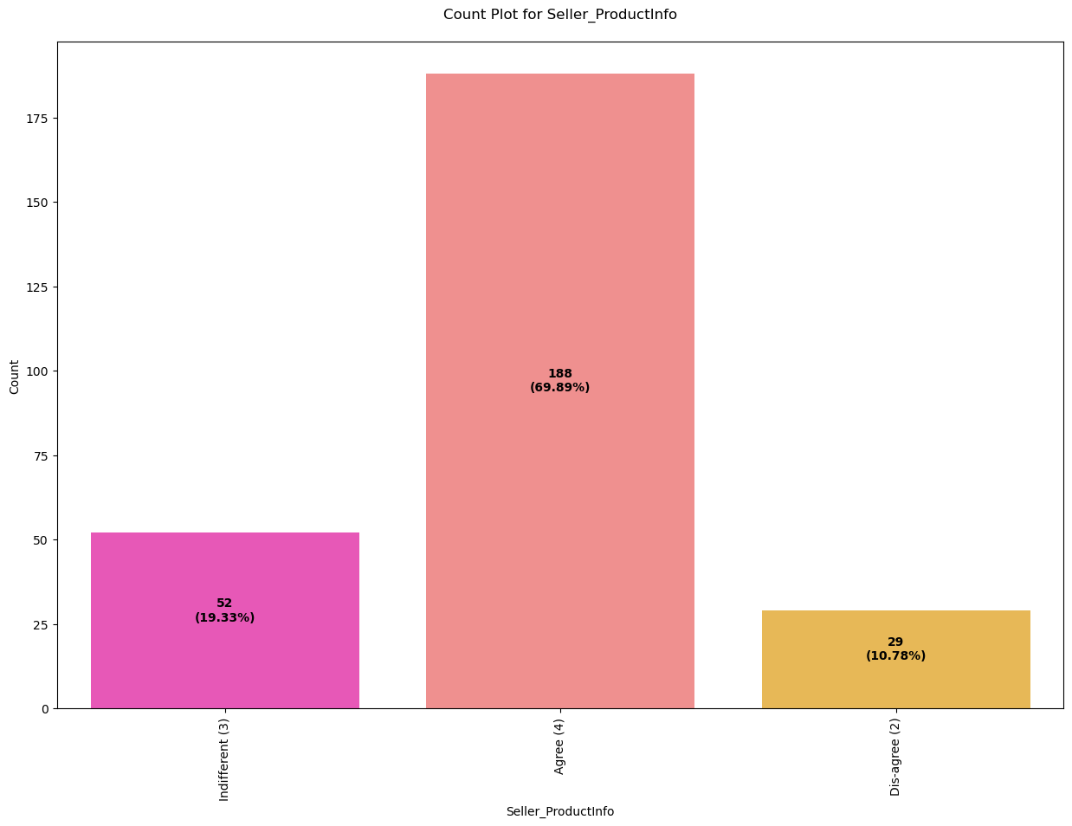

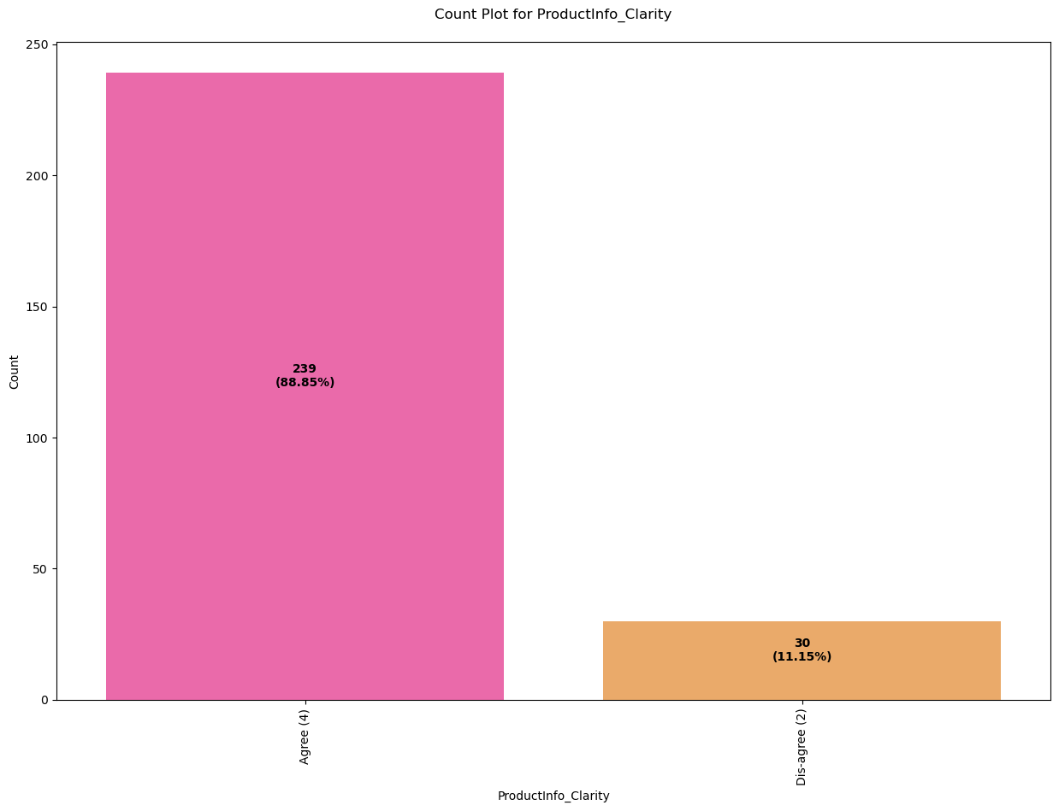

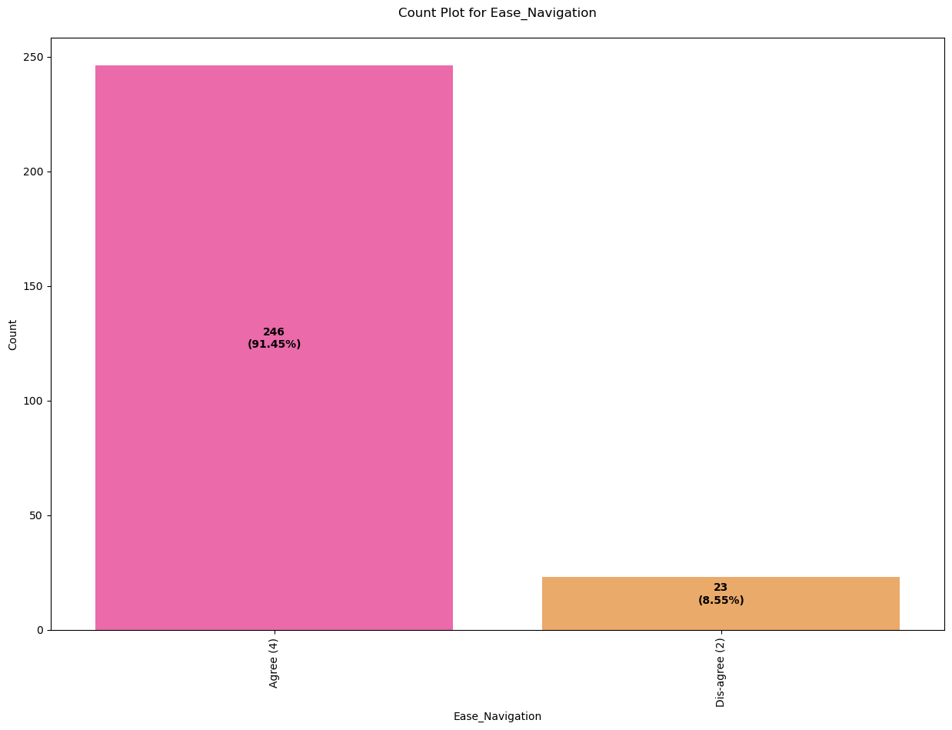

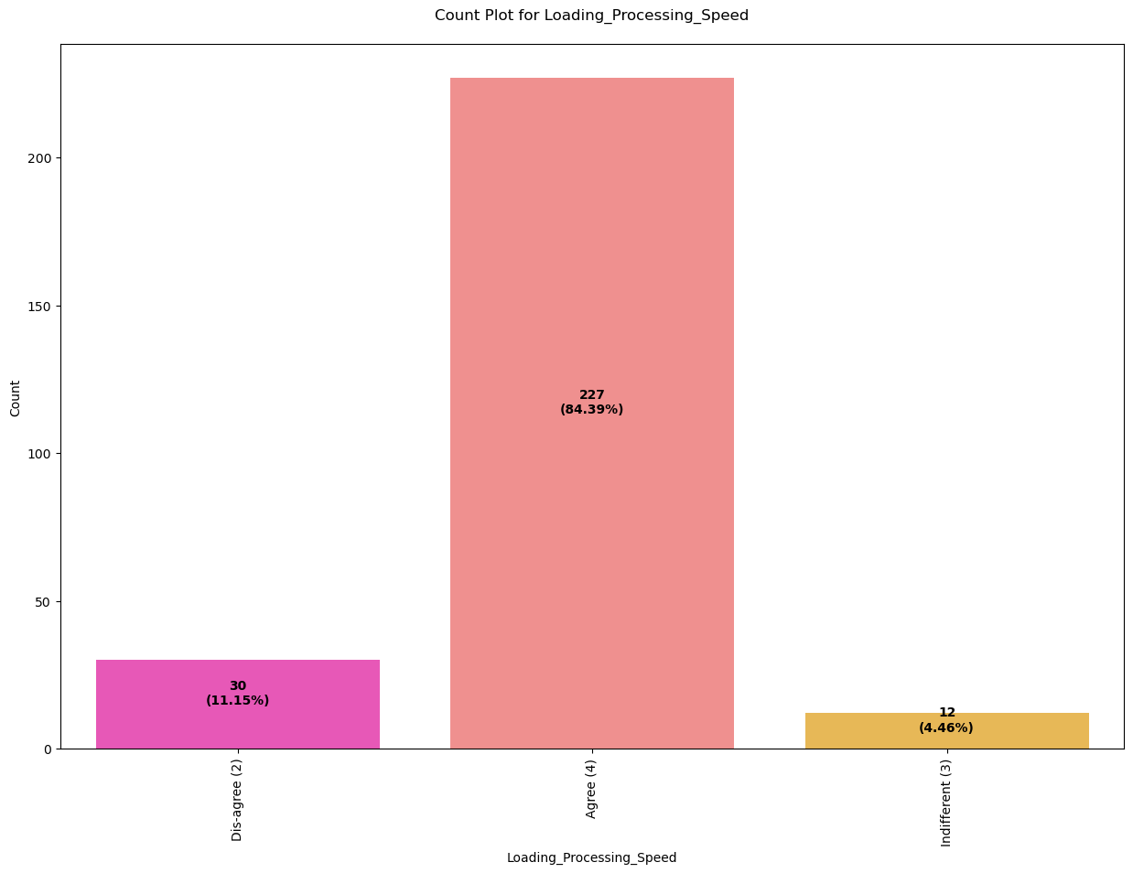

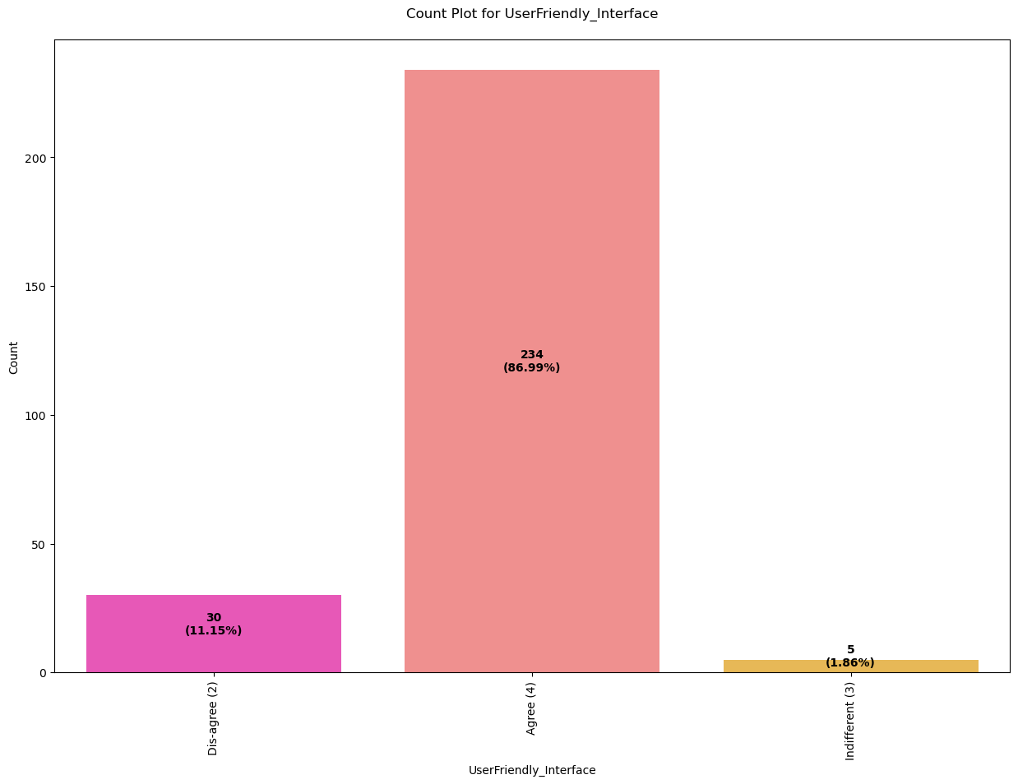

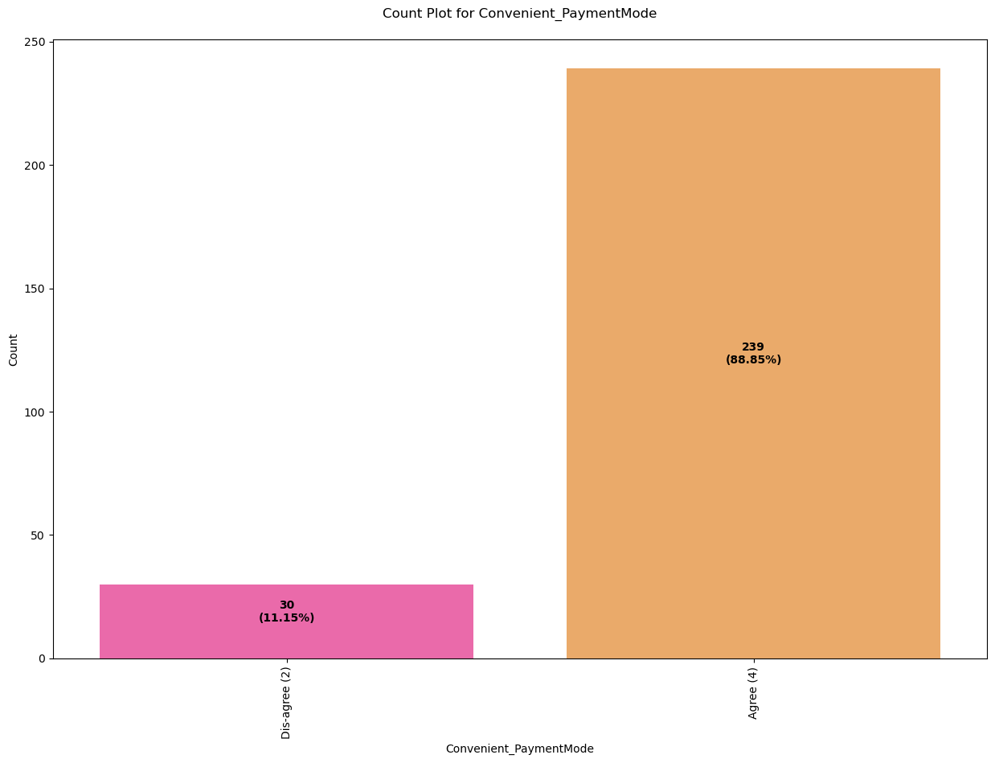

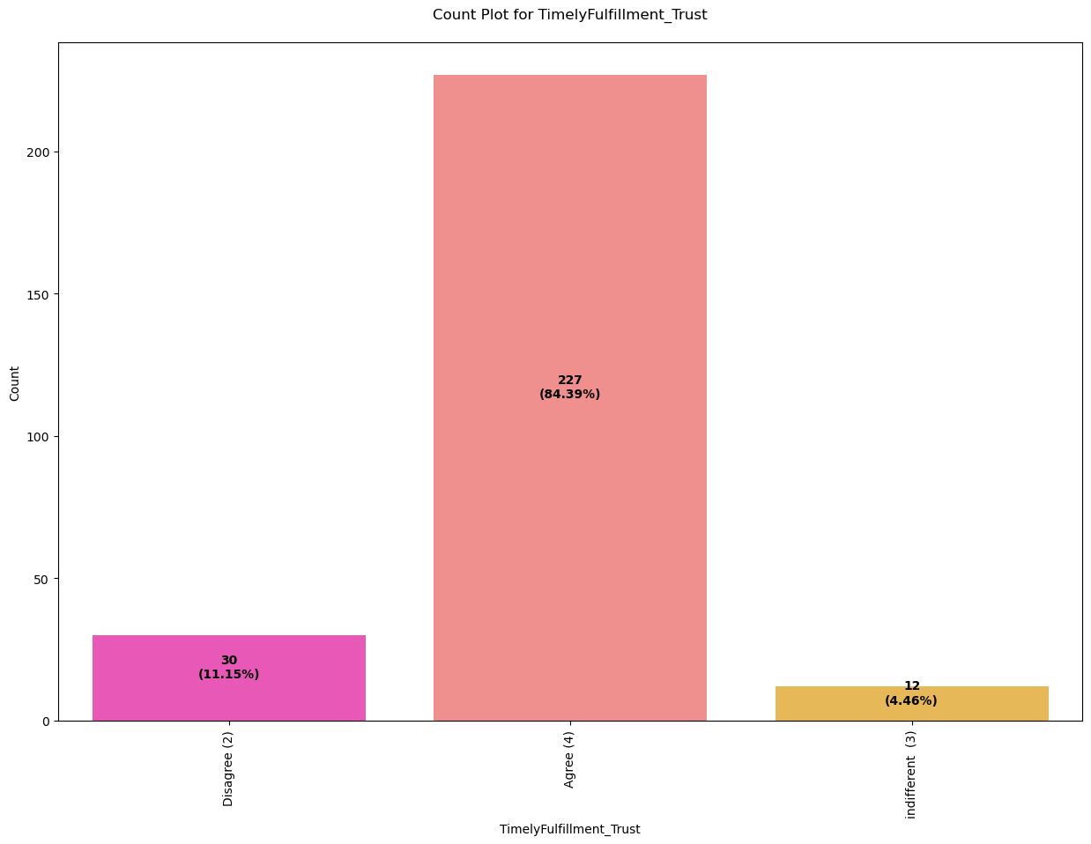

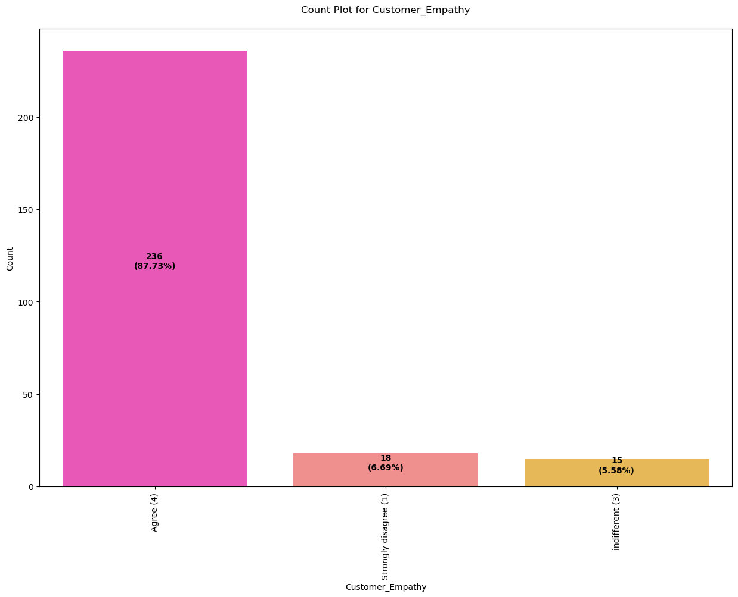

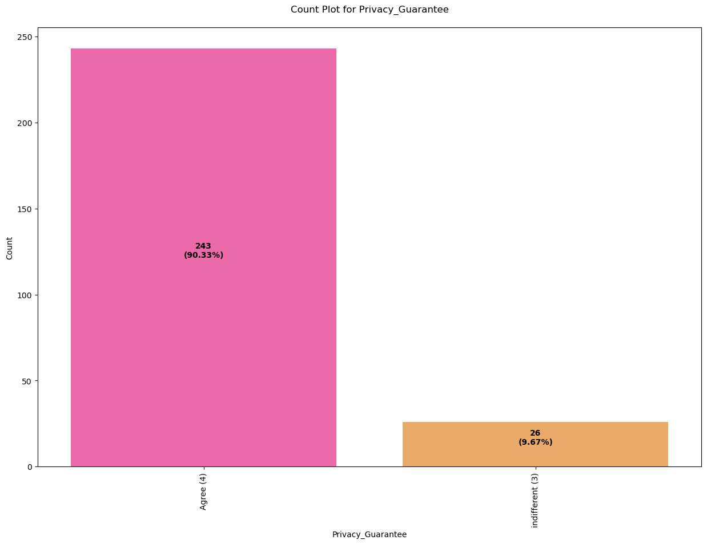

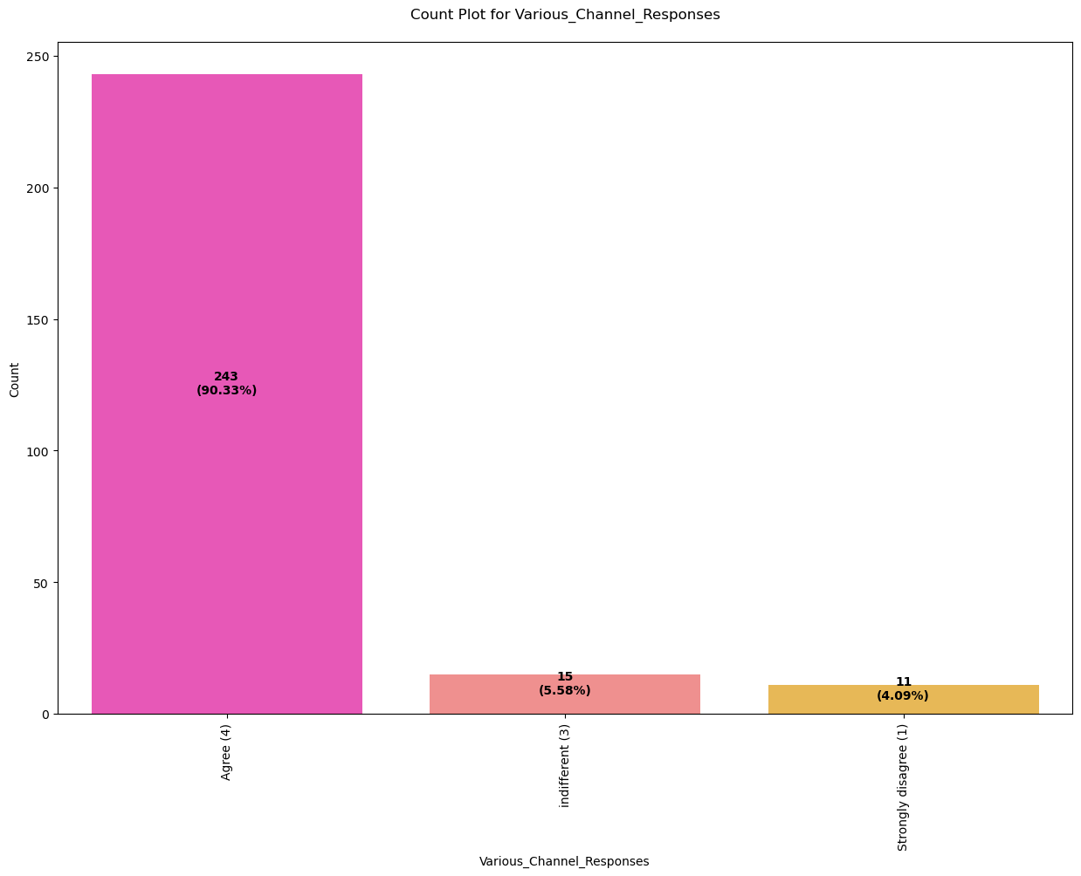

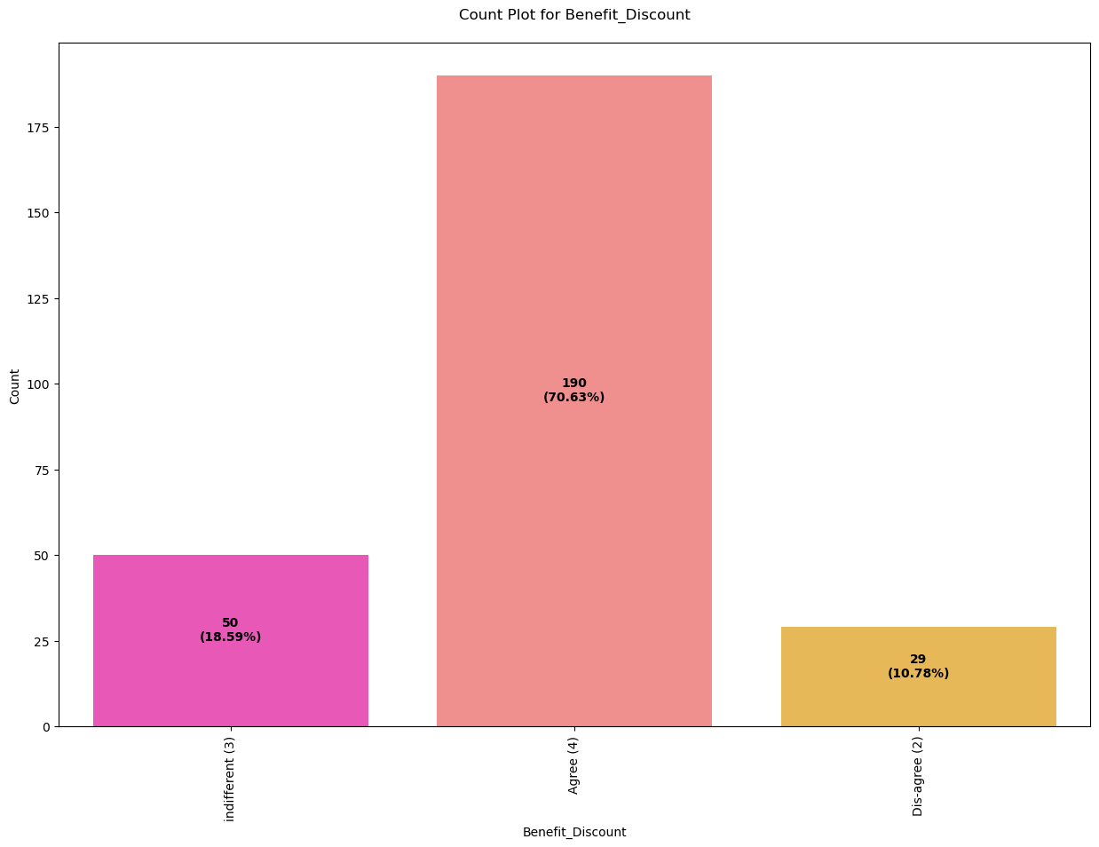

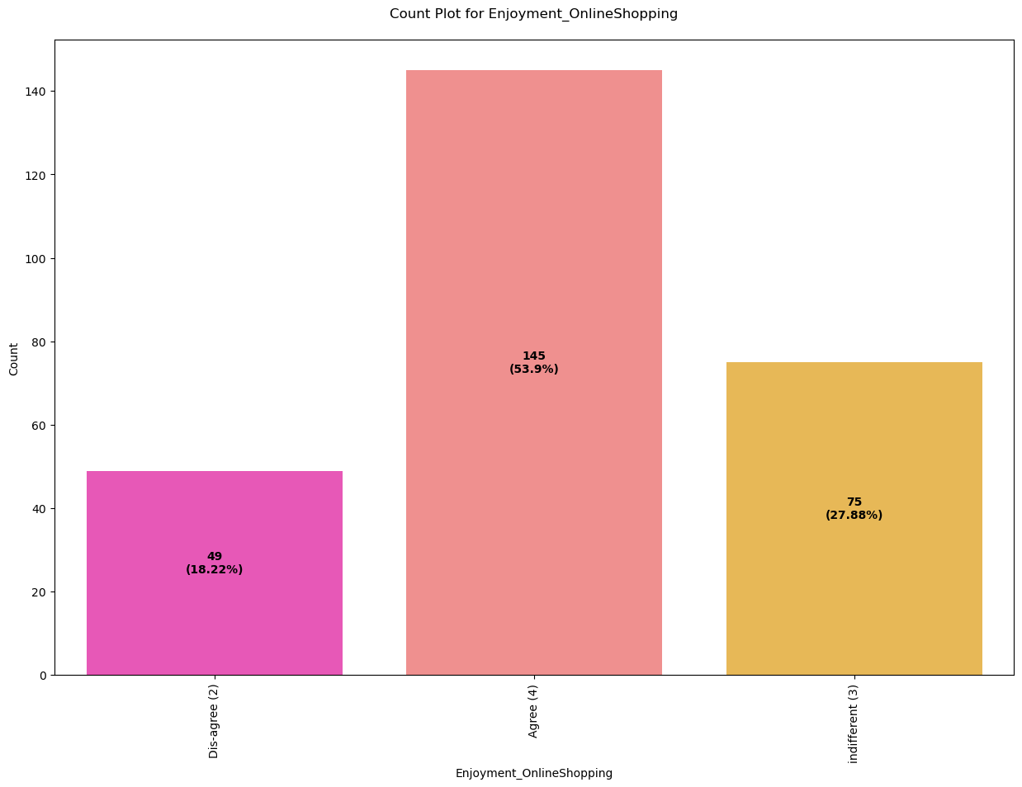

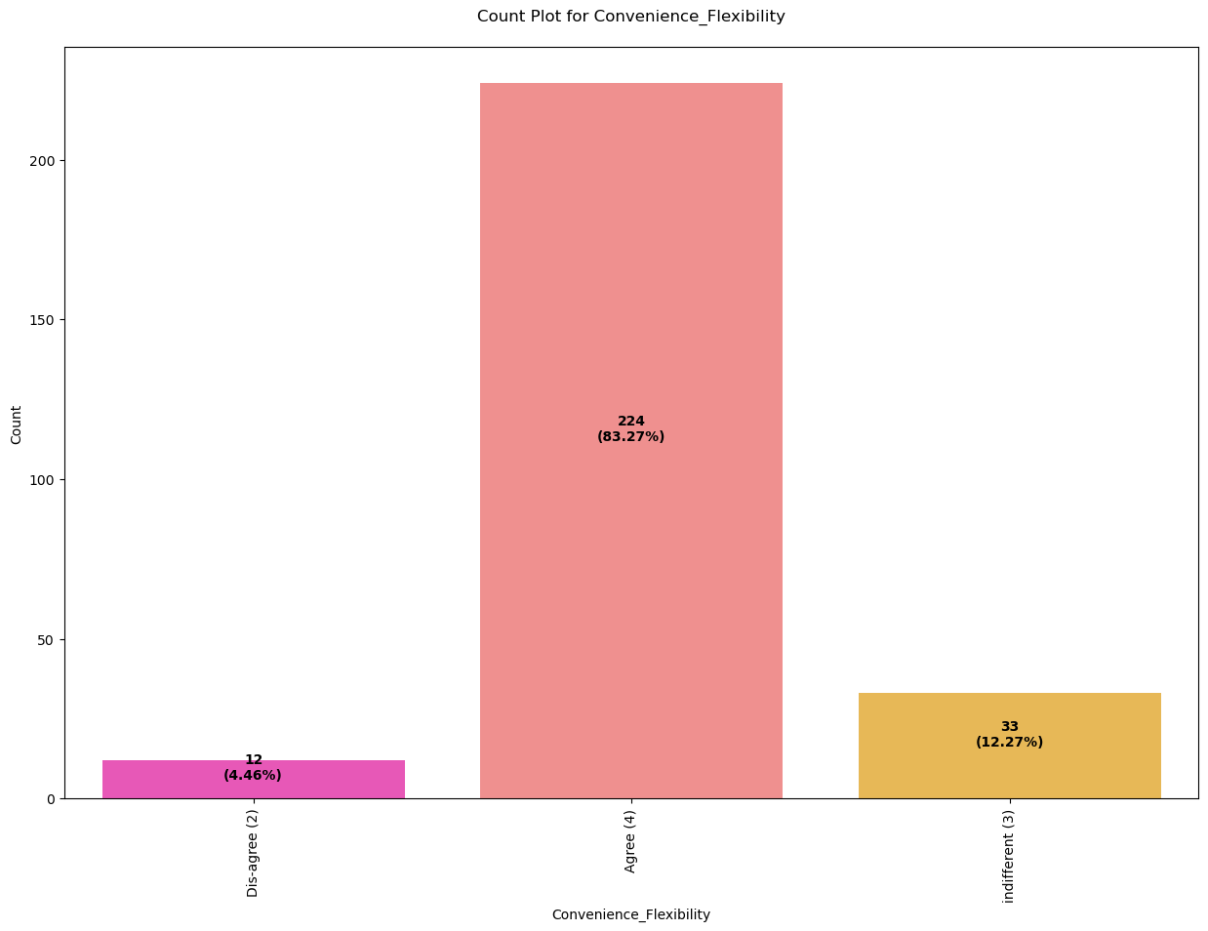

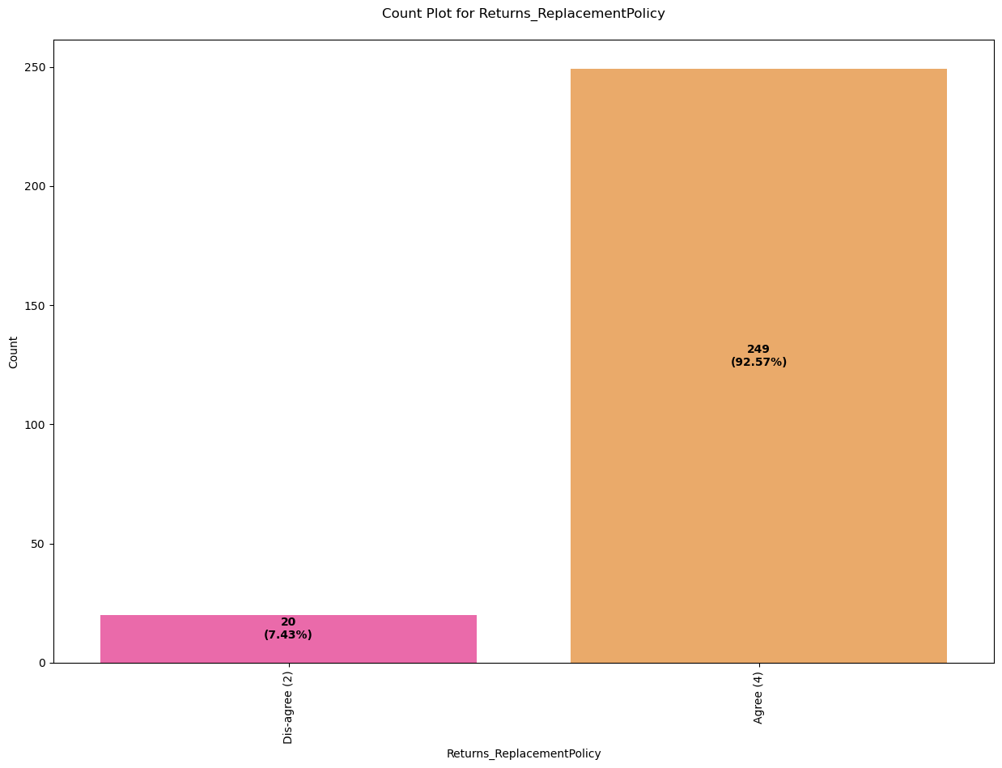

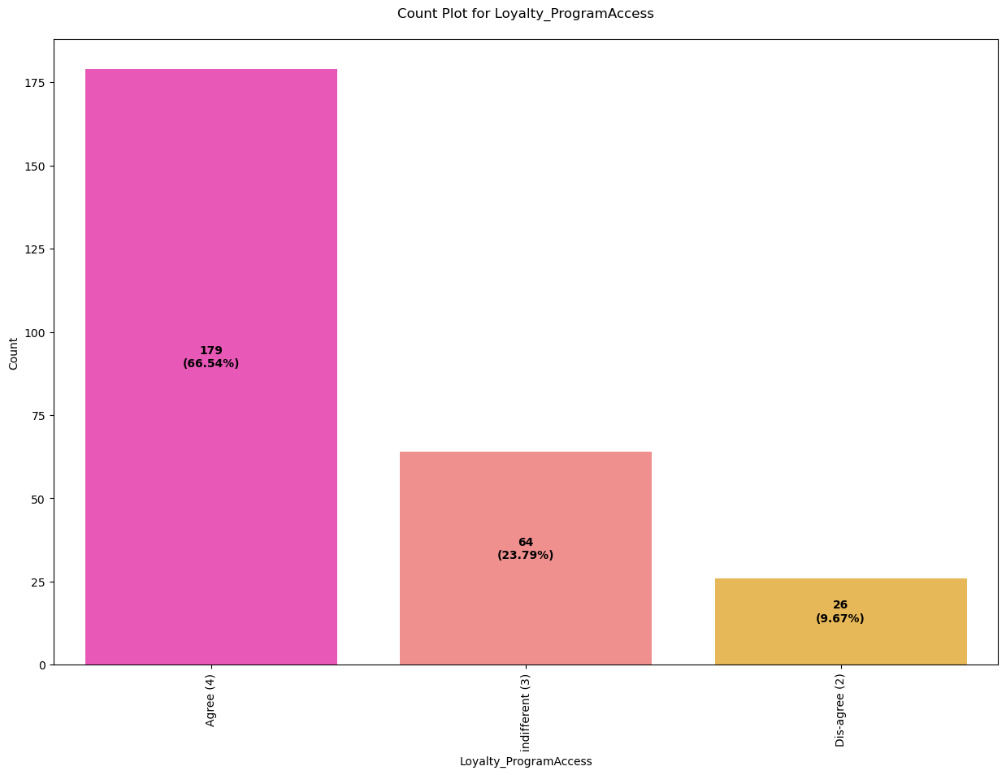

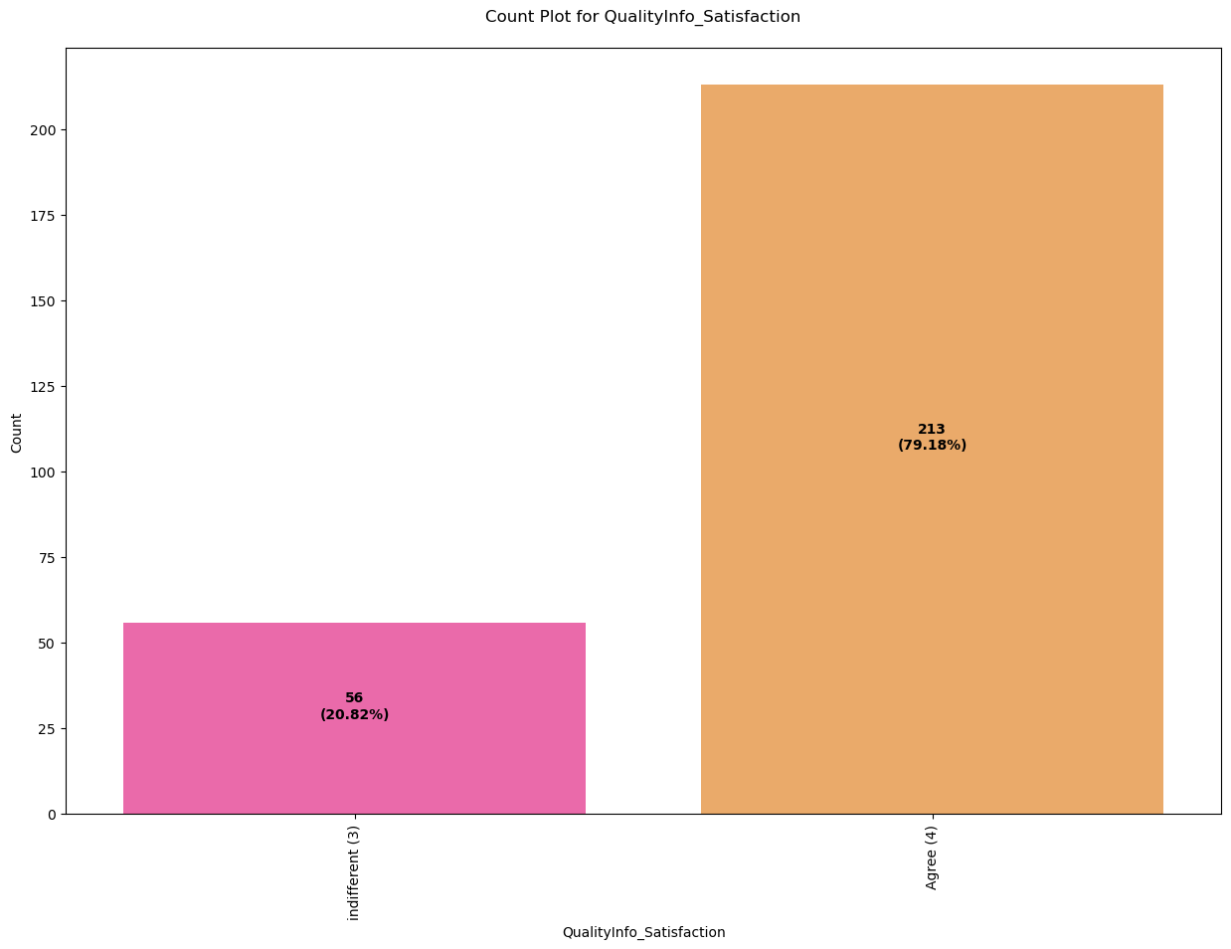

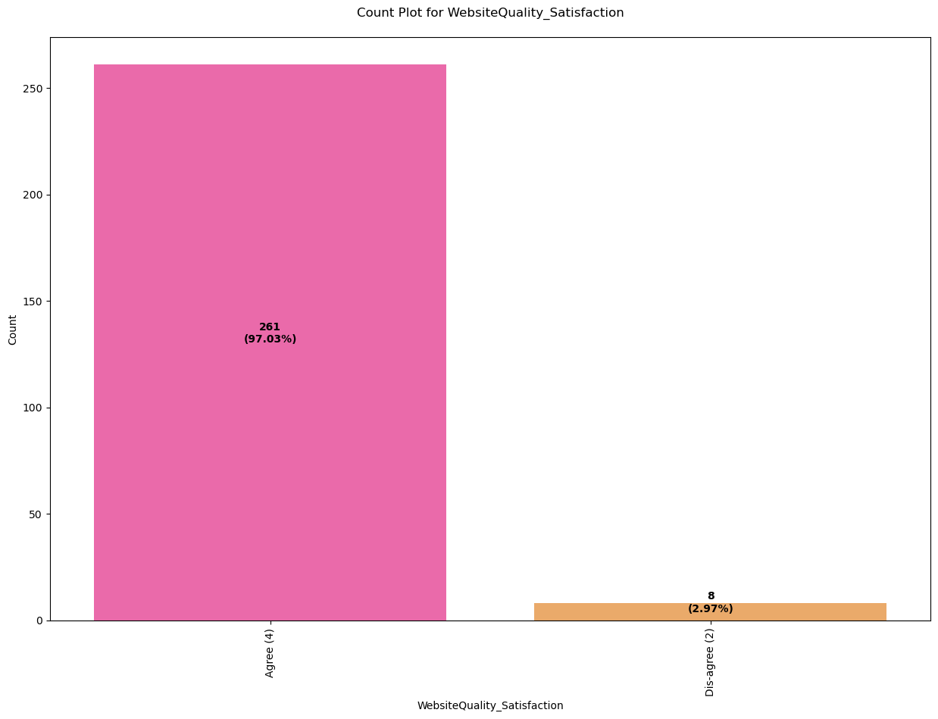

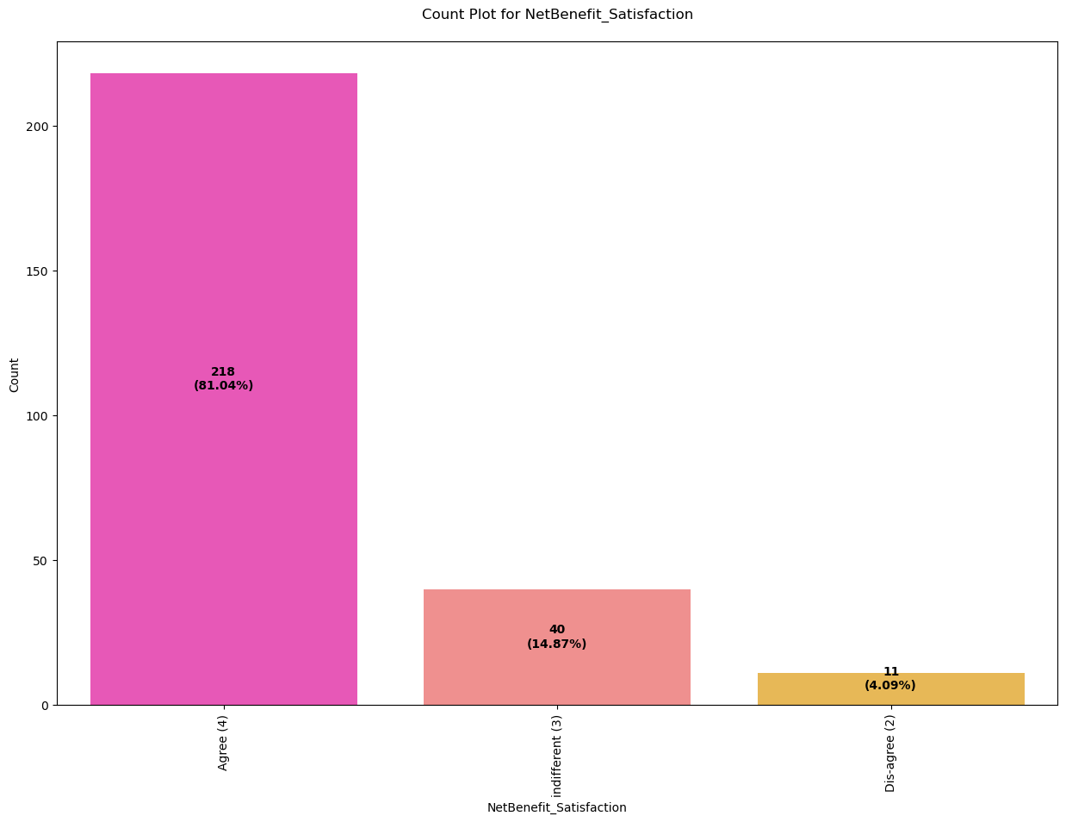

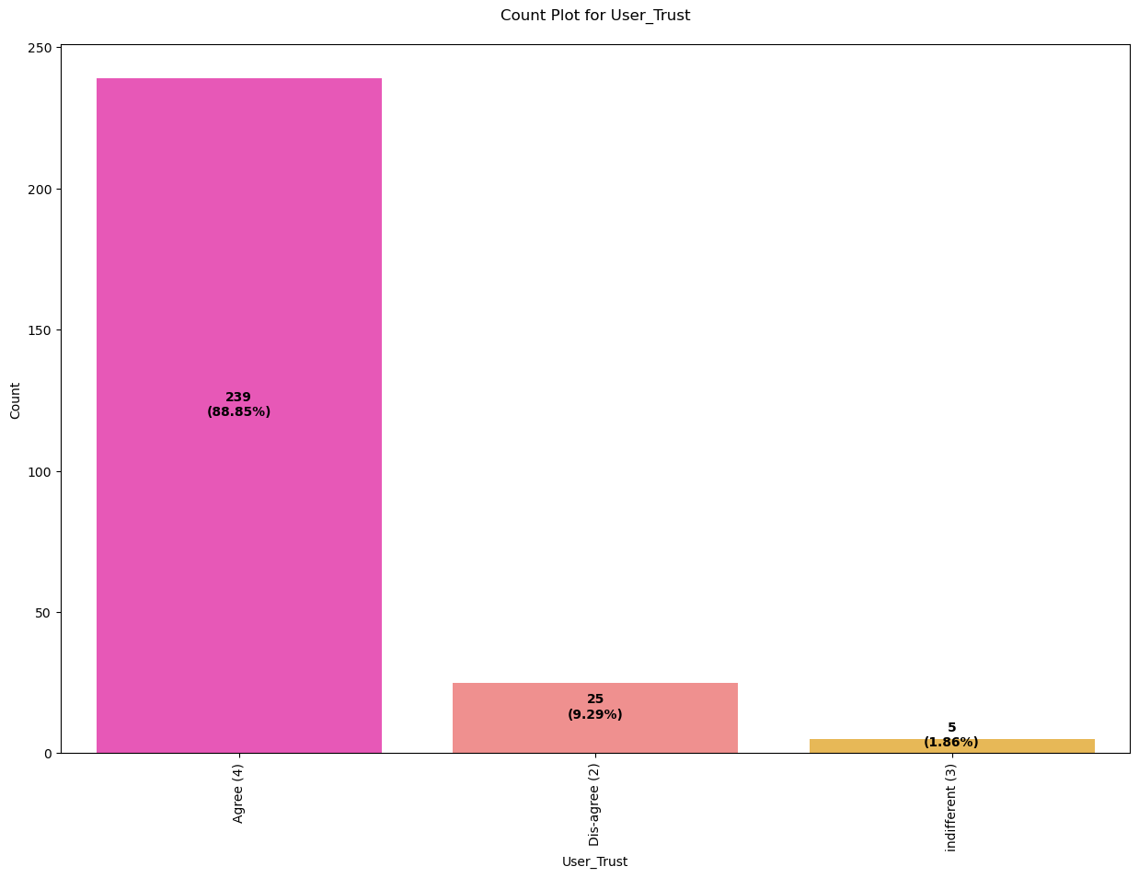

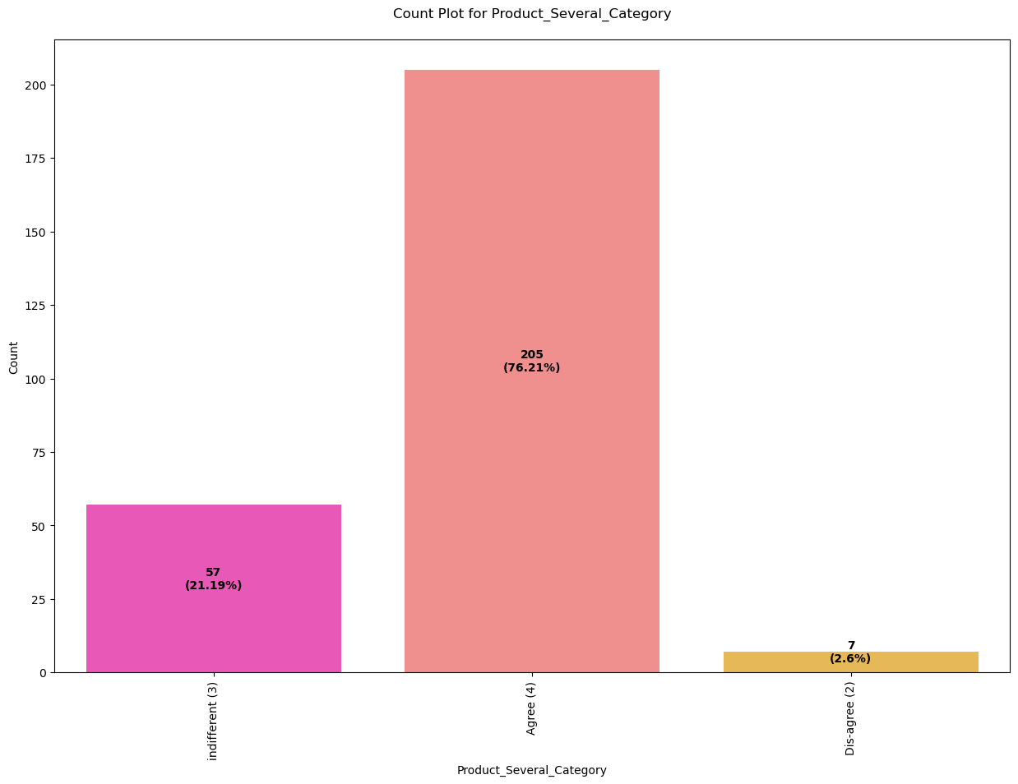

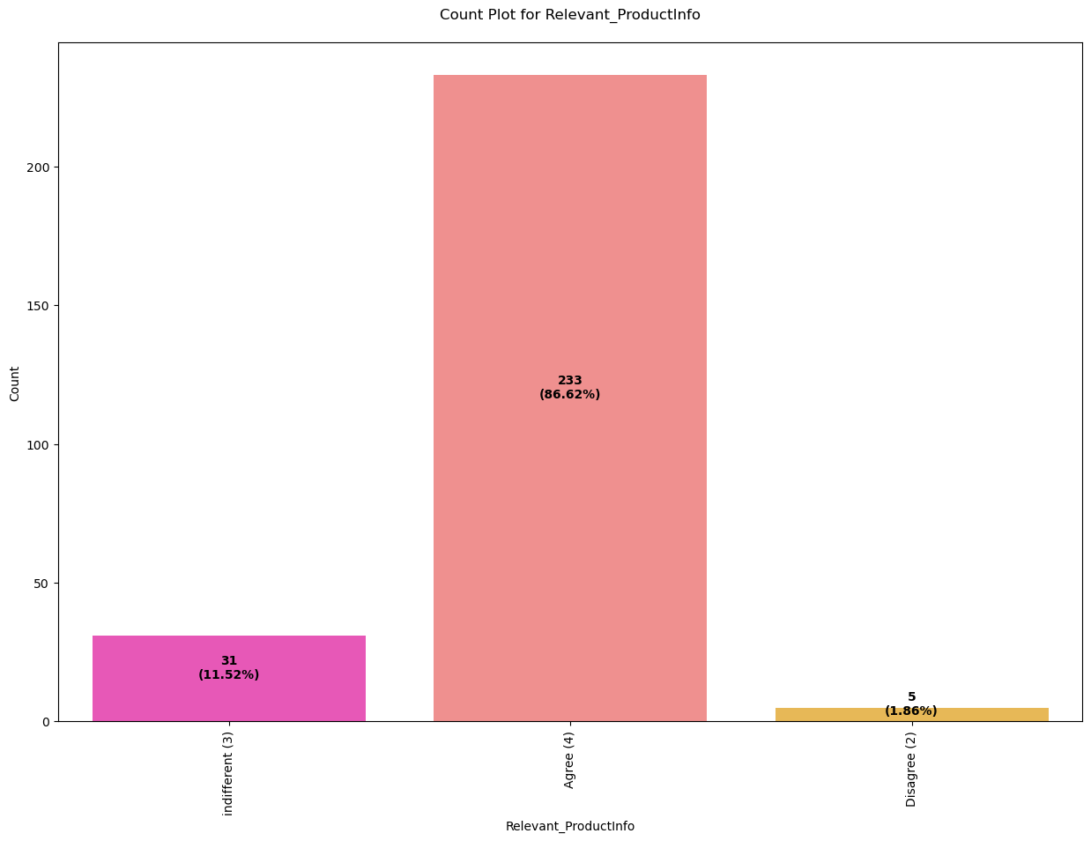

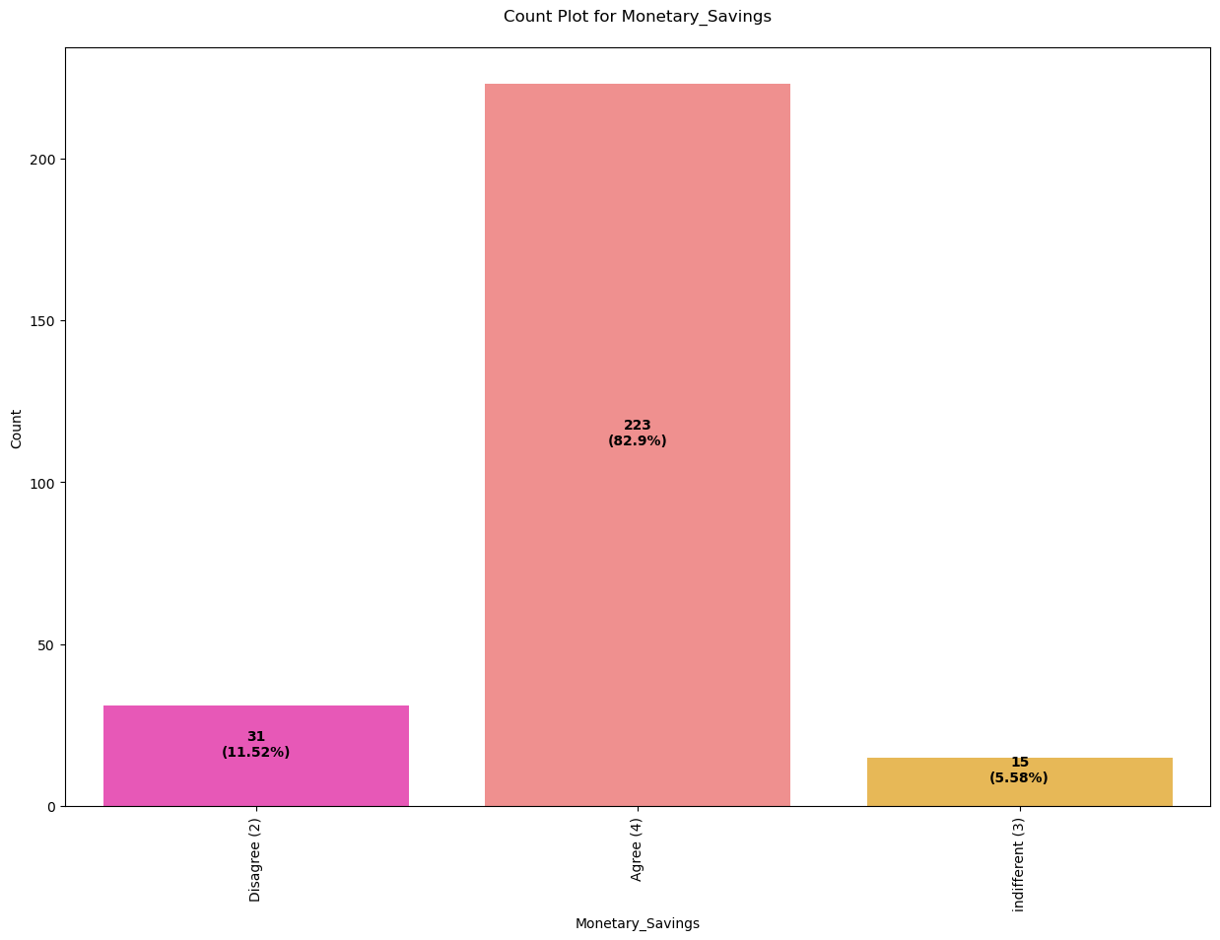

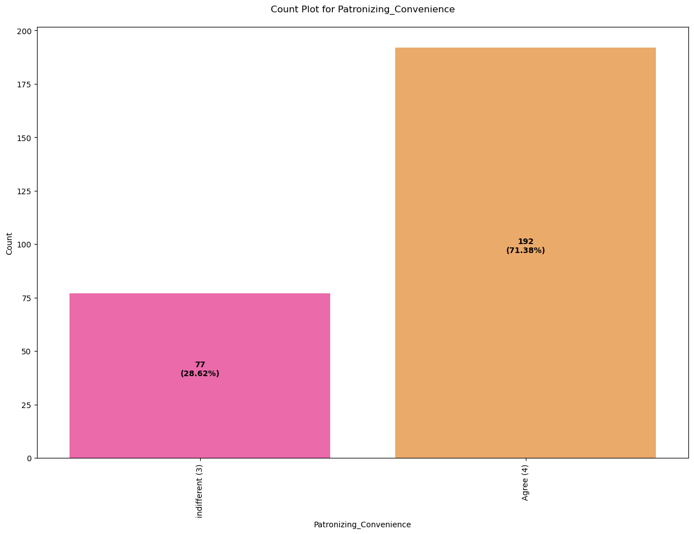

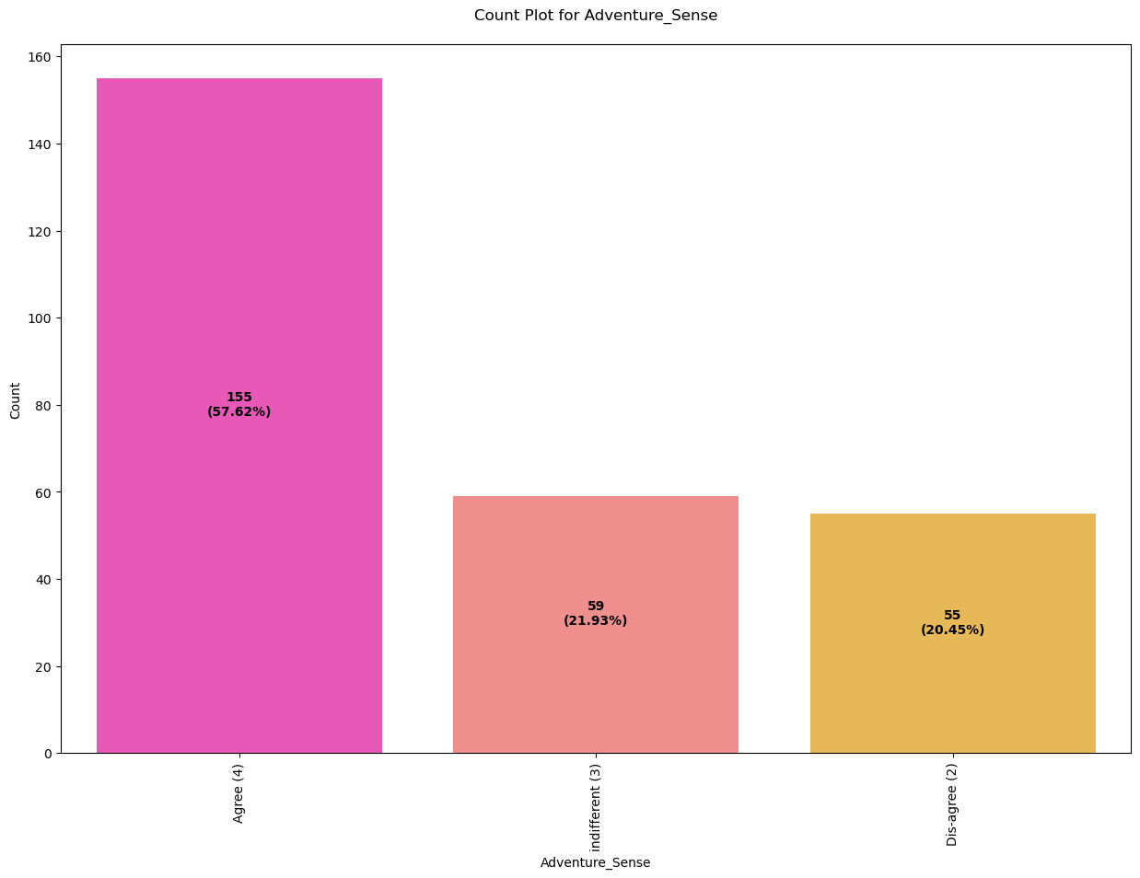

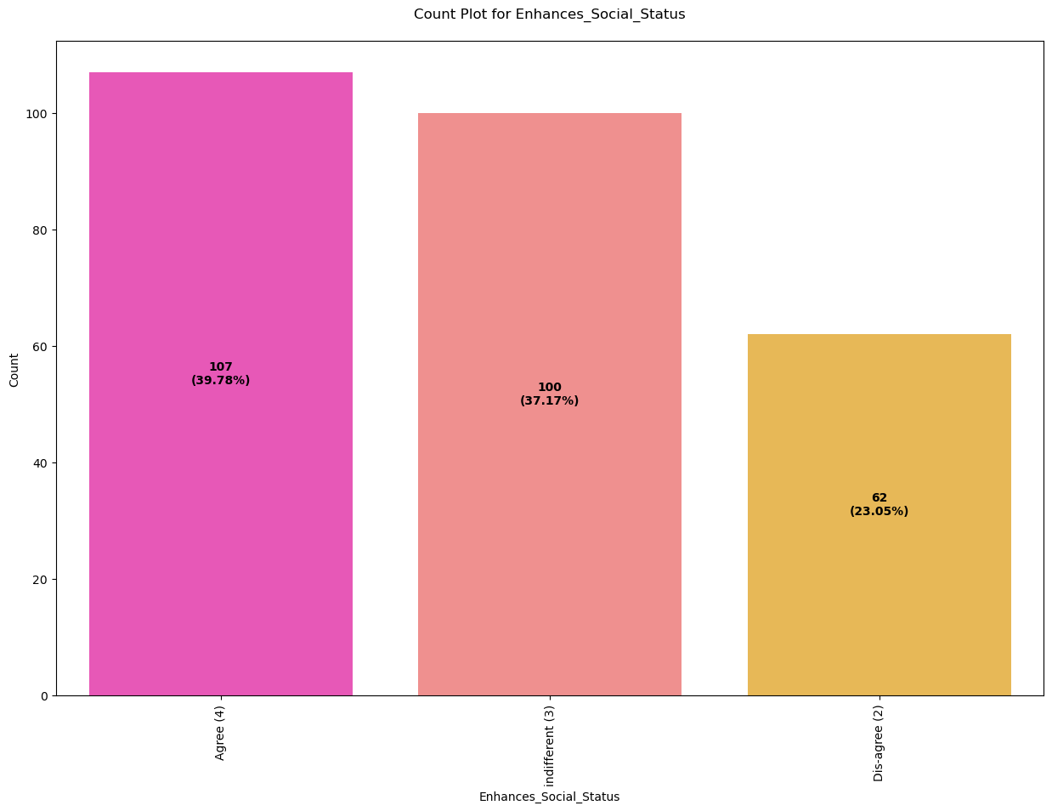

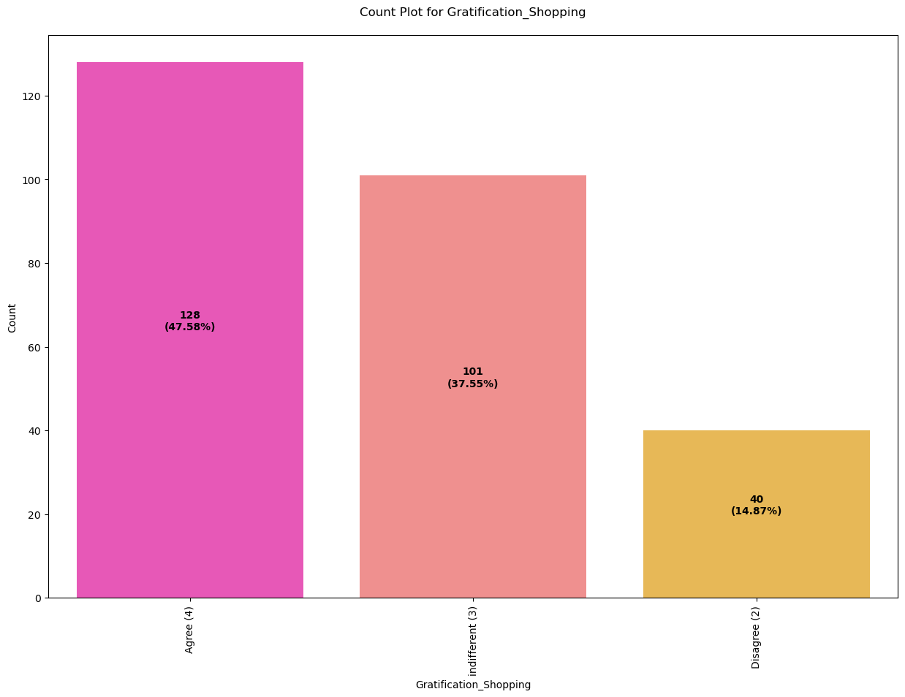

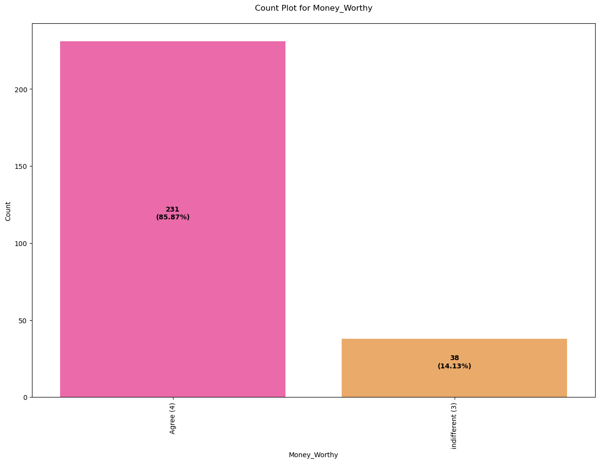

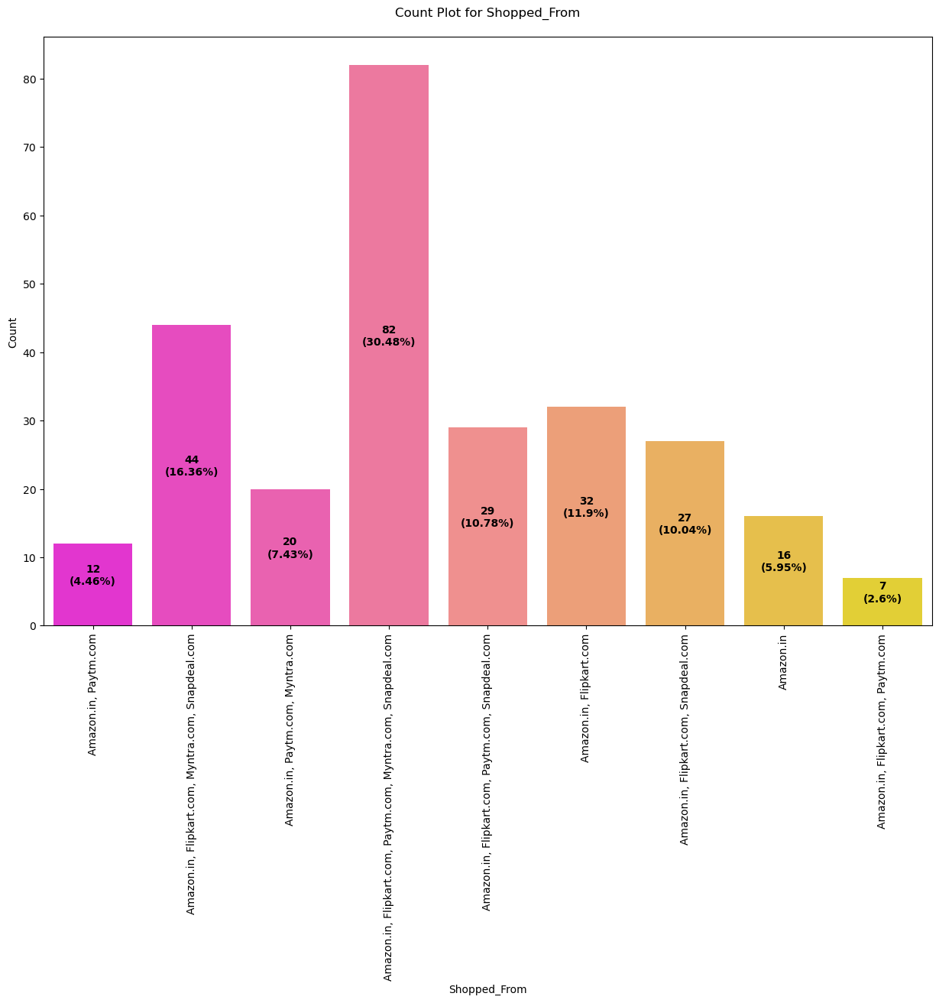

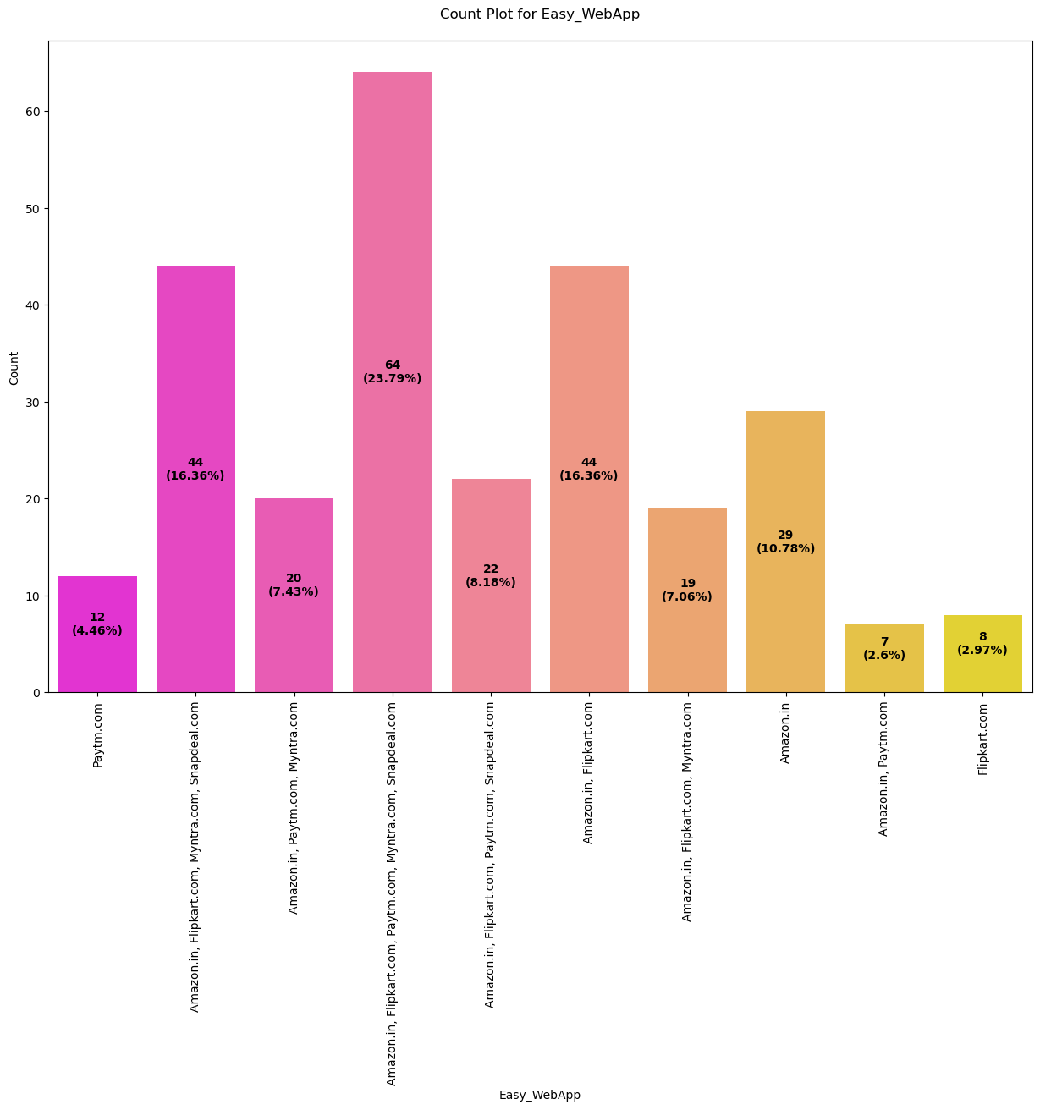

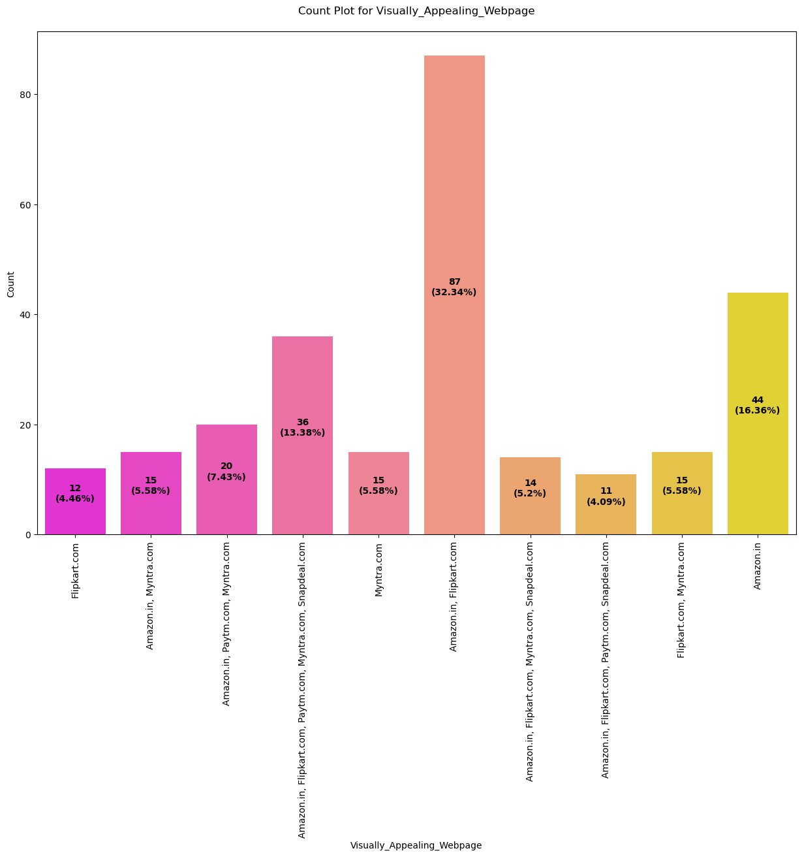

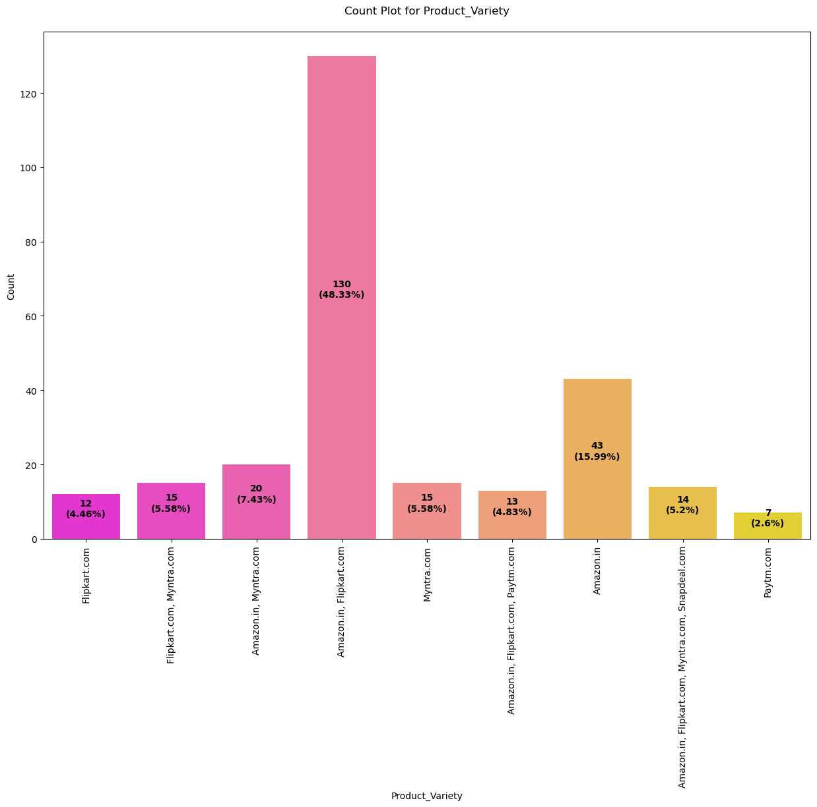

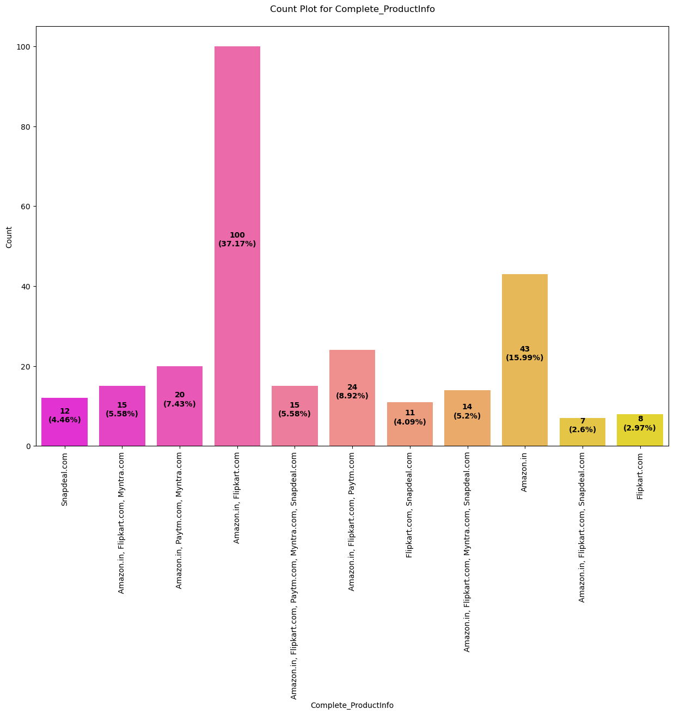

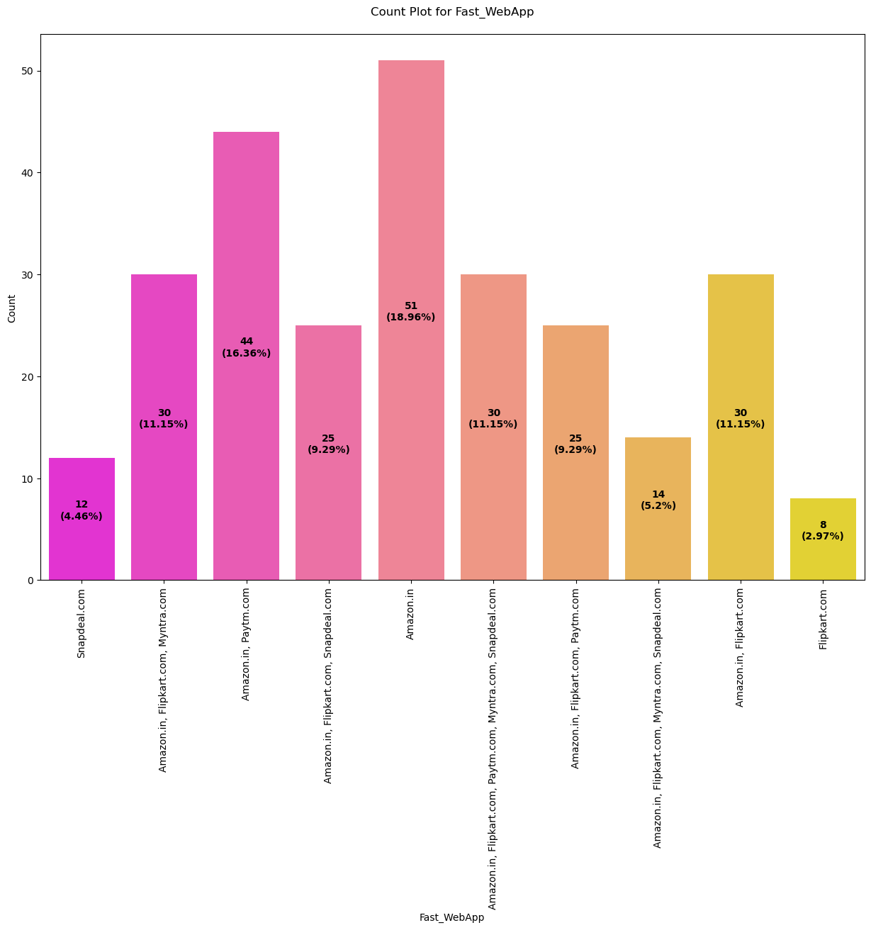

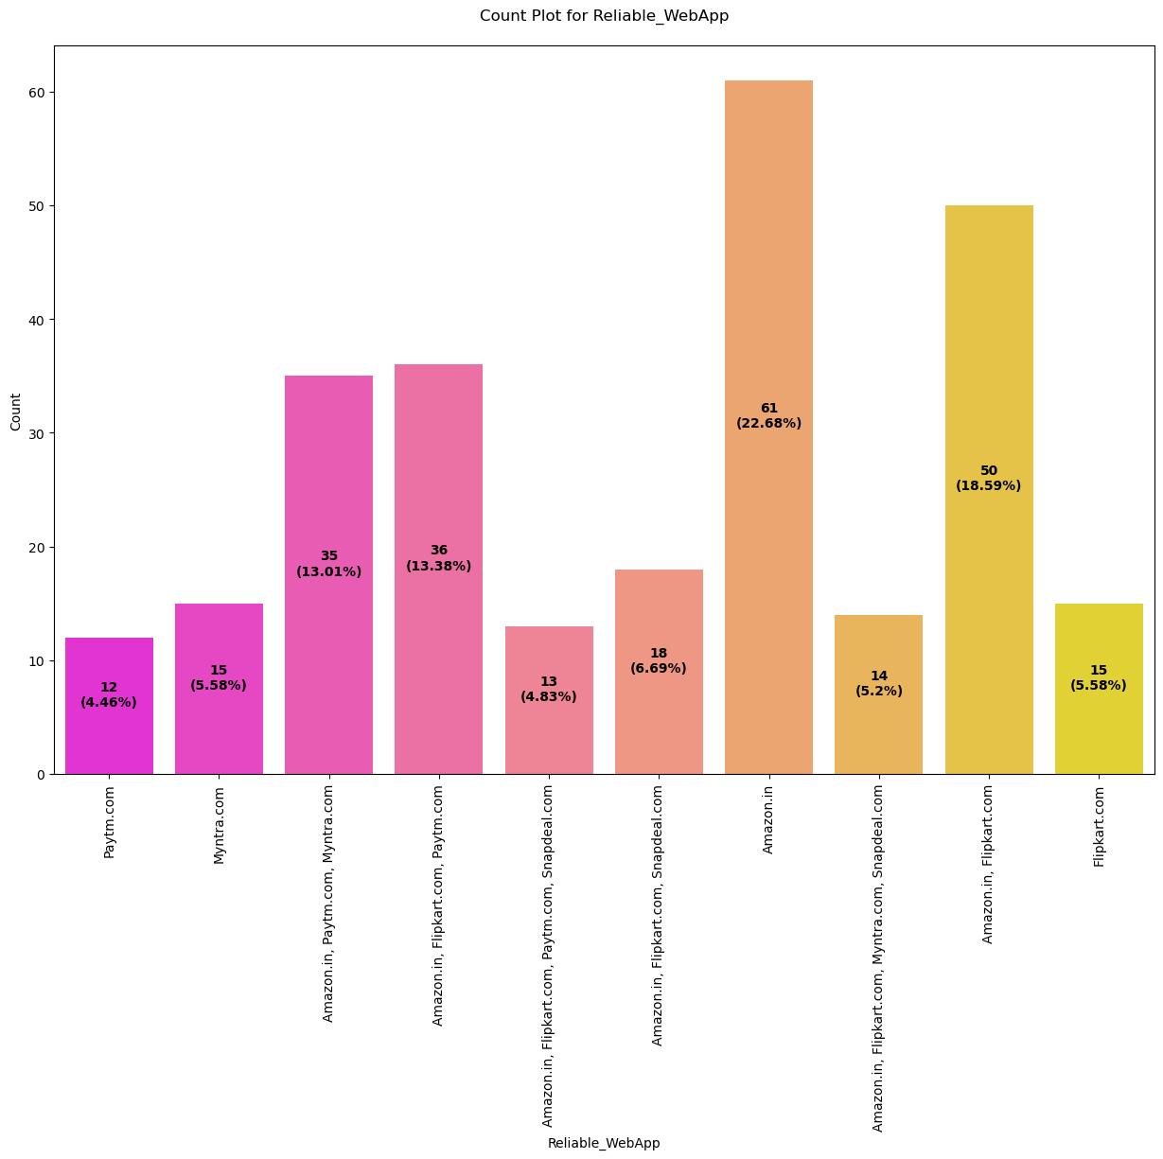

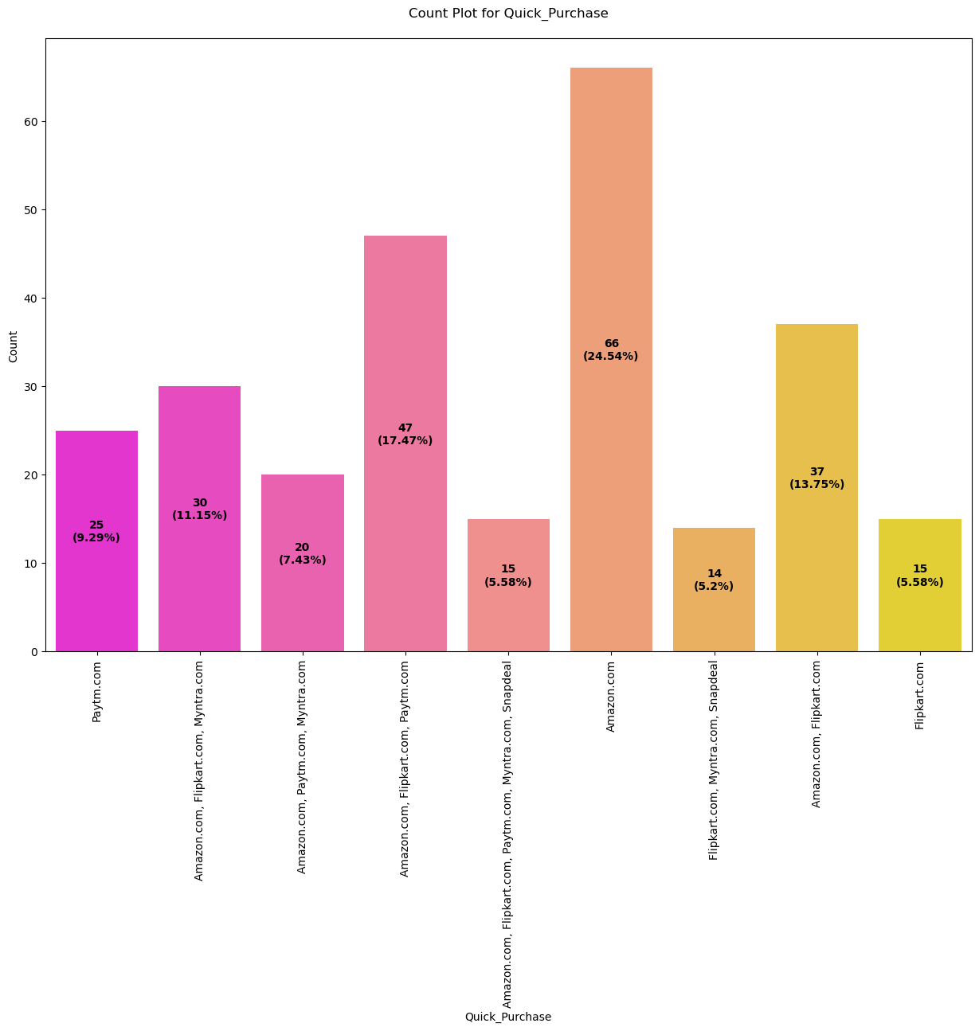

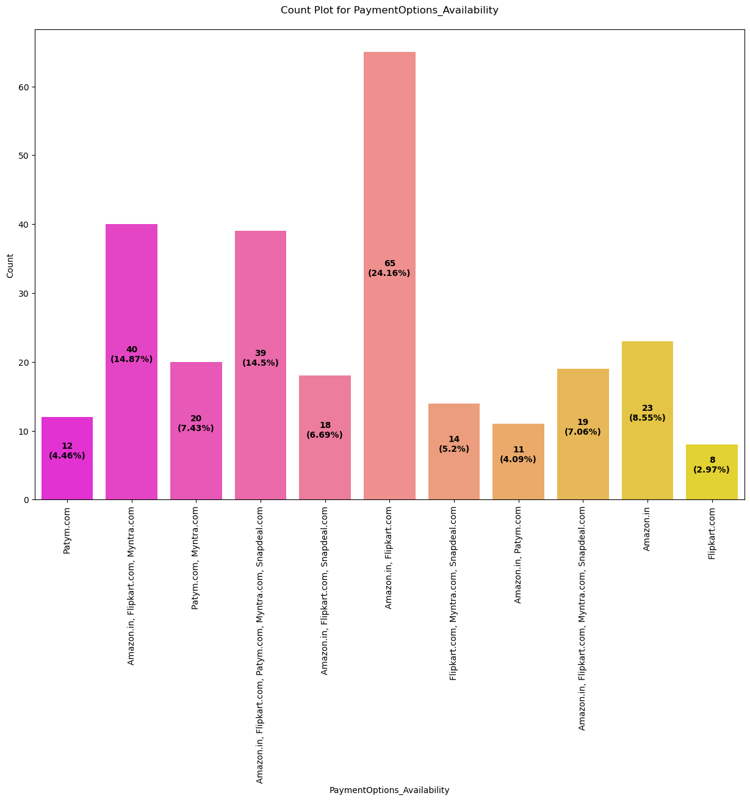

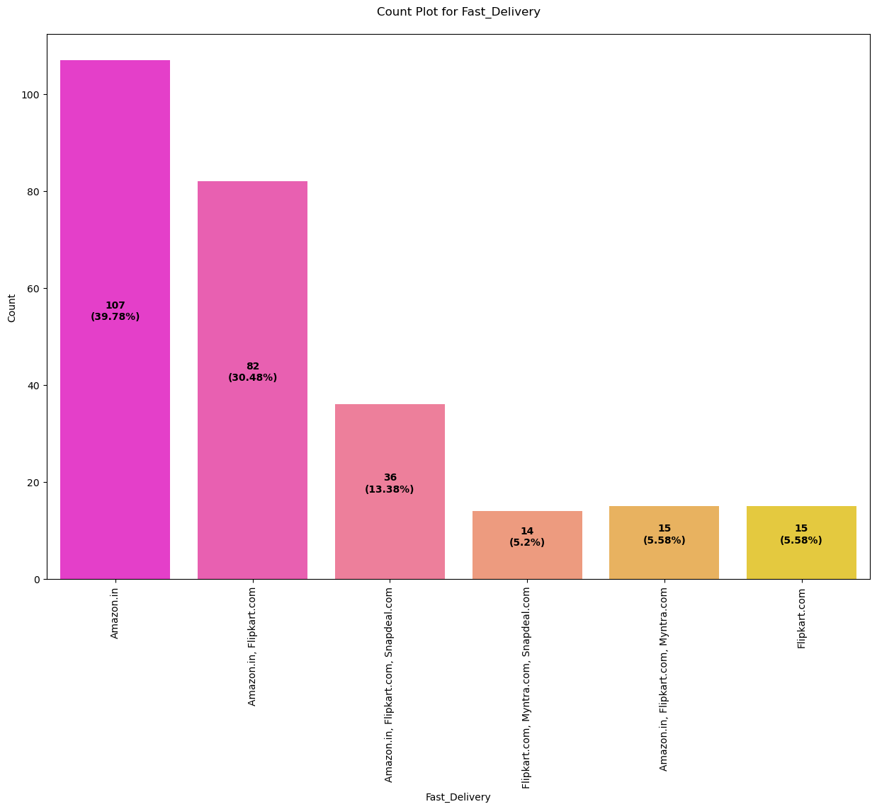

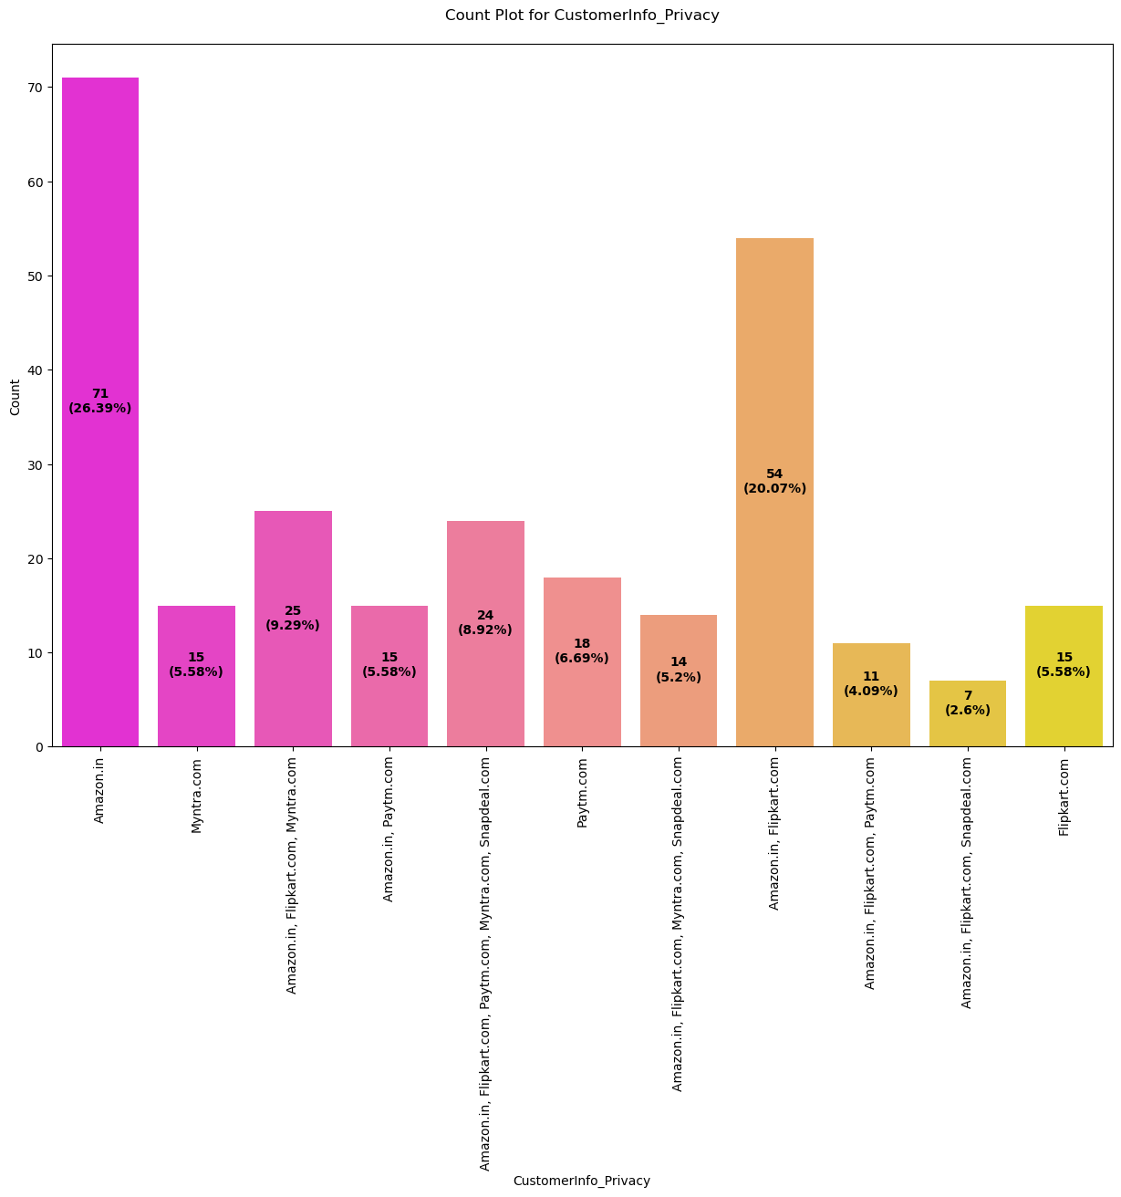

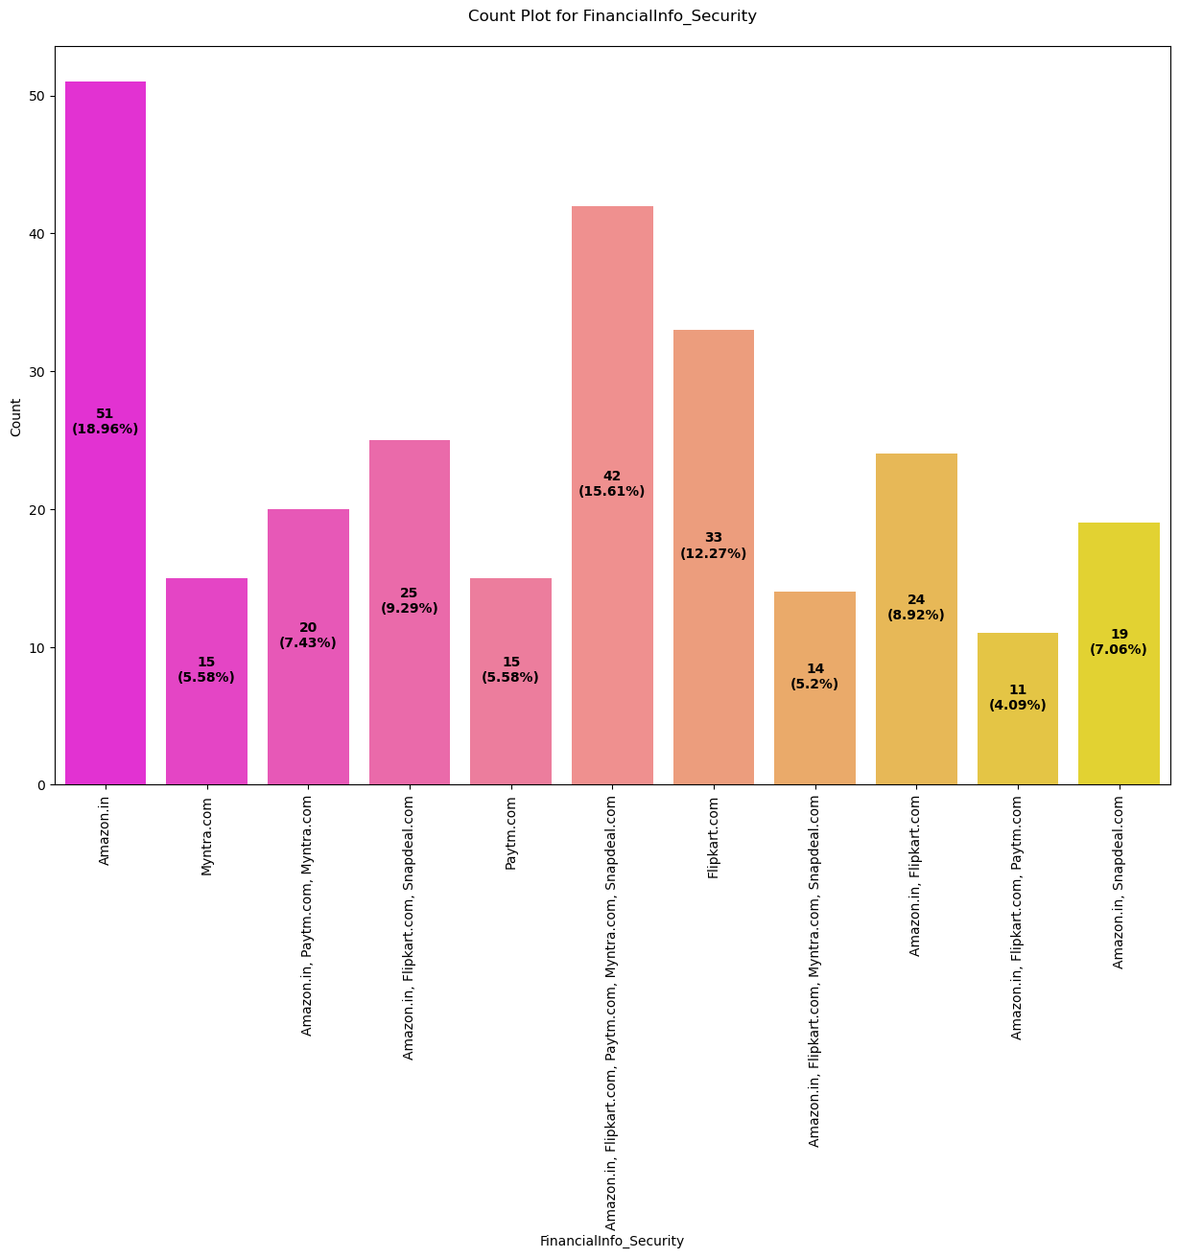

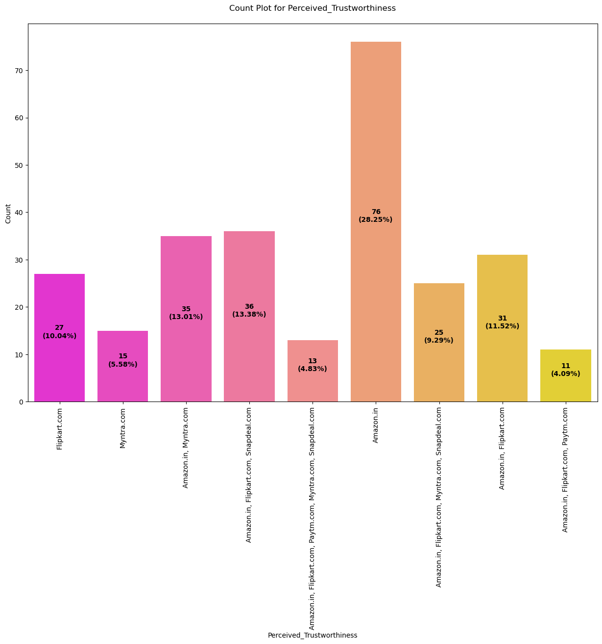

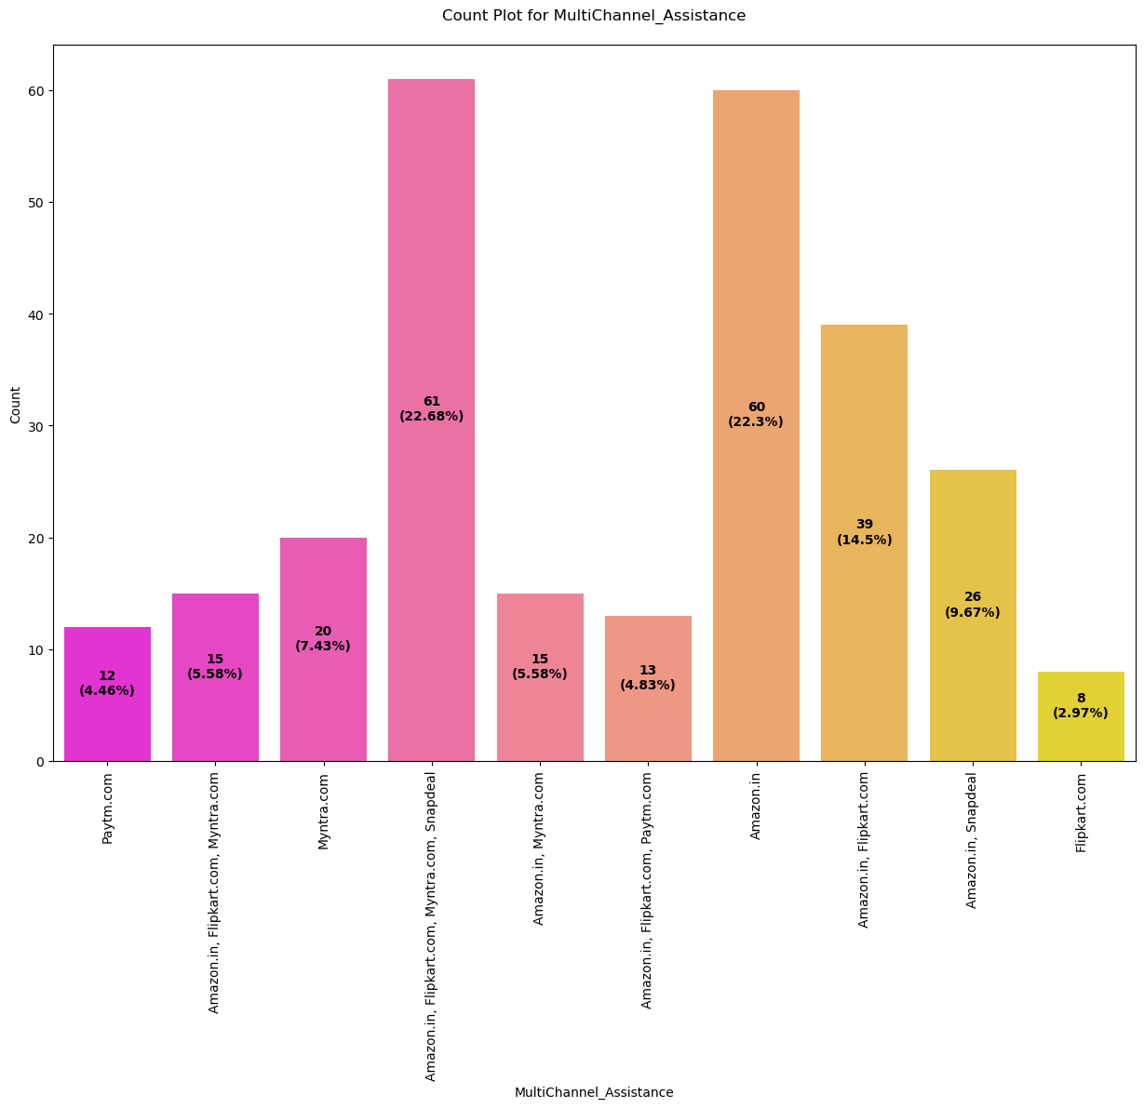

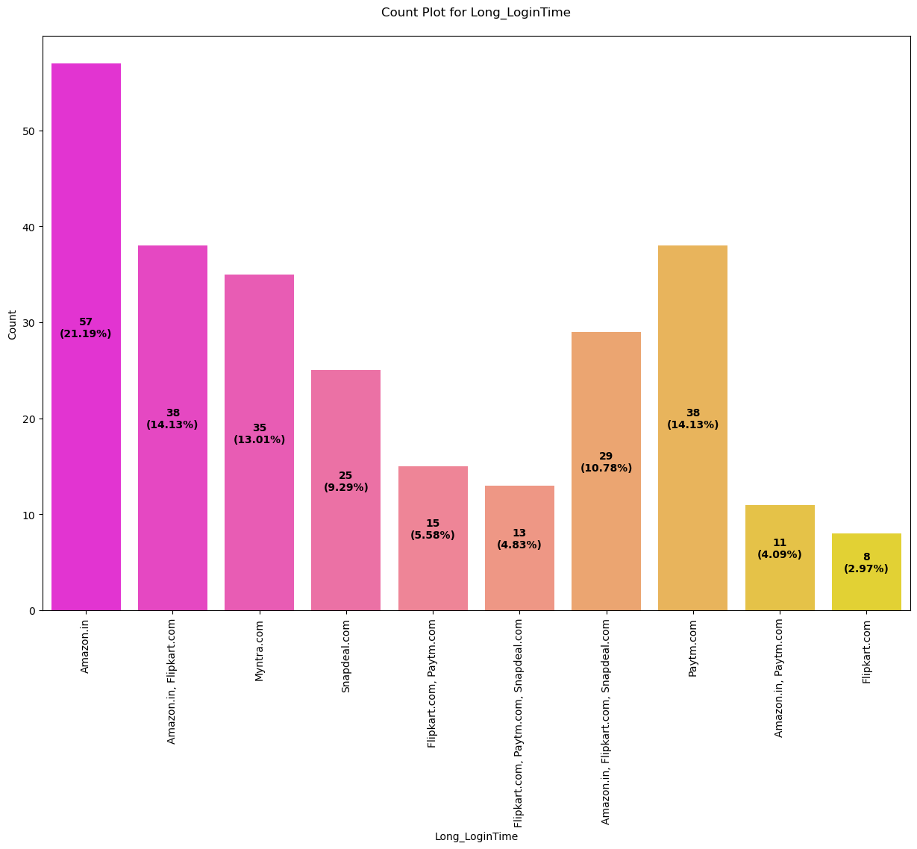

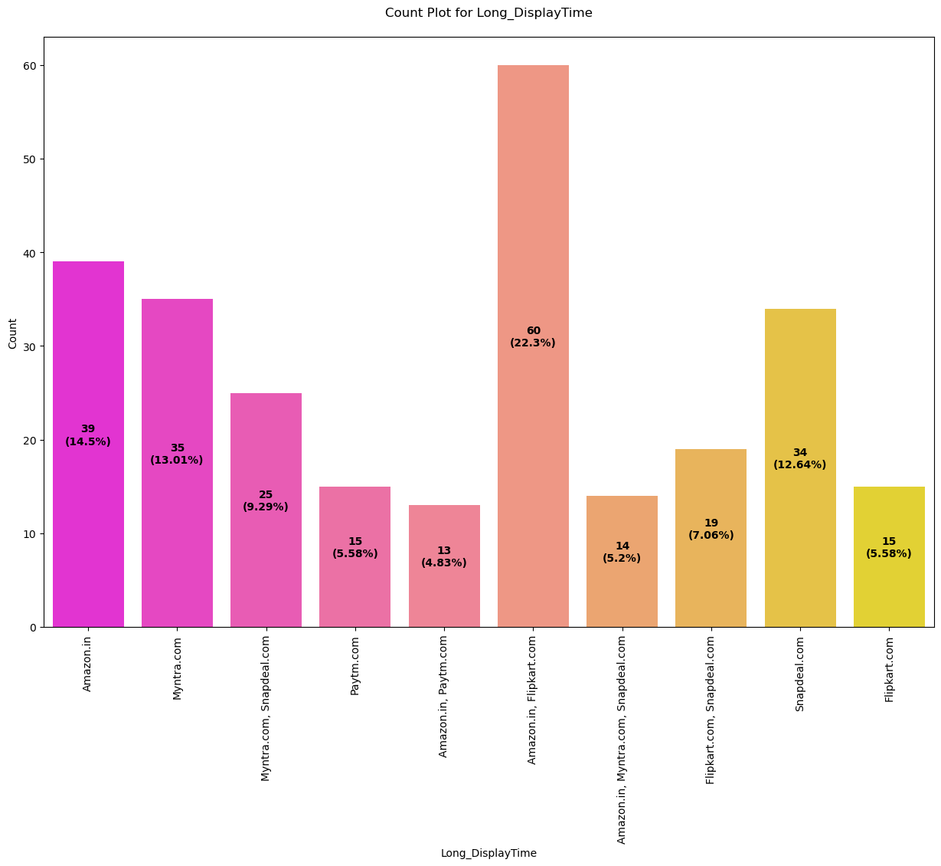

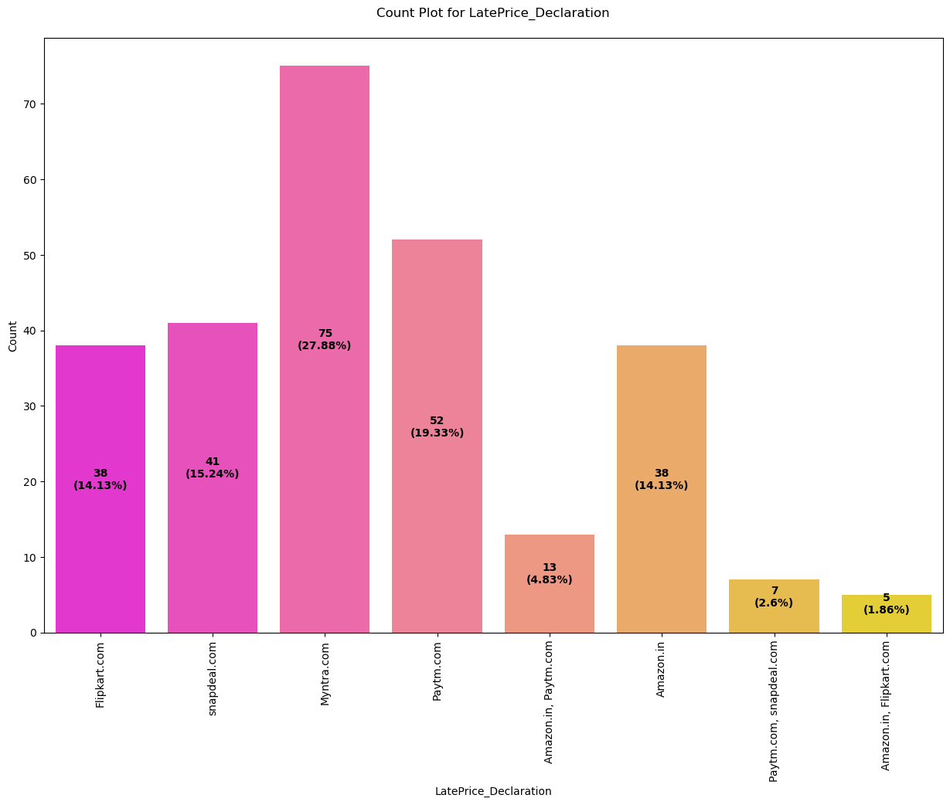

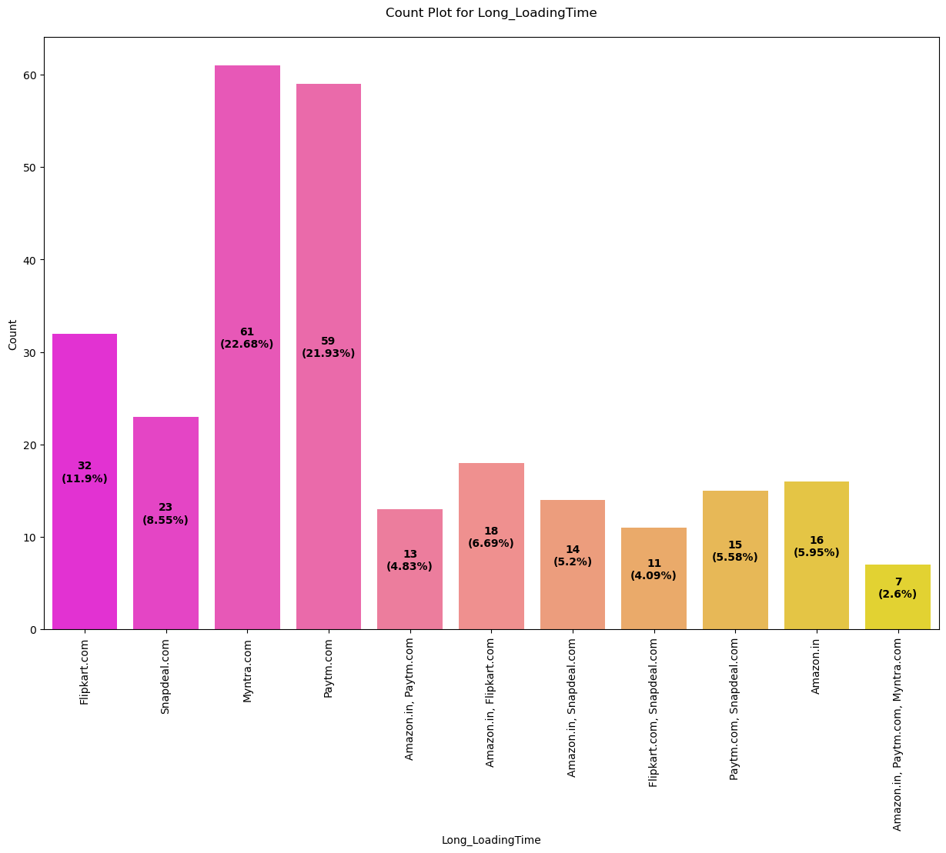

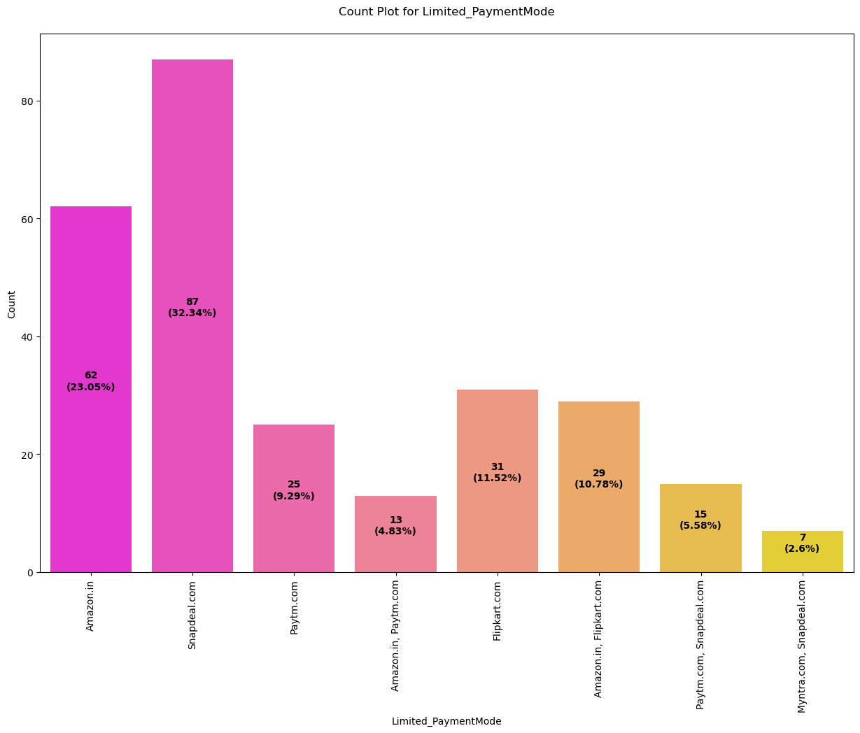

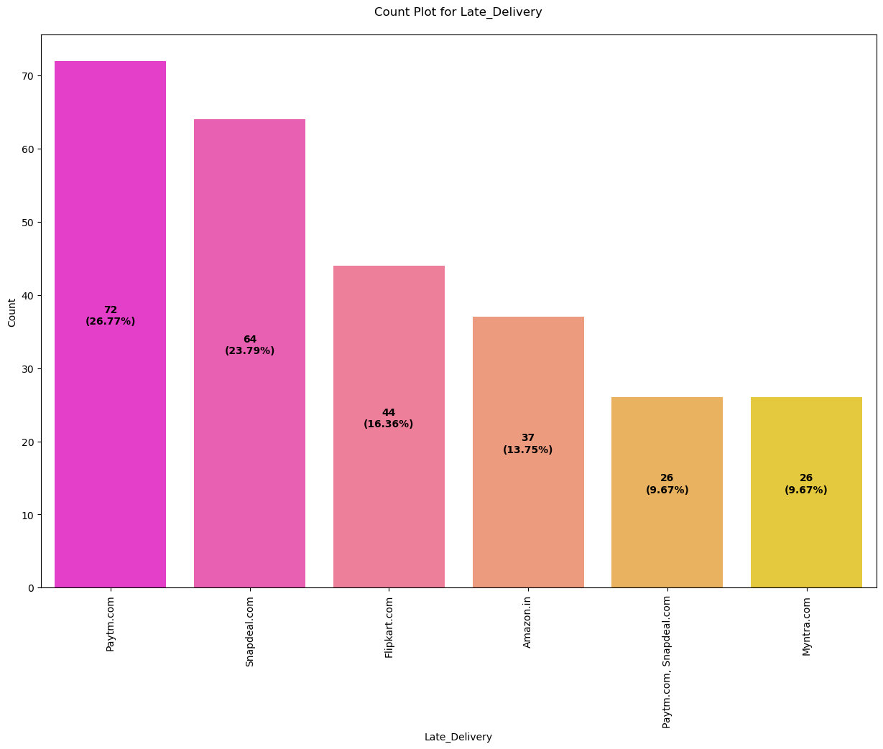

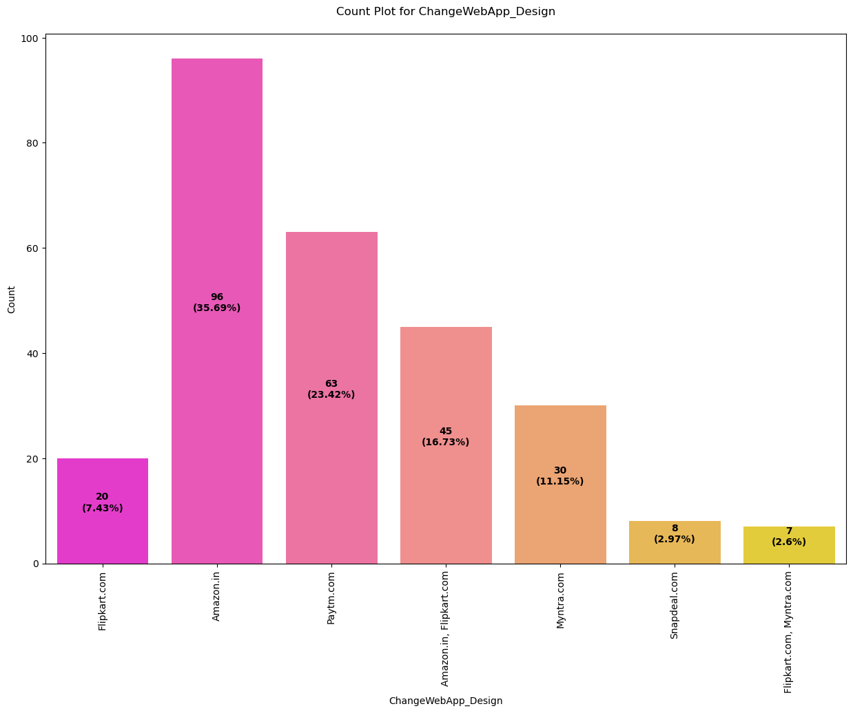

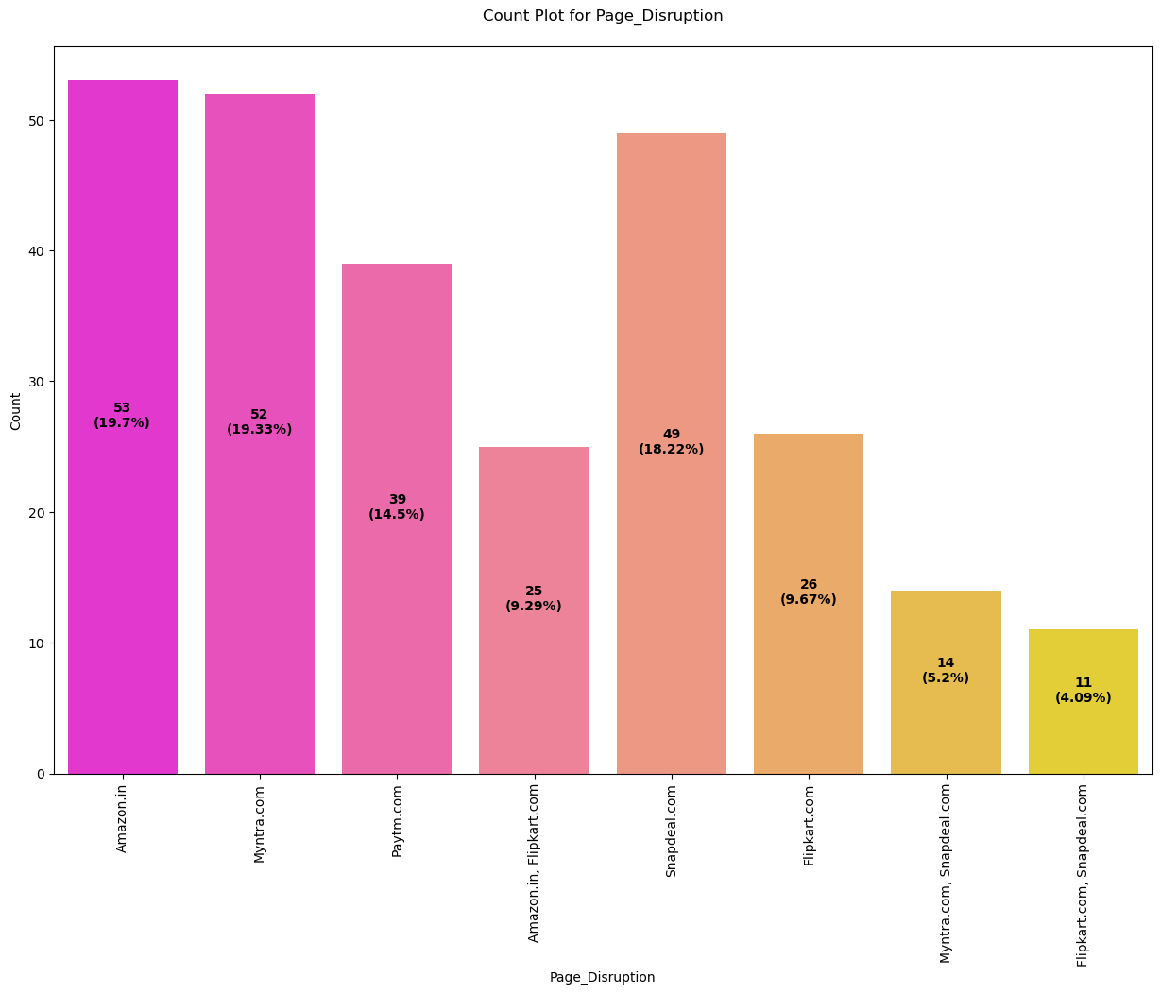

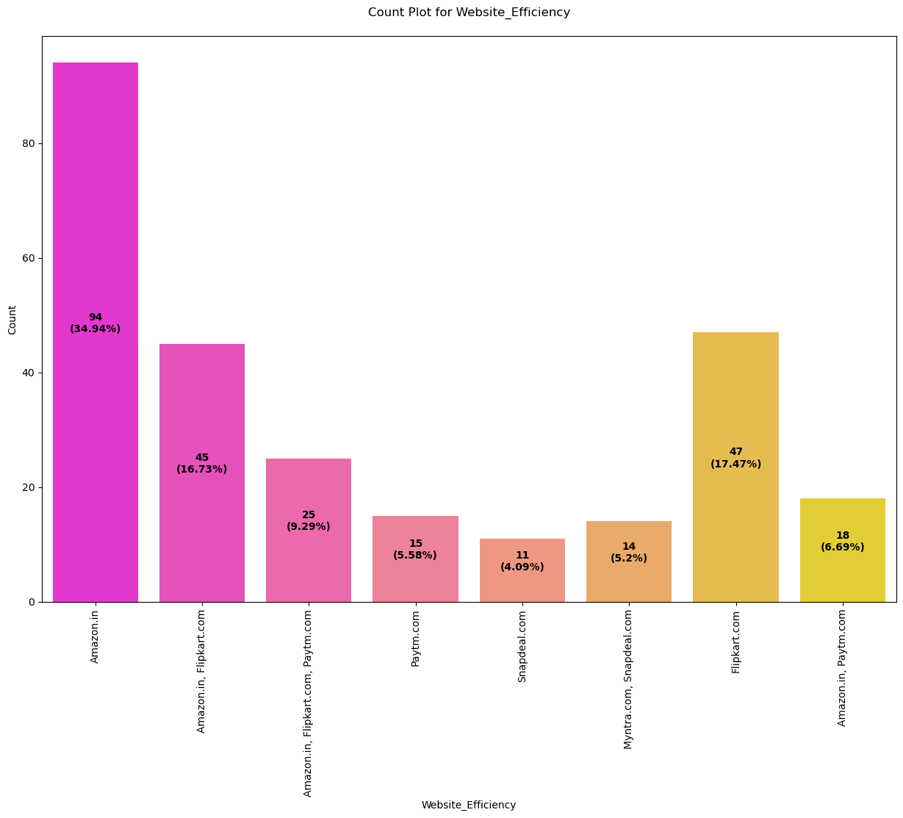

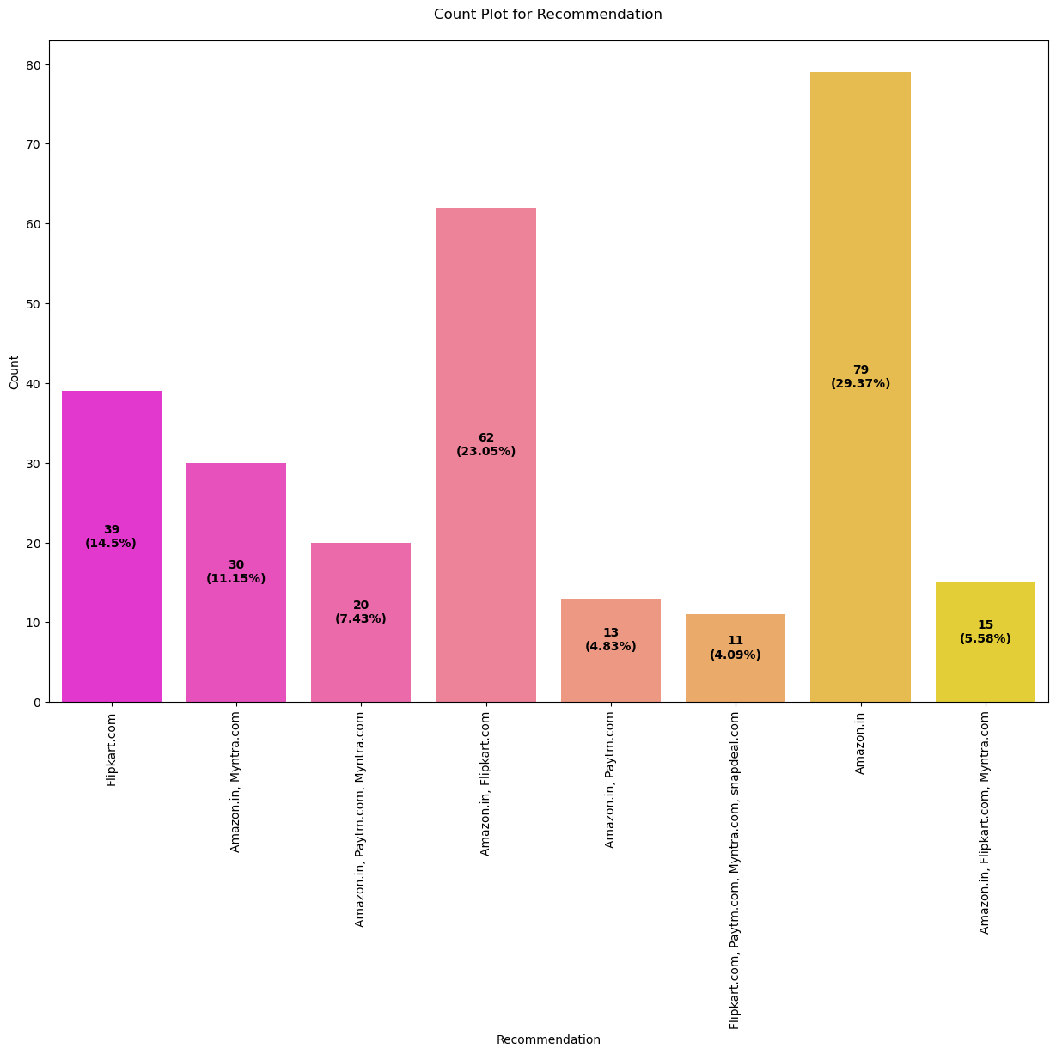

**Observations of Univariate Analysis:**

* Majority of the customers are Female, followed by Male.
* Majority of the customers are in the Age Group of 31-40, followed by 21-30 years.
* Majority of the customers are from Delhi, followed by Greater Noida. Least online shopping is done from Bulandshahar.
* Majority of the online shopping is done from Uttar Pradesh.
* Majority of the customers are shopping online since more than 4 years.
* Majority of the customers have made an online purchase less than 10 times. Very few online shoppers have made an online purchse between 21-30 times.
* Majority of the customers use Mobile Internet for shopping online.
* Majority of the customers use Smartphone for shopping online.
* Majority of the customers use Smartphone, whose screen size is other than 4.7, 5 and 5.5 inches.
* Majority of the customers use Windows Operating System, followed by Android. Very few online shoppers use IOS/Mac.
* Majority of the customers use Google Chrome. Very few online shoppers use Mozilla Firefox.
* Majority of the customers arrive at your favorite online store for the first time by using Search Engine.
* Majority of the customers use Search Engine and Application for reaching the online retail store.
* Majority of the customers explore the e- retail store for more than 15 mins, before making a purchase decision. Very few impulsive customers explore the e- retail store for just 1-5 mins or even less than 1 minute, before making a purchase decision.
* Majority of the customers prefer Credit/Debit card for making payment, followed by Cash on Delivery (CoD) option.
* Majority of the customers abandon (selecting an items and leaving without making payment) their shopping cart.
* Majority of the customers abandon their shopping cart because they get "Better alternative offer". The second main reason to abandon their shopping cart is "Promo code not applicable". Then comes the reasons "Change in Price", "Lack of trust" and "No preferred mode of payment". There is also have a good number of customers who abandon their shopping cart, due to "Lack of trust". Hence, there is a need to gain trust of the customers.
* Majority of the customers are of the opinion that the content on the website must be easy to read and understand.
* Majority of the customers are of the opinion that the information on similar product to the one highlighted is important for product comparison.
* Majority of the customers are of the opinion that the complete information on listed seller and product being offered is important for purchase decision.
* Majority of the customers are of the opinion that all relevant information on listed products must be stated clearly.
* Majority of the customers are of the opinion that the website should be easy to navigate.
* Majority of the customers are of the opinion that the loading and processing speed should be high.
* Majority of the customers are of the opinion that the Interface of the website should be User friendly.
* Majority of the customers prefer convenient Payment methods.
* Majority of the customers trust that the online retail store will fulfill its part of the transaction at the stipulated time.
* Majority of the customers desire Empathy (readiness to assist with queries) towards the customers.
* Majority of the customers want that the privacy of the customer is guaranteed.
* As we can see, majority of the customers want Responsiveness, availability of several communication channels (email, online rep, twitter, phone etc).
* Majority of the customers are of the opinion that Online shopping gives monetary benefit and discounts.
* Majority of the customers are of the opinion that Enjoyment is derived from shopping online.
* Majority of the customers are of the opinion that Shopping online is convenient and flexible.
* Majority of the customers are of the opinion that Return and replacement policy of the e-tailer is important for purchase decision.
* Majority of the customers are of the opinion that gaining access to loyalty programs is a benefit of shopping online.  
  Majority of the customers are of the opinion that displaying quality Information on the website improves satisfaction of customers.
* Majority of the customers derive satisfaction while shopping on a good quality website or application.
* Majority of the customers agree that the Net Benefit derived from shopping online can lead to users satisfaction.
* Majority of the customers agree that User satisfaction cannot exist without trust.
* Majority of the customers agree that there should be a wide variety of listed product in several category.
* Majority of the customers agree that there should be a Provision of complete and relevant product information.
* Majority of the customers agree that there should be Monetary savings.
* Majority of the customers agree that there should be convenience of patronizing the online retailer.
* Majority of the customers agree that shopping on the website gives them the sense of adventure.
* Majority of the customers agree that shopping on their preferred e-tailer enhances their social status.
* Majority of the customers agree that they feel gratification shopping on their favorite e-tailer.
* Majority of the customers agree that shopping on the website helps them fulfill certain roles.
* Majority of the customers agree that they should get value for money spent.
* Majority of the customers have shopped from - Amazon.in, Flipkart.com, Paytm.com, Myntra.com, Snapdeal.com
* Majority of the customers are of the opinion that Amazon.in, Flipkart.com, Paytm.com, Myntra.com, Snapdeal.com have an easy to use website or application.
* Majority of the customers are of the opinion that Amazon.in and Flipkart.com have a visual appealing web-page layout.
* Majority of the customers are of the opinion that Amazon.in and Flipkart.com offer a wide variety of products on offer.
* Majority of the customers are of the opinion that Amazon.in and Flipkart.com give complete, relevant description information of products.
* Majority of the customers are of the opinion that Amazon.in is the fastest loading website.
* Majority of the customers are of the opinion that Amazon.in has the most reliable website and application, followed by Amazon.in and Flipkart.com
* Majority of the customers complete their purchase quickly on Amazon.com, followed by Amazon.com, Flipkart.com and Paytm.com
* Majority of the customers are of the opinion that Amazon.in and Flipkart.com have several payment options.
* Majority of the customers are of the opinion that Amazon.in offers fastest order delivery, followed by Amazon.in and Flipkart.com
* Majority of the customers are of the opinion that Amazon.in offers highest privacy of customers’ information, followed by Amazon.in and Flipkart.com
* Majority of the customers are of the opinion that Amazon.in offers highest security of customer financial information, followed by Amazon.in, Flipkart.com, Paytm.com, Myntra.com, Snapdeal.com
* Majority of the customers are of the opinion that Amazon.in is the most trustworthy website.
* Majority of the customers are of the opinion that Amazon.in, Flipkart.com, Myntra.com and Snapdeal.com provide online assistance through multi-channels.
* Majority of the customers are of the opinion that Amazon.in takes a longer time to get logged in (promotion, sales period).
* Majority of the customers are of the opinion that Amazon.in and Flipkart.com take longer time in displaying graphics and photos (promotion, sales period).
* Majority of the customers are of the opinion that Myntra.com offers late declaration of price (promotion, sales period), followed by Paytm.com. This is definitely a drawback from the business perspective, hence the companies need to work on this aspect.
* Majority of the customers are of the opinion that Myntra.com takes a longer page loading time (promotion, sales period), followed by Paytm.com
* Majority of the customers are of the opinion that Snapdeal.com offers a limited mode of payment on most products (promotion, sales period), followed by Amazon.in
* Majority of the customers are of the opinion that Paytm.com has a longer delivery period, followed by Snapdeal.com. This is definitely a drawback from the business perspective, hence the companies need to work on this aspect.
* Majority of the customers are of the opinion that Amazon.in should consider a change in website/Application design, followed by Paytm.com
* Majority of the customers are of the opinion that when using Amazon.in, they suffer from frequent disruption when moving from one page to another, followed by Myntra.com
* Majority of the customers are of the opinion that Amazon.in is as efficient as before.
* Majority of the customers would recommend Amazon.in to a friend, followed by Amazon.in and Flipkart.com

**Bivariate Analysis:**

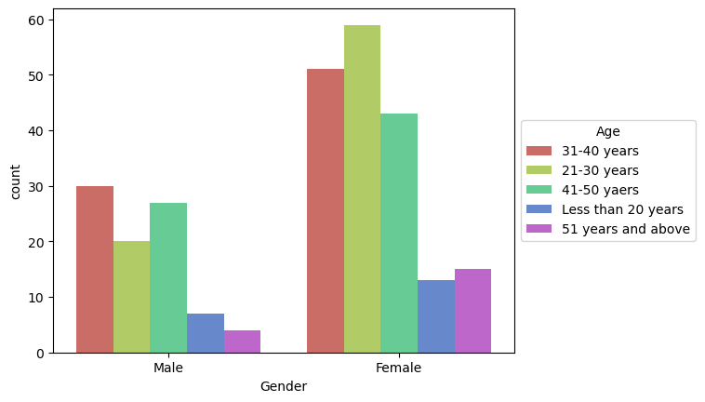

As we can see, majority of the female customers who shop online are in the age group of 21-30 years, followed by 31-40 years.

As we can see, majority of the male customers who shop online are in the age group of 31-40 years, followed by 41-50 years.

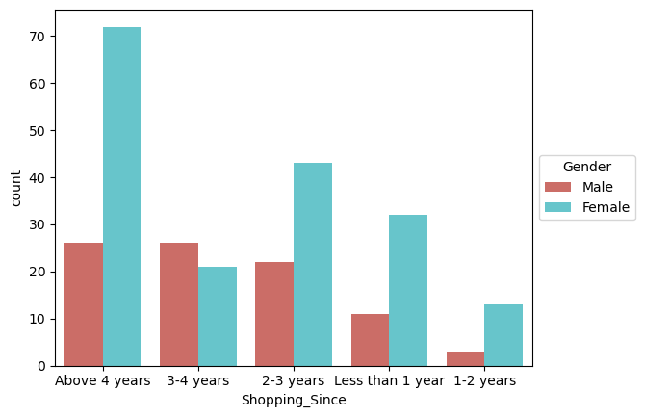

As we can see, majority of the female customers have been shopping online for more than 4 years. Also, a considerable amount of female customers have been shopping online since 2-3 years.

As we can see, male customers who have been shopping online for more than 4 years is considerably low, as compared to female customers.

Thus, we can conclude that, a vast majority of customers who shop online are female.

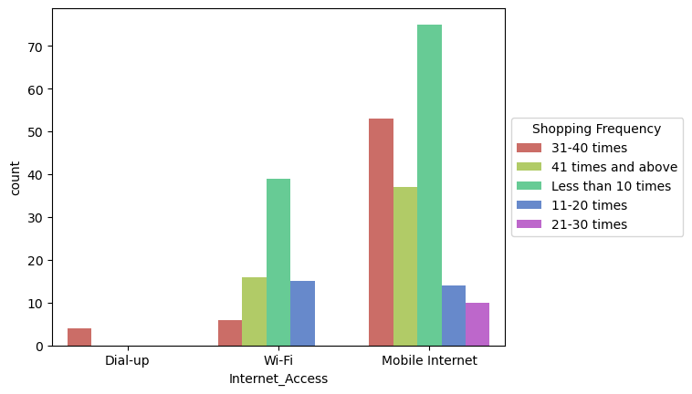

As we can see, majority of the customers shop online less than 10 times in a year by using Mobile Internet, followed by customers who shop online 31-40 times in a year.

Few customers also shop online less than 10 times in a year by using Wi-Fi.

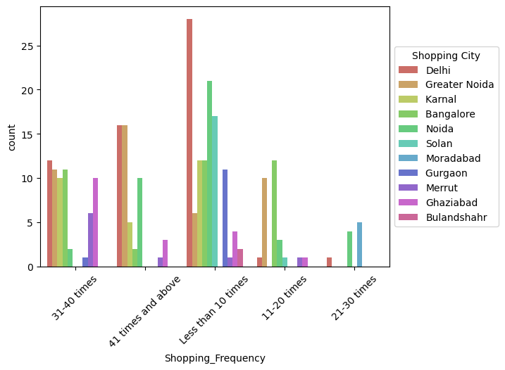

As we can see, majority of the customers who shop online less than 10 times in a year are from Delhi.

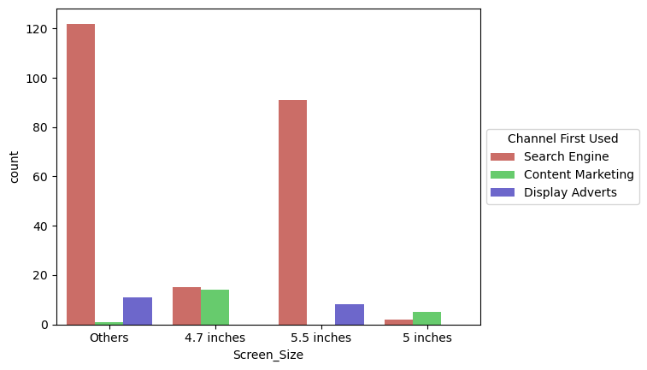

As we can see, majority of the customers whose Screen Size was other than 4.7, 5 and 5.5 inches used Search Engine to arrive at their favorite online store for the first time.

Also, the customers whose Screen Size was 5.5 inches also used Search Engine to arrive at their favorite online store for the first time.

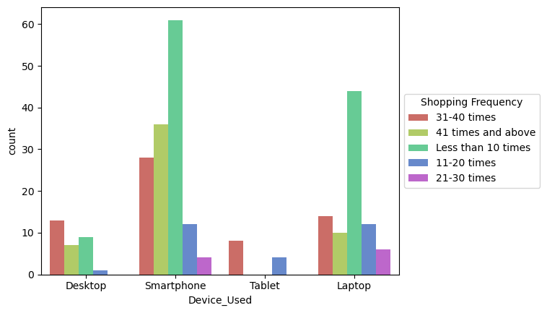

As we can see, majority of the customers used Smartphones to make an online purchase less than 10 times in the past 1 year.

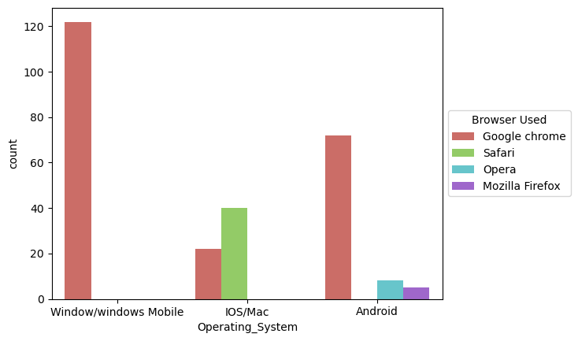

As we can see, majority of the customers having Windows Operating System in their device used Google chrome to access the ecommerce shopping websites.

Also, a considerable amount of customers having android used Google Chrome to access the ecommerce shopping websites.

There are also a few customers having IOS/Mac operating system who used Safari, followed by Google Chrome to access the website.

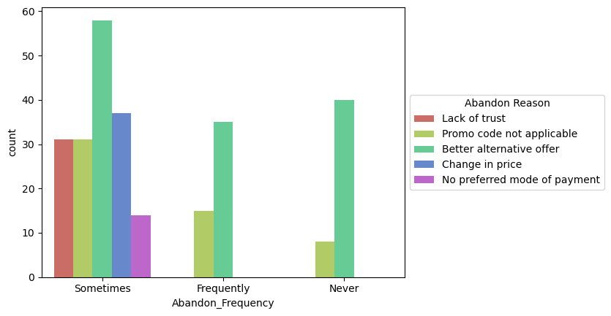

As we can see, majority of the customers sometimes abandoned their shopping cart because they found a better alternative offer, followed by customers who abandoned their shopping cart due to change in price.

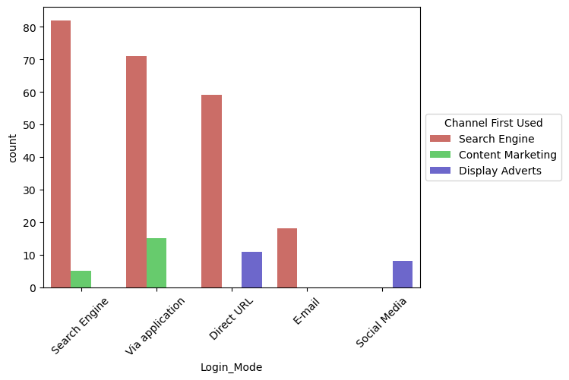

As we can see, majority of the customers used Search Engine to arrive at their favorite online store for the first time.

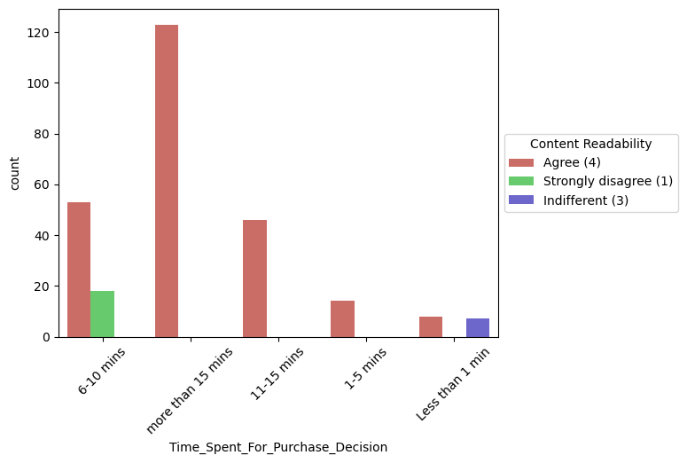

As we can see, majority of the customers who spent more than 15 mins for making a purchase decision, agreed that the content on the website must be easy to read and understand.

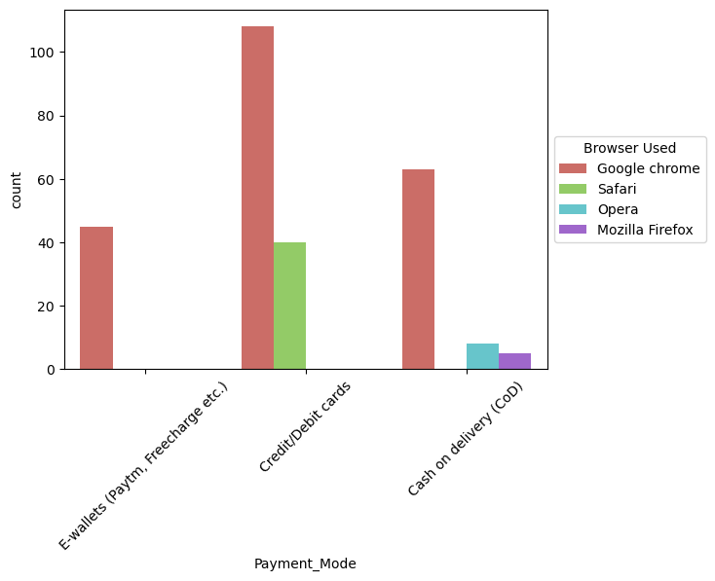

As we can see, majority of the customers who used Google chrome, made a payment for their online purchase by using Credit/Debit cards.

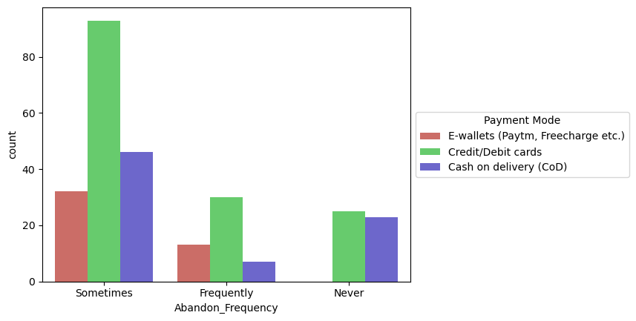

As we can see, majority of the customers sometimes abandon their shopping cart, when the mode of payment used is Credit/Debit cards.

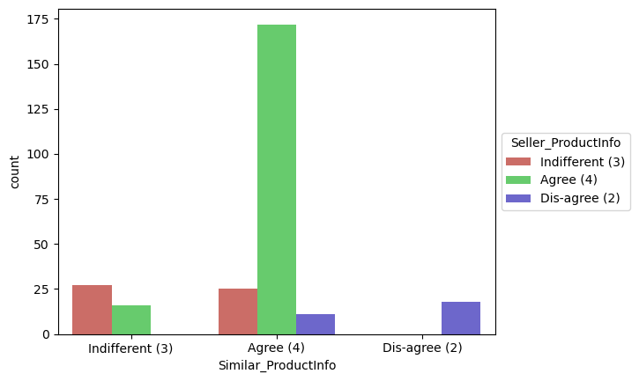

As we can see, majority of the customers agreed that the information on similar product to the one highlighted is important for product comparison. The customers not only want a complete information about the products, but also want a complete information on listed seller.

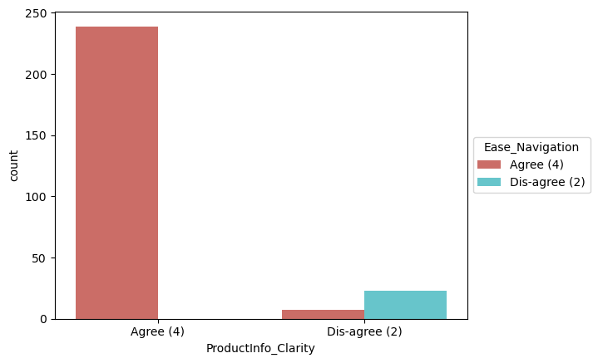

As we can see, majority of the customers agreed that they should be able to navigate the website easily and all the relevant information on listed products must be stated clearly. If these conditions are met, then the customers are more likely to make an online purchase.

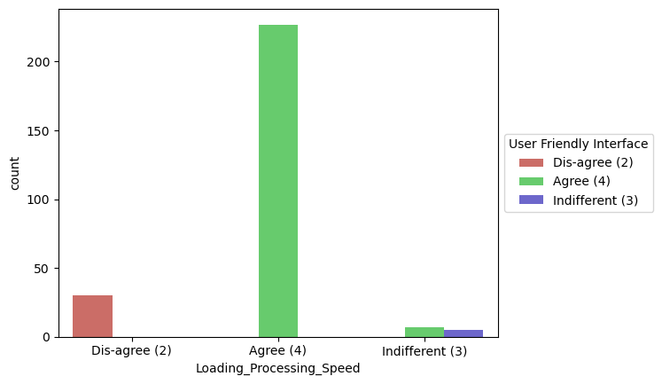

As we can see, majority of the customers are of the opinion that the loading and processing speed should be high and also the interface of the website should be user friendly. If these requirements are satisfied, then the customers are obviously attracted towards the ecommerce websites, which would results in the betterment of sales.

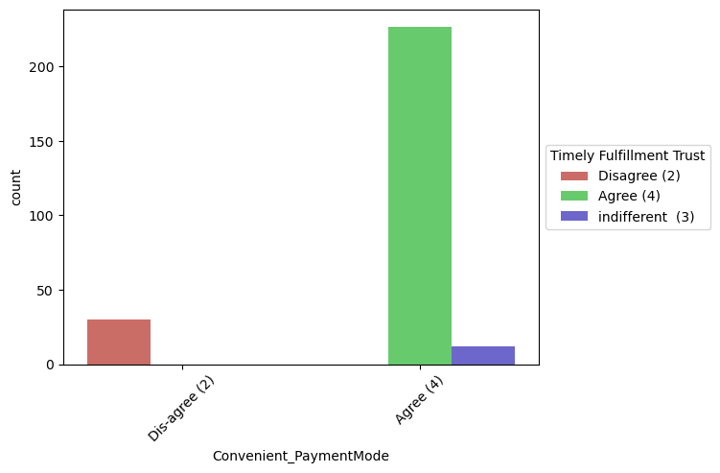

As we can see, majority of the customers are of the opinion that the ecommerce websites should provide convenient payment methods, and majority of the customers trust that the online retail store will fulfill its part of the transaction at the stipulated time.

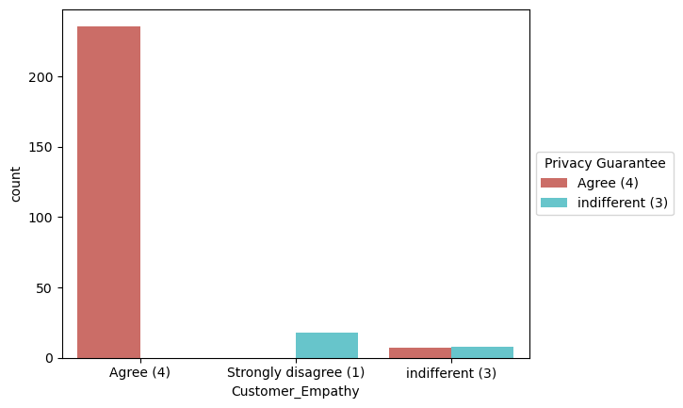

As we can see, majority of the customers desire Empathy from the ecommerce websites, and they also want that their privacy is guaranteed. Hence, the ecommerce websites should be able to resolve all the queries of the customers and they have to assure the customers, that their credentials are secured and confidential. If the ecommerce websites guarantee the privacy of the customers, then the customers feel safe to shop online and are likely to shop more, which will enhance the sales.

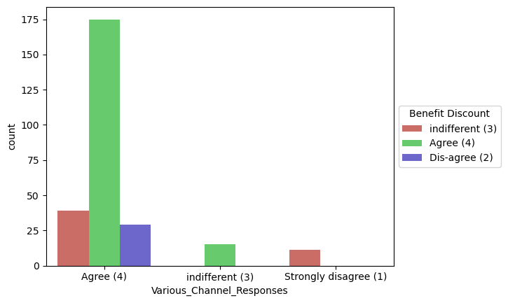

As we can see, majority of the customers agree that shopping online gives them monetary benefits and discounts. Hence, the ecommerce websites should give discounts and coupon codes to the customers. Also, majority of the customers agree that the ecommerce websites should be responsive to their queries, and they should be available on several communication channels (email, online rep, twitter, phone etc). thus, in order to improve the sales, the ecommerce websites should ask the feedback regarding their services, ratings of the products, reviews etc.

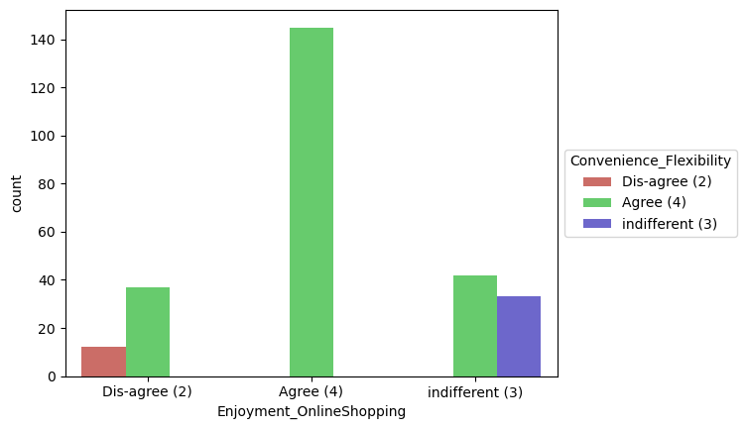

As we can see, majority of the customers agree that shopping online is convenient and flexible. If the customers feel that shopping online is convenient and flexible, then it is obvious that they would enjoy the whole shopping experience.

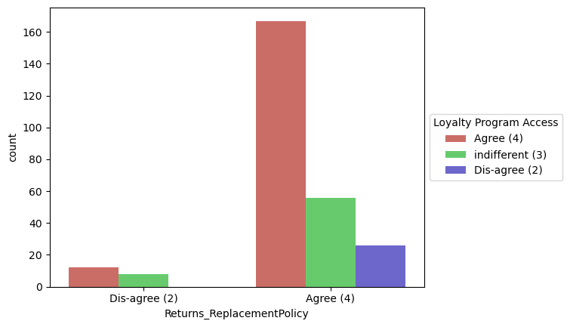

As we can see, majority of the customers agreed that return and replacement policy of the ecommerce websites is important for making a purchase decision. If the products are non-returnable, then the customers feel skeptical about ordering the products, as they would not be able to return the products, in case they don't like it. So, in order to improve the sales, the ecommerce websites should provide easy return and replacement policy. Also, majority of the customers are of the opinion that they should be able to gain access to loyalty programs. If an access to loyalty programs is provided, then the customers tend to shop more. Thus, the ecommerce websites should provide access to loyalty programs, which inturn would result in improvement of sales.

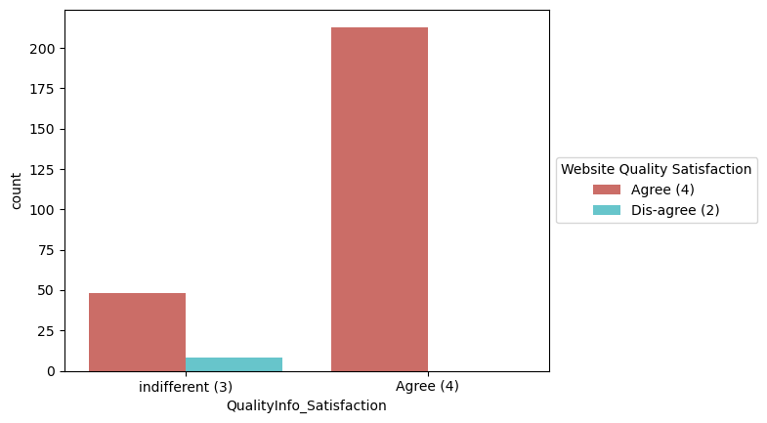

As we can see, majority of the customers agreed that displaying quality information on the website improves satisfaction of customers. If complete information about the quality of the products is provided, then the customers tend to feel that the website or application is good to shop from. This would result in the customers ending up making purchases on the ecommerce website, as they feel satisfied while shopping from a good quality website or application.

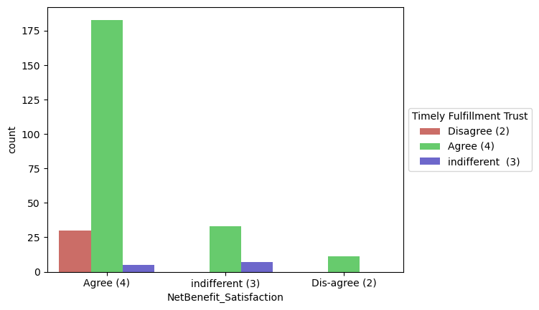

As we can see, majority of the customers agreed that Net Benefit derived from shopping online can lead to users satisfaction. The customers should feel that they are getting benefitted by shopping online. Thus, the ecommerce websites should attract the customers by giving them huge discounts and coupon codes. Also, note that majority of the customers agree that there should be a trust that the online retail store will fulfill its part of the transaction at the stipulated time. thus, the ecommerce websites should work with their delivery partners, and make sure that the orders are delivered on time.

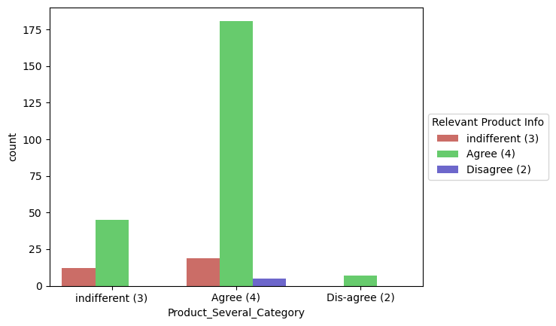

As we can see, the customers agree that the ecommerce websites should offer them a wide variety of products across several categories, so that the customers can have many products to choose from. Also, majority of the customers agree that there should be provision of complete and relevant product information. Both these factors can help the ecommerce websites in improving their business.

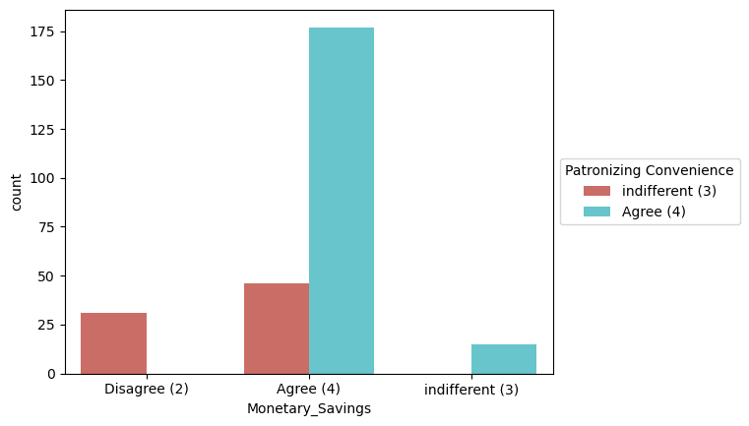

As we can see, majority of the customers agree that it should be convenient to patronize the online retailer, and there should be monetary savings involved.

In this digital and competitive world, everyone wants to save money. thus, the ecommerce companies need to know that the best way to sell online is to make the consumer feel that he is saving money doing so. And not just feel, online shopping should result in a lot of saving for the consumer. This saving would automatically get converted into trust and brand equity for the seller. To do this the online companies should offer the best deals and bargains to the consumer through social platforms. If the retailers give some discounted prices then the customers can make money savings and they tend to purchase in the same websites regularly. Convenience is the important thing for ecommerce and most of the customers agreed with it.

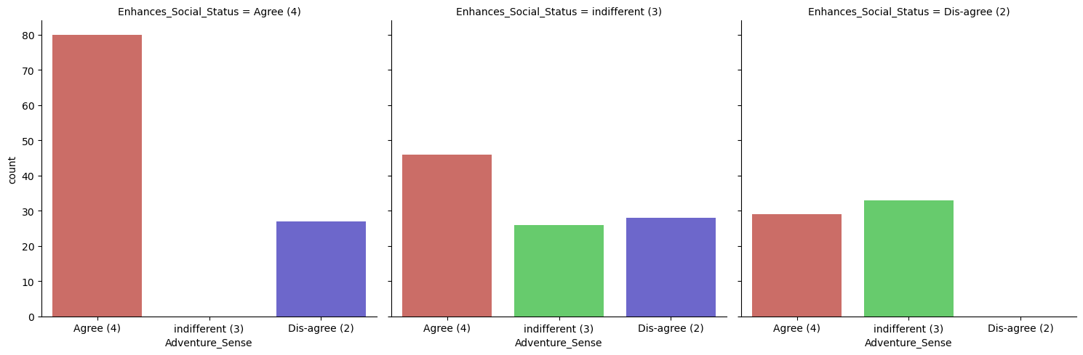

As we can see, majority of the customers agree that shopping on their favorite website gives them a sense of adventure, and also enhances their social status.

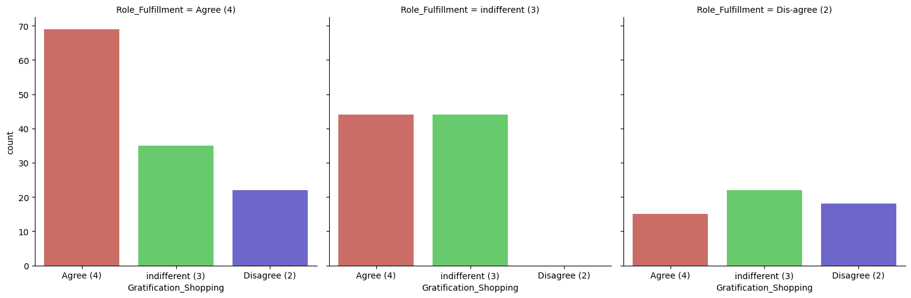

As we can see, majority of the customers agree that shopping on their favorite website helps them fulfill certain roles, and they feel gratified shopping on their favorite website.

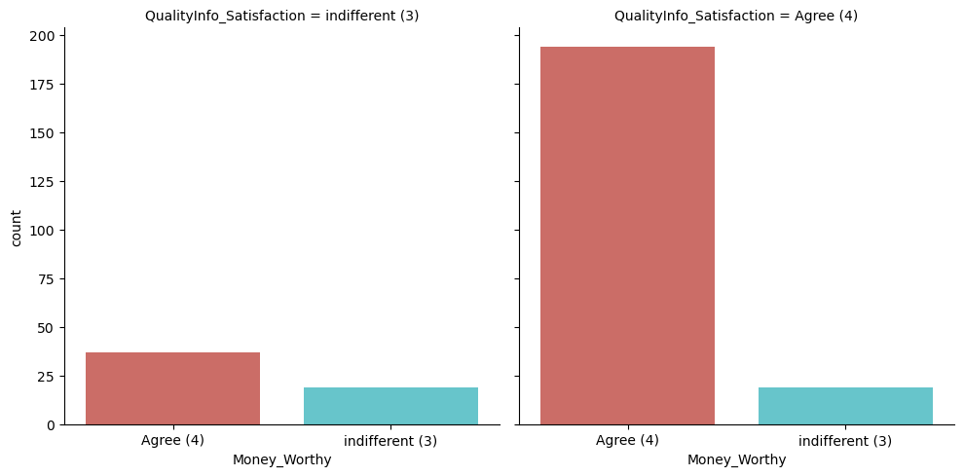

As we can see, majority of the customers agree that quality information on the website should be displayed, which in turn results in improvement of satisfaction of the customers. If the customers are satisfied with the information about the quality of the products, then they tend to feel that they are getting value for money spent.

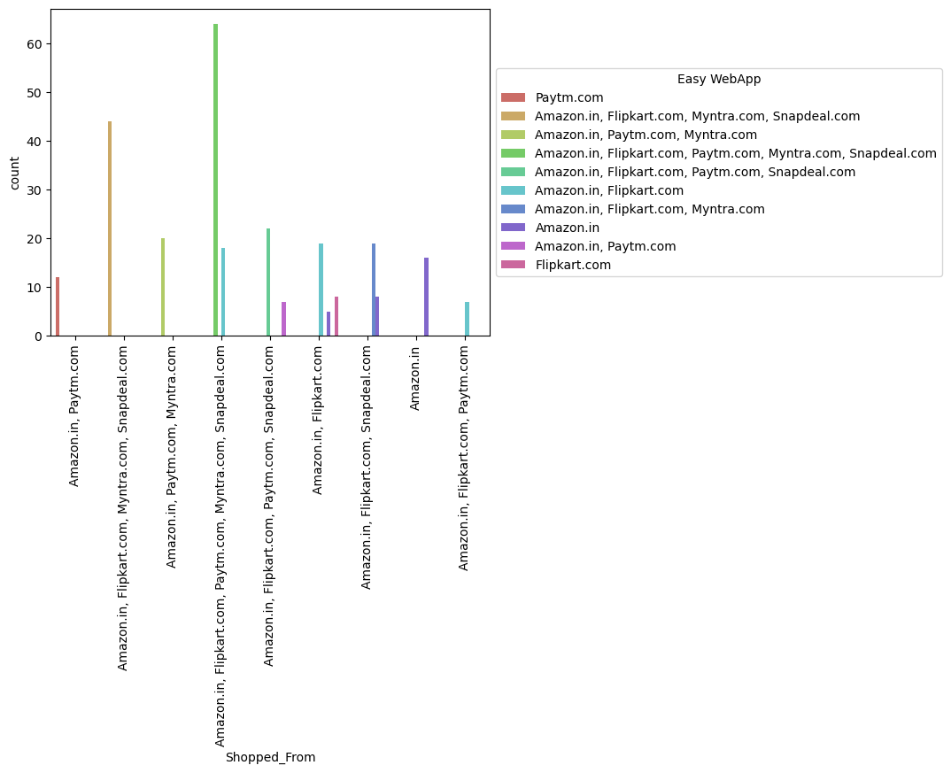

As we can see, majority of the customers feel that Amazon.in, Flipart.com, Paytm.com, Myntra.com and Snapdeal.com have an easy to use website and application. Hence, they tend to shop from these ecommerce websites.

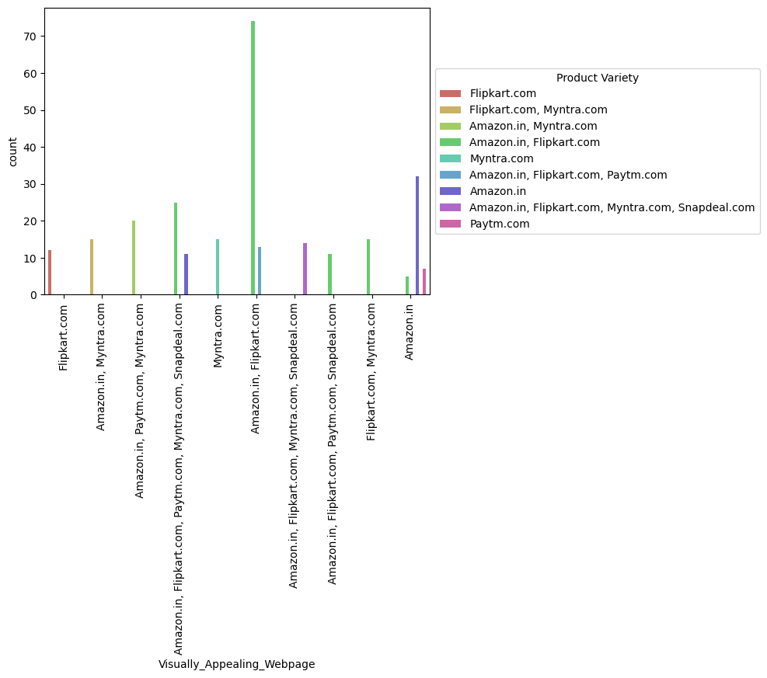

As we can see, majority of the customers feel that Amaon.in and Flipkart.com have a visually appealing webpage, and also they have a wide variety of products on offer.

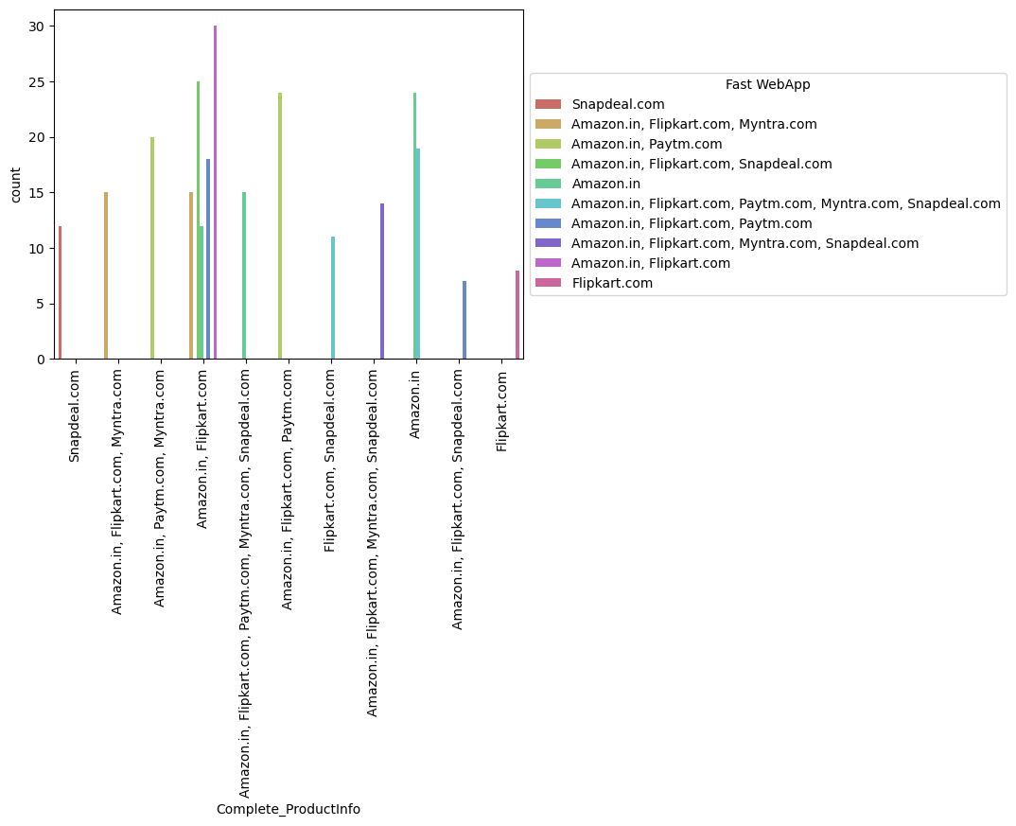

As we can see, customers feel that Amazon.in and Flipkart.com provide a complete information about the listed products, and they also feel that, Amazon.in and Flipkart.com have the fastest website and application.

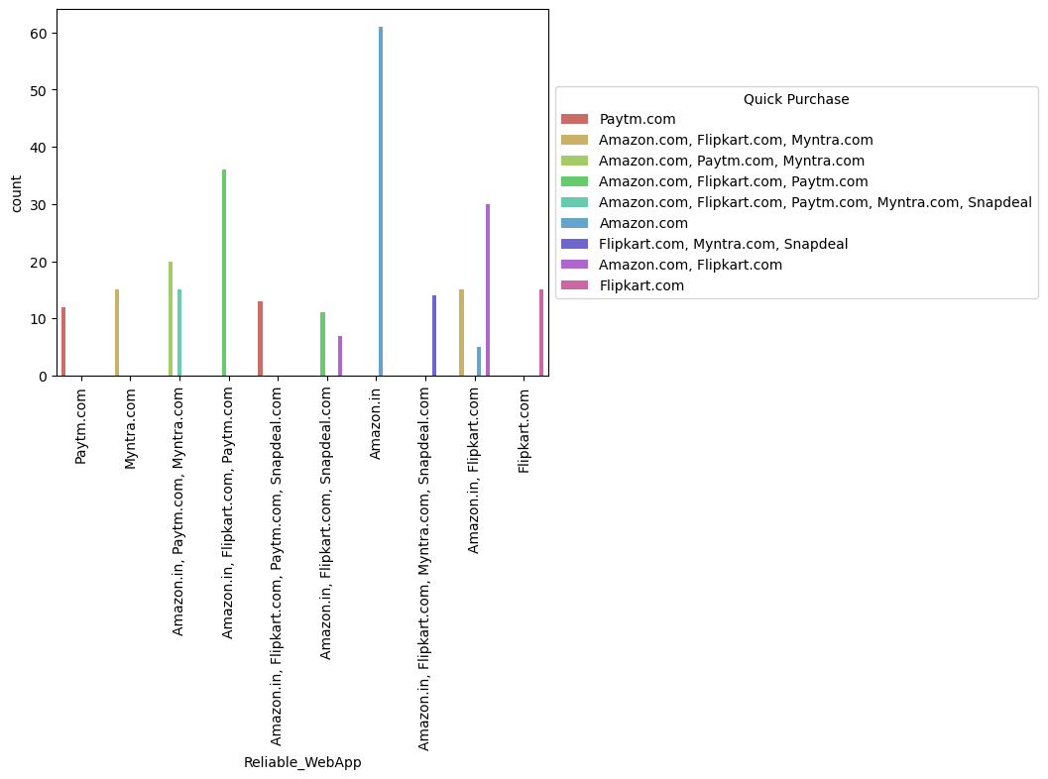

As we can see, majority of the customers feel that amazon.in has the most reliable website and application. As the customers feel that Amazon.in is reliable, they tend to make a quick purchase.

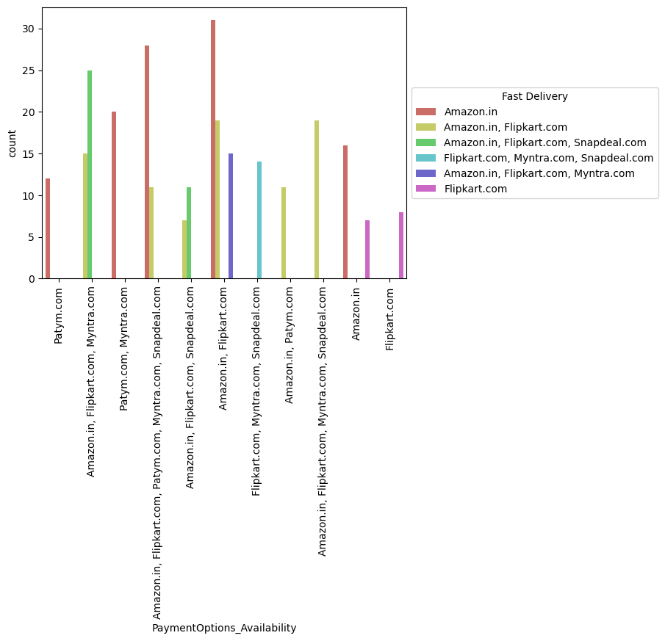

As we can see, Amazon.in offers availability of several payment options, due to which the customers find it convenient to shop on Amazon.in. Also, Amazon.in delivers the products very fast.

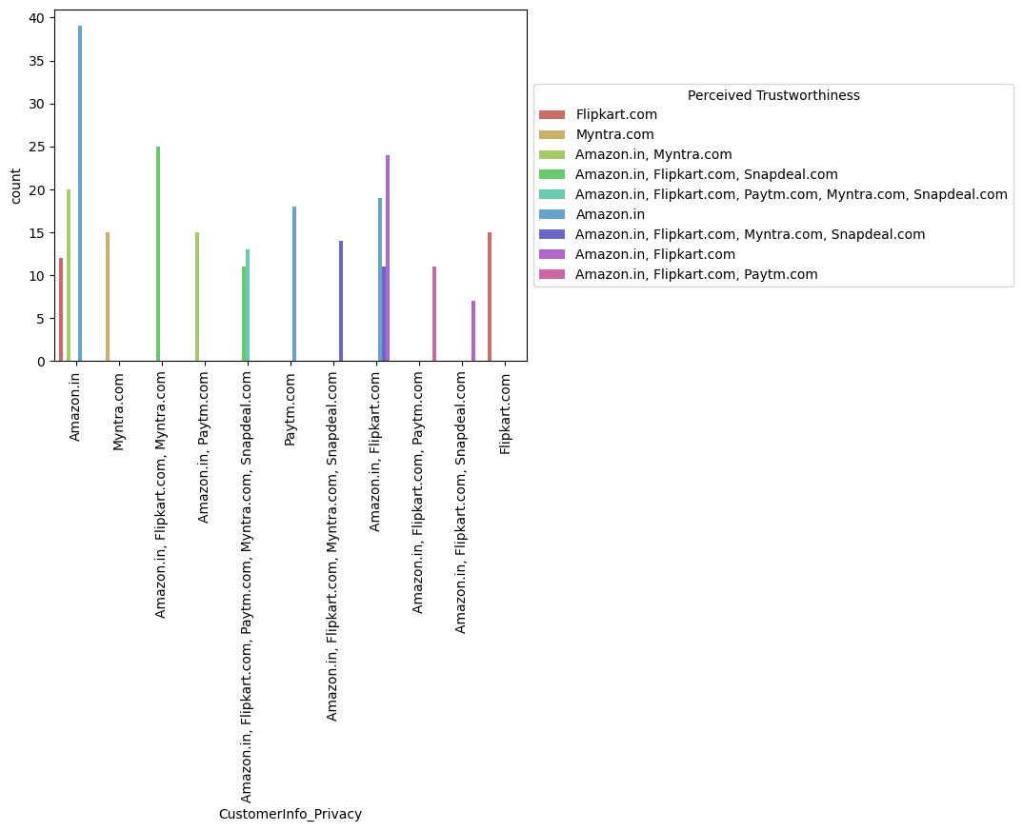

As we can see, Amazon.in provides the best privacy of customers information, and hence the customers trust Amazon.in.

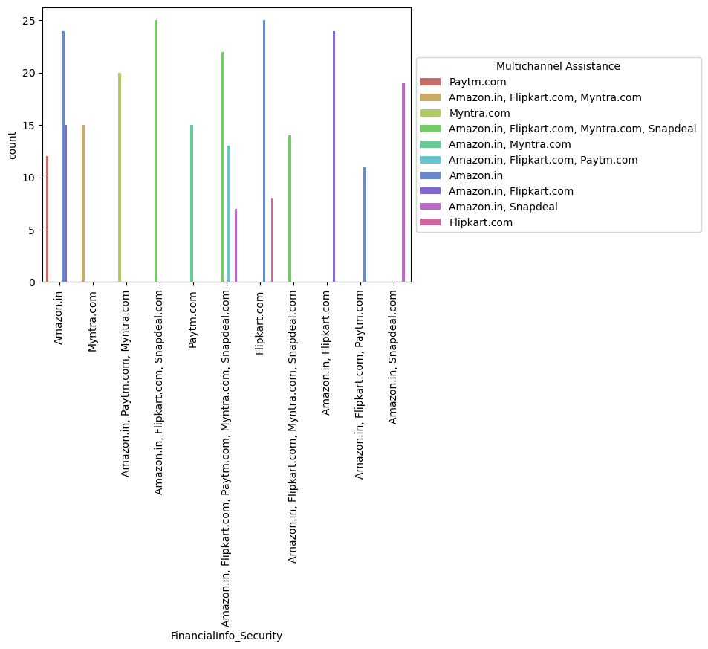

As we can see, majority of the customers feel that Amazon.in, Flipkart.com and Snapdeal.com provide security of customer financial information. Also, Amazon.in, Flipkart.com and Snapdeal.com provide online assistance through multichannel.

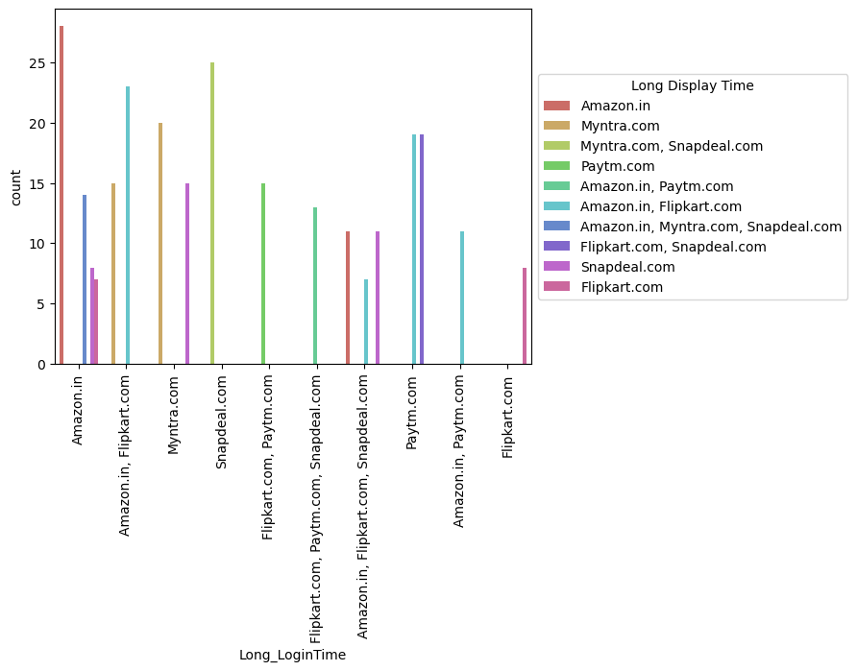

As we can see, during the promotion and sales period, the traffic on the ecommerce websites increases tremendously, especially on Amazon.in. Due to this, the login time and display time for Amazon.in is higher.

On the second position, there is Snapdeal.com with longer login and diplay time.

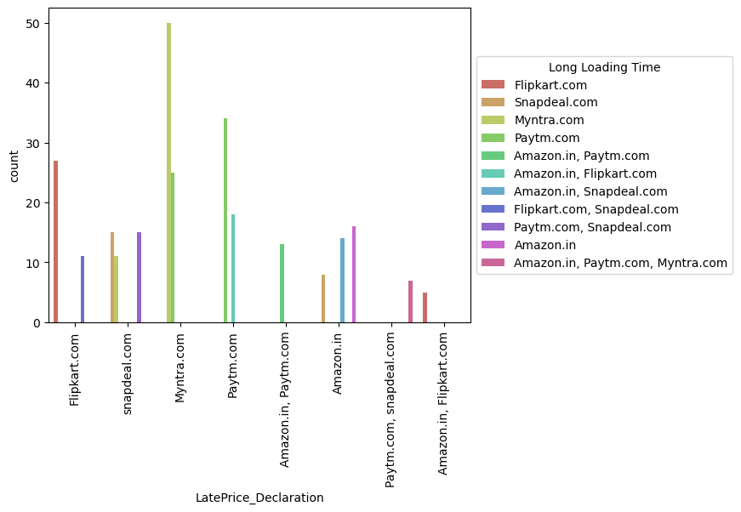

Myntra.com declares the prices late during the promotion and sales period, due to which the traffic on the wesite increases tremendously during the promotion and sales period, which ultimately leads to longer login time.

The same issues are faced while using Paytm.com, although to a lesser extent.

Thses factors are a major drawback from the business perpective, and should be taken care of by the ecommerce websites.

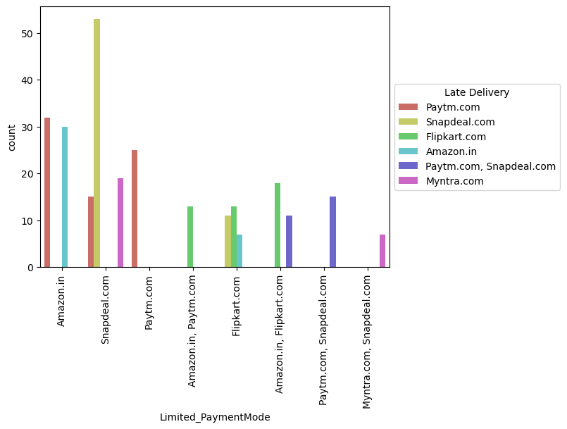

As we can see, Snapdeal.com has limited payment modes and also delivers the products late, followed by paytm.com.

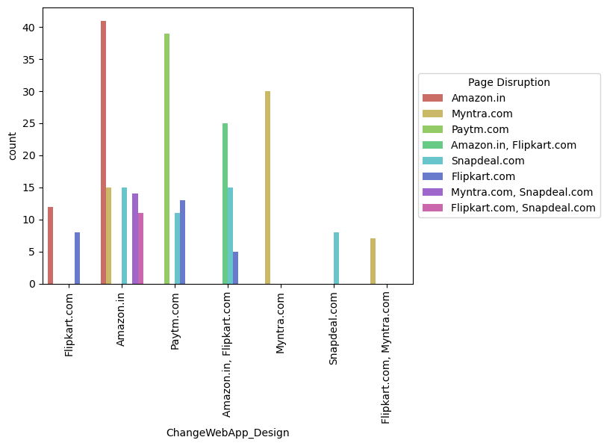

As we can see, majority of the customers want a change in website or Application design, as they are facing frequent page disruption when moving from one page to another.

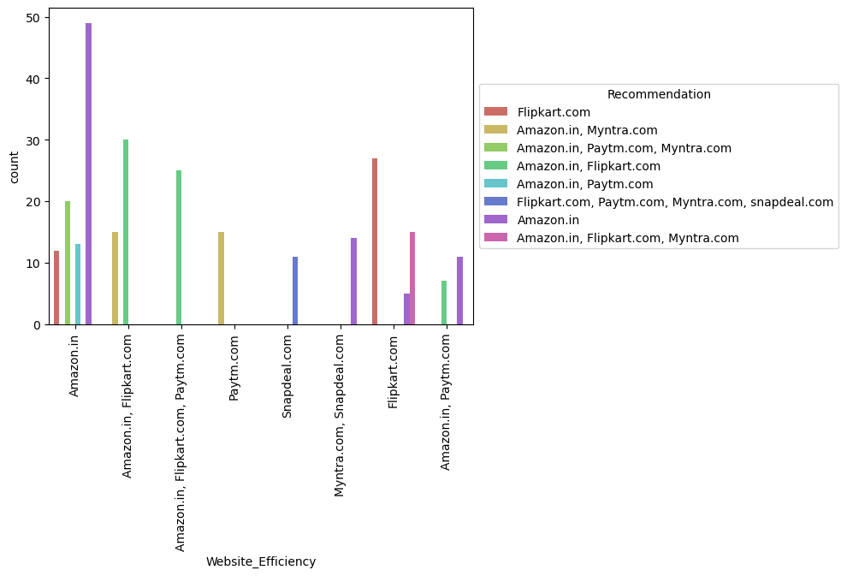

As we can see, majority of the customers find Amazon.in to be an effiecient website for online shopping, and hence would recommend it to their friends.

**Findings of Data Analysis:**

1. **Amazon.in**



|  |
| --- |
| ***To be improved:***  • During promotions, try to give a disturbance free shopping experience to customers.  • Give more payment options to customers.  • Try to give price early during promotion.  • Reduce the delivery time of the products.  ***Positive feedback summary:***   * Convenient to use and also a good website for shopping. * Fast delivery of products. * Availability of complete information of the products. * Presence of online assistance through multi-channels. * Reliable website or app, perceived trustworthiness. |
| 1. ***2. Flipkart.com***     ***To be improved:***   * *During promotions, try to give a disturbance free shopping experience to customers.* * *Give more payment options to customers.* * *Try to give the price early during promotion.* * *Reduce the delivery time of the products.* * *Flipkart and Amazon almost share the same feedbacks with varying percentages as the only difference.*   ***Positive feedback summary:***   * *Convenient to use and also a good website for shopping.* * *Fast delivery of products.* * *Availability of complete information of the products.* * *Presence of online assistance through multi-channels.* * *Reliable website or app, perceived trustworthiness.* * *Wild variety of products to offer.* |
| ***3. Myntra.com***    ***To be improved:***   * *During promotions, try to give a disturbance free shopping experience to customers.* * *Try to give the price early during promotions.* * *Reduce the delivery time of the products during promotions.*   ***Positive feedback summary:***   * *Convenient to use and also a good website.* * *Availability of several payment options.* * *Faster products delivery.* * *Complete information of products available.* * *Reliable website or app, perceived trustworthiness.* * *Wild variety of product to offer*  |  | | --- | | ***4. Paytm.com***    ***To be improved:***   * *Reduce the delivery time of the products during promotions.* * *Try to give the price early during promotion.* * *During promotions, try to give a disturbance free shopping experience to customers.* * *Late declaration of price and discounts.* * *Frequent disturbance is occurring while moving from one page to another.*   ***Positive feedback summary***   * *Convenient to use and a good website.* * *Quickness to complete a purchase.* * *About 64% of the customers feel that either web or app is reliable.* * *Around 20% of the customers believe that Paytm has a wild variety of products on offer.* | |

|  |
| --- |
| **5.** **Snapdeal.com**    *To be improved:*   * Reduce the delivery time of the products during promotions. * Try to give the price early during promotion. * During promotions, try to give a disturbance free shopping experience to customers. * Late declaration of price and discounts. * No one has expressed to recommend Snapdeal to a contact as it has the most negative feedbacks among all other websites.   Positive feedback summary:   * Convenient to use. * 54% of the customers are happy about the availability of financial information security. |
| **Conclusion:**  The results of this study suggest following outputs which might be useful for E-commerce websites to extend their business  1. The cost of the product, the reliability of the E-commerce company and the return policies all play an equally important role in deciding the buying behaviour of online customers. The cost is an important factor as it was the basic criteria used by online retailers to attract customers. The reliability of the E-commerce company is also important, as it is even required in offline retail. It is important because customers are paying online, so they need to be sure of security of the online transaction. The return policies are important because in online retail customer does not get to feel the product. Thus, he wants to be sure that it will be possible to return the product if he does not like it in real. Whereas, the logistics factor, which included Cash on delivery option, One day delivery and the quality of packaging plays a secondary role in this process though these are Must-be-quality. This is so because these all does not interfere with the real product and people believe that this is the basic value that E-commerce websites provide.  2. All the websites were not equally preferred by online customers. Amazon was the most preferred followed by Flipkart. This can be explained easily by previous result that we got. These two companies are most trusted in the industry and hence, have a huge reliability. Also, the sellers listed on these websites are generally from Tier 1 cities as compared to Snapdeal and PayTM which have more sellers from tier 2 and 3 cities. Also, these websites have the most lenient return policies as compared to others and also the time required to process a return is low for these. |